We're going on a ...QUEST! | Stage 3 (Year 5, 6) | English

Summary | Duration
This 10 week unit is primarily an English unit which focuses on building students' skills, values and attitudes in subject English. Through reading, viewing, writing, speaking and listening to a range of texts, students will understand and identify features of a range of quests. Students will draw on the plot of a journey to structure narrative which concludes with the achievement of writing their own quest.  We focus on a number of English Textual Concepts (ETCs) throughout the unit. We revise narrative and character. We look at connotation, symbol and imagery, as the main text, The Glimme by Emily Rodda, contains rich visual literacy in the illustrations and text layout throughout. The main ETC is genre. We include familiar texts that fall into this genre (quests) that students have experienced through earlier grades, including We're going on a Bear Hunt (Rosen & Oxenbury, 2008), Beware the Deep, Dark Forest (Whiting & White, 2018) and To The Bridge (Fenton & McLean, 2018). The Glimme, We're Going on a Bear Hunt and Beware the Deep, Dark Forest contain elements of poetry, including alliteration, rhyme, rhythm and figurative language.  The other main ETC in the unit is theme. Most quests contain a main message to the reader/ viewer, as in the Greek Myths and Legends which stem from ancient times, some of which are included in the unit. Quests, however differ from myths and legends in that the protagonist usually achieves a significant goal, after a difficult and challenging voyage. Quests are commonly described as "a hero's journey". | Sample term: 10 weeks.  Detail: 60 minute lesson, 4 lessons per week for a term.  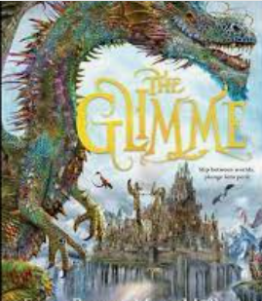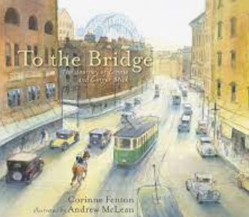  Main text: The Glimme suggest a class set of texts.  Subsidiary texts: suggest one copy per class.  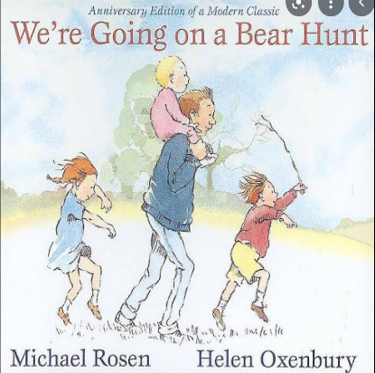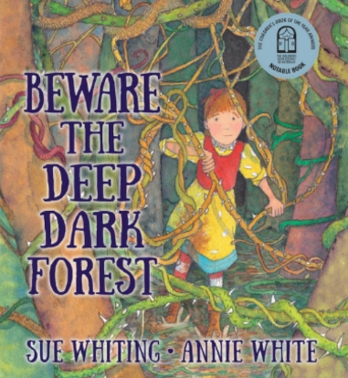

Unit overview | We're going on a ... QUEST!
This unit integrates elements of Creative Arts with subject English. Students will draw on a range of quality texts that all contain elements of a quest- a plot device of narrative writing where character/s and their companions search for something challenging and extremely important, something often extraordinarily difficult to find. Along the journey, they conquer phantasmagorical creatures that stand in the way of the heroes achieving their dreams.  We focus on a number of English textual concepts throughout the unit, "We're going on a ...QUEST!". We revise narrative, character and code and convention. Additionally, the main English textual concepts contained in the unit are genre (a quest is a particular form of narrative, traced back to Greek myths and legends of ancient times), and theme, as quests usually contain an important message for the reader that, if embraced, make us better people as a result.  The main text of the unit is The Glimme (Rodda, 2018), a traditional quest where the hero seeks to achieve a goal with the help of their companions. Along the trek, they face ordeals and challenges, magical creatures and life-threatening dangers, until they finally achieve their goal and reap a reward.  Other texts include multimodal texts, Greek myths and legends and webpages. We discuss familiar, famous quests including Harry Potter, Star Wars, Lord of the Rings and others. As an enrichment activity, students are invited to tinker with the computer coding website Tynker, to attempt to write/ construct their own multimodal text, as the quest genre has stretched to include webquests over recent years.  We revisit texts that students have read in prior grades, to identify the main features of quests, including We're going on a Bear Hunt, Beware the Deep Dark Forest, and To the Bridge, to raise awareness that we come into contact with quests across all years of schooling, and beyond into our adult lives. Quests entertain us. They excite us, frighten, fill us with gladness and sadness. It could be construed that quests are possibly a metaphor for describing life's journey. We set out on an extended and arduous expedition, from birth to death, with the goal of a long and happy life as the priceless gift. | Integration:  English: 3.5 hours per week  Creative Arts: 30 minutes per week  English Textual Concepts focus of unit:  - Genre  - Theme  - Style  - Revise Character, Narrative; Code and convention.  - Connotation, Image, Symbol.  Shorthand used in unit:  - T: Teacher/s  - S: Student/s  - KQ: Key class discussion questions  - LI: Learning Intention  - SC: Success Criteria  - IWB: Interactive whiteboard  Learning across the curriculum icons including cross curriculum priorities, are incorporated and identified by icons throughout the unit:  The general capabilities include:  - Critical and creative thinking  - Ethical understanding  - Information and communication technology capability  - Intercultural understanding  - Literacy  - Numeracy  - Personal and social capability e.g. (ACELA 1443)  The unit includes the Australian curriculum content descriptions for English, identified by the Australian curriculum codes in brackets at the end of each content descriptor.  An audio version of The Glimme is available free from public libraries (Borrowbox), useful for students to listen to/ read along with to practise their oral reading fluency and accuracy.
Outcomes | Assessment overview
English K-10  - EN3-1A communicates effectively for a variety of audiences and purposes using increasingly challenging topics, ideas, issues and language forms and features  - EN3-2A composes, edits and presents well-structured and coherent texts  - EN3-3A uses an integrated range of skills, strategies and knowledge to read, view and comprehend a wide range of texts in different media and technologies  - EN3-4A draws on appropriate strategies to accurately spell familiar and unfamiliar words when composing texts  - EN3-5B discusses how language is used to achieve a widening range of purposes for a widening range of audiences and contexts  - EN3-6B uses knowledge of sentence structure, grammar, punctuation and vocabulary to respond to and compose clear and cohesive texts in different media and technologies  - EN3-7C thinks imaginatively, creatively, interpretively and critically about information and ideas and identifies connections between texts when responding to and composing texts  - EN3-9E recognises, reflects on and assesses their strengths as a learner  - EN3-8D identifies and considers how different viewpoints of their world, including aspects of culture, are represented in texts | Assessment for learning:  T. reflects on those students requiring differentiation throughout the unit. Class teacher to use differentiation planning sheet for this purpose, before beginning to teach the unit.  Class collaboratively compose a writing rubric from the National Literacy Learning Progression (NLLP) substrands CrT, UnT, Punct., and Sp. to assess and monitor their writing growth throughout the term. An example writing marking rubric is provided, Handout 2.  Pretest writing task: The unit begins with a pretest writing task in which students retell a Greek legend, explaining its theme. The class will view and discuss two legends for this purpose, and students choose which legend they will write about.  Pretest oral reading task: A one minute oral reading fluency and accuracy reading passage student copy (Handout 3), and teacher copy (Handout 4), is used as a pretest and post-test for student oral reading, from main text, The Glimme.  Pretest vocabulary task: Mini vocabulary assessment (Handout 5) adapted from Quigley, (2018). Closing the Vocabulary Gap. London. Routledge.  Pre and post- test vocabulary assessment task  Students select Likert scale 0-5 from a range of vocabulary from text, The Glimme:  - I have never heard of the word  - I have heard of the word  - I have a vague idea of what it means  - I can say what the word means precisely  - I know some synonyms for the word  - I know some antonyms for the word. (p169)  Assessment as learning:  Formative assessment tasks can be selected from learning tasks: e.g. from unit:  - S. write a description of their magical creatures drawings (free choice e.g. castle, dragons) and use writing rubric to self, peer, teacher assess writing sample.  -S. write a character description using figurative language chapt. 3.  Assessment of Learning:  The unit concludes with students writing a quest scaffolded by the five common, defining features of quests that they will be familiarised with in authentic texts throughout the unit.  The oral reading and fluency test will be re-administered as a post test task, also the vocabulary activity to monitor student growth throughout the term. Suggest teachers record and graph student results pre and post on Excel as evidence of student learning.

Content | Teaching, learning and assessment | Resources | Registration
Pretest tasks: Assessments for learning  Stage 3 - Speaking and listening  participate in and contribute to discussions, clarifying and interrogating ideas, developing and supporting arguments, sharing and evaluating information, experiences and opinions (ACELY1709)  identify and summarise key ideas and information from guest speakers, eg note-taking or using digital technologies (ACELY 1709)  Stage 3 - Reading and viewing  Respond to, read and view texts  summarise a text and evaluate the intended message or theme (ACELT 1617)  Stage 3 - Writing and representing  identify and explore underlying themes and central storylines in imaginative texts (ACELT 1613)  plan, draft and publish imaginative, informative and persuasive texts, choosing and experimenting with text structures, language features, images and digital resources appropriate to purpose and audience (ACELY1704, ACELY1714) | LI: S. will complete pretest reading, writing and vocabulary tasks.  -Creating a class writing rubric. Discuss the importance of monitoring writing growth from multiple perspectives- self for monitoring writing growth, setting learning goals; teacher for determining where to take individual students to next in their learning. Class construct a writing rubric based on NLLP sub- elements of CrT, UnT, Punct., Gr. and Sp., or whichever elements that data suggests should be the learning focus for your students.  -Pretest oral reading. Teacher (or LAST) to assess students oral reading fluency and accuracy, as pretest reading data. Record results.  -Talk about Greek myths and legends and how they have relevance to our lives today. They usually contain a message that we can learn from (theme), and magical/ mythical creatures, many of whom students may be unfamiliar with (e.g. centaurs, minotaurs, sea serpents).  -Pretest writing task. The unit begins with a pretest writing task in which students retell a Greek legend (video), explaining its theme. The class will view and discuss two short Greek legends for this purpose. Students choose which legend they wish to write about. The class will discuss each legend, and compose a vocabulary word bank together, prior to beginning the task, setting them up for success.  -T. to model pretest writing task on IWB, modelling the SC for the task.  - Differentiation: some students may wish to use a writing scaffold provided to assist in the completion of the writing task.  -S. plan, draft and edit their pretest writing task. S. use class rubric to assess their writing samples and students set individual learning goals, based on their writing task. | Teacher prereading: Handout 1- (PETAA Paper, 2021). T. also need to read the main text, The Glimme (Rodda, 2018) prior to beginning the unit, so they can teach it effectively, with passion. Itis very important that T. are familiar with text prior to teaching the unit.  Handout 2- Example of class writing rubric. Class to create their own/ nuance rubric to address their particular learning needs.  Handouts 3, 4- One minute read proforma (teacher and student copy)  Greek legends for kids (videos YouTube):  1. Athena and Poseidon  2. Medusa and Athena  Magical creatures images from myths and legends  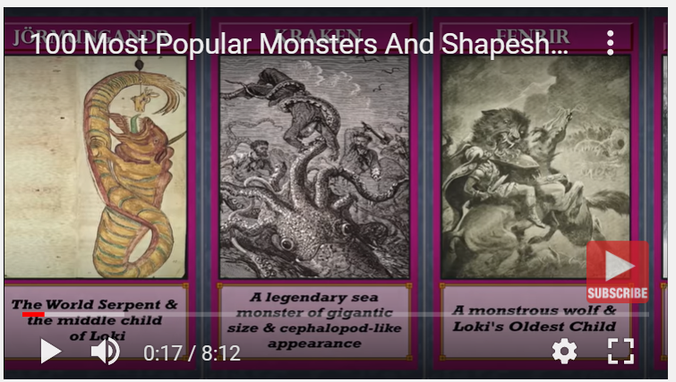  Source: (93) Dabshaleem - YouTube  Differentiation- for students requiring a writing scaffold, prewriting planning sheet, is provided. Handout 6.
Creative Arts K-6  VAS3.2 Makes artworks for different audiences assembling materials in a variety of ways.  Stage 3 - Reading and viewing  compare texts including media texts that represent ideas and events in different ways, explaining the effects of the different approaches (ACELY1708)  interpret picture books, comic strips and sequences of digital images which do not contain written text  Stage 3 - Grammar, punctuation and vocabulary  understand how noun groups/phrases and adjective groups/phrases can be expanded in a variety of ways to provide a fuller description of the person, place, thing or idea (ACELA1508)  Stage 3 - Writing and representing  plan, draft and publish imaginative, informative and persuasive texts, choosing and experimenting with text structures, language features, images and digital resources appropriate to purpose and audience (ACELY1704, ACELY1714, ACELA1797)  Stage 3 - Reflecting on learning  reflect on own learning achievements against specific criteria  critically reflect on the effectiveness of their own and others' writing, seeking and responding to feedback (ACELY1705) | LI: S. will create artworks and describe them using extended noun and verb groups. Write a description of their artwork/ character.  -T. & S. talk about the imaginary creatures in the Greek legends they viewed in pretest writing task videos. Revise magical creatures images from prior lesson.  -T. introduce directed drawing activity- castles, dragons and phoenix, all things found in new text, "The Glimme" by Emily Rodda. S. may choose to draw a different fantasy creature.  -S. independently completed drawing activity of their choice.  -S. label their drawings with descriptive language and extended noun and verb groups that can be used as vocabulary for writing activities e.g. "angry, fire-breathing dragons; green scales glinting in the sun".  -S. share artworks and vocabulary with class. Display drawings in classroom.  -T. writes a brief description of one student's magical creature or castle on IWB, as a model of SC for class.  -S. write a description of their magical creatures drawings, modelling the success criteria for the writing task.  -S. use writing rubric to self, peer, teacher assess writing sample.  -Differentiation: some students may choose to use a character proforma to complete their writing task.  -S. share their drawings and descriptive writing via a gallery walk around the classroom. | The Glimme drawing activity resources  Pencils, erasers, coloured pencils, textas, art paper.  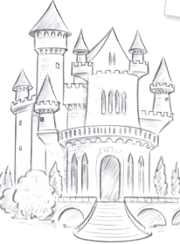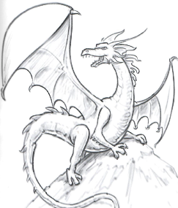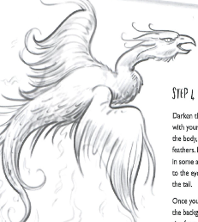  Source: Ashforth, K., Ashforth, L. & Kanye, P. (2020). Kaleidoscope: funky things to draw. Heatherton, Vic. Hinkler Books, p38, 39.  Development (enrichment) activity: Some students may choose to create their own phantasmagorical creature.  Differentiation: Character writing proforma  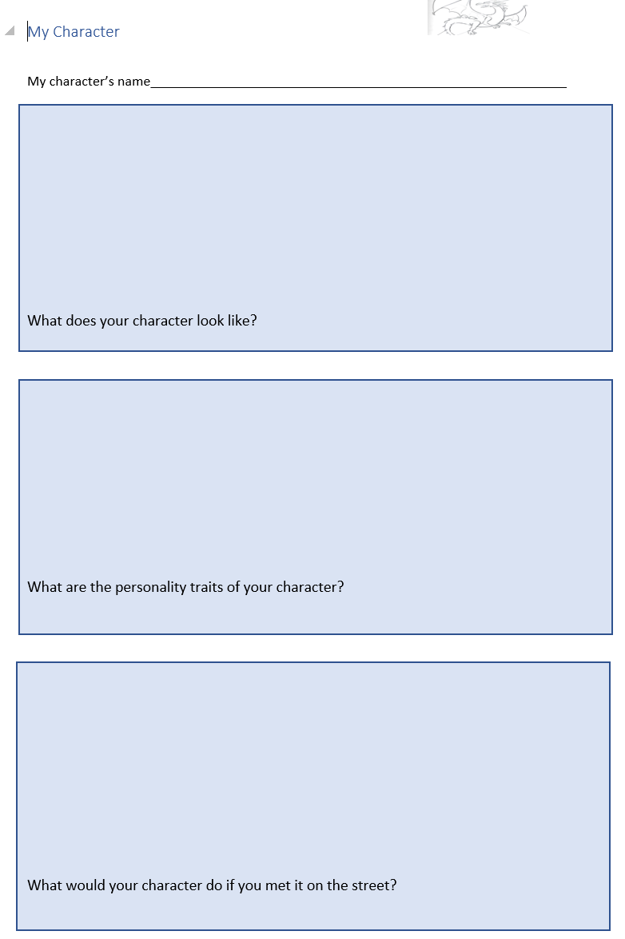
Stage 3 - Reading and viewing  navigate and read texts for specific purposes applying appropriate text processing strategies, for example predicting and confirming, monitoring meaning, skimming and scanning (ACELY1702)  use comprehension strategies to interpret and analyse information and ideas, comparing content from a variety of textual sources including media and digital texts (ACELY1703, ACELY1713)  Stage 3 - Speaking and listening  participate in and contribute to discussions, clarifying and interrogating ideas, developing and supporting arguments, sharing and evaluating information, experiences and opinions (ACELY1709)  Stage 3 - Responding and composing  Understand and apply knowledge of language forms and features  investigate how the organisation of texts into chapters, headings, subheadings, home pages and sub pages for online texts and according to chronology or topic can be used to predict content and assist navigation (ACELA1797) | LI: S. will be familiar with the style of the author of The Glimme- Emily Rodda. Identify audience and purpose of text.  -T. asks class whether they have read any of Emily Rodda's work. KQ: What do you know about Emily Rodda and her work?  -S. share any other Rodda texts and what they are about. T. lists them on IWB. Watch Rodda video about her inspiration for writing The Glimme.  KQ:  - Who is the intended audience?  - What is the purpose of her writing this text?  - What commonalities can we see in Emily Rodda's body of work (over 100 books- the most famous being the Rowan of Rin series and Deltora Quest series).  -In pairs, S. peruse Emily Rodda websites and videos. -S. find three interesting facts to share with the class about the author and/ or her body of work.  -S. write their three facts about Emily Rodda in English Books and share their research findings with the class. | Emily Rodda talks about her inspiration for writing  Emily Rodda official website:  STAGE 3 (Year 5, 6) Style excerpt:  "Students understand that particular styles result from the use of identifiable language features appropriate to each mode and medium.  "Students learn that:  - style may be changed by manipulating certain elements  - style creates connections between and among texts  - literary devices such as sound, images and figurative language can enhance expression.  - personal style can be cultivated".  Retrieved from English textual concepts- Style S3.  https://www.penguinrandomhouse.com/authors/250547/emily-rodda
Stage 3 - Speaking and listening  Use appropriate metalanguage to identify and describe relationships between and among texts.  participate in and contribute to discussions, clarifying and interrogating ideas, developing and supporting arguments, sharing and evaluating information, experiences and opinions (ACELY1709, ACELT 1795)  Stage 3 - Writing and representing  Engage personally with texts  Identify and explore underlying themes and central storylines in imaginative texts  (ACELY 1801) | LI: S. will be familiar with the style of the illustrator of text, The Glimme. Identify aspects of visual literacy in text.  -Class watch videos of Marc McBride discussing how he created the illustrations, and his illustrator style.  Marc McBride on the story of the Glimme.  Marc McBride Fantasy Illustrator  KQ:  - How did Marc McBride create the images?  - What materials did he use?  - What is his illustrator style?  - What is Marc McBride's advice to the next generation? Why does he advise this?  -Walk through text together, discussing illustrations and what students notice about them.  -T. introduces visual literacy terms to S. e.g. placement, salience, vectors, framing, gaze, social distance. Locate examples in text together.  - S. find other examples in text separately, in pairs.  -S. share what they found in text with class, using the visual literacy terminology they learned throughout the lesson. | Marc McBride on the story of the Glimme  Marc McBride Fantasy Illustrator  Visual Literacy terms:  Vector- item that directs our eyes towards a focal point e.g. p10, 19, 109, 364 text.  - Salience- a strategy that highlights what is important in a text/ illustration. Often the colour red is used in illustrations for emphasis, bold or italics used in text e.g. 293-295, 373 text.  - Gaze- the directed look of a viewer or figure in an illustration. Could be a demand (looking straight at the viewer e.g. p120, 257, 258, 259) or offer (inviting the viewer to engage e.g. p47, 262, 263 text)  - Framing- how elements are arranged to create a specific interpretation. Strong framing, sense of enclosure; weak framing, sense of openness. e.g. p364-367 text. All the text is framed throughout the book.  - Social distance- culturally determined boundaries suggesting different relationships e.g. intimate distance (close up p190, 326), public distance (long shot p209, 93-95 text)  ref. NESA (2012) English K-10 syllabus glossary
Stage 3 - Speaking and listening  Understand and apply knowledge of language forms and features  (ACELT 1609, ACELY 1796)  Stage 3 - Responding and composing  Understand and apply knowledge of language forms and features  investigate how the organisation of texts into chapters, headings, subheadings, home pages and subpages for online texts and according to chronology or topic can be used to predict content and assist navigation (ACELA1797)  Stage 3 - Reflecting on learning  reflect on own learning achievements against specific criteria  critically reflect on the effectiveness of their own and others' writing, seeking and responding to feedback (ACELY 1705) | LI: S. will revise paragraph structure.  -T. asks students why paragraphing is an important writing skill to learn. Record S. responses on p1-4, PPT- paragraphing student revision lesson.  -Class use mind maps, pros and cons charts thinking tools together, to scaffold paragraph writing (p6-9 PPT).  -Class peruse paragraph structure in current text, The Glimme. Can students identify topic sentences, supporting statements, concluding sentence?  -Review range of texts on p11-13 PPT and discuss paragraph structure.  -Identify paragraph structure in Chapter 1, The Glimme on IWB p14, 15 PPT. Annotate topic sentence, supporting statements, concluding sentence, explicitly on IWB for students.  -Peruse a series of paragraph scaffolds to assist students in their independent writing. Discuss. p16-19 PPT.  -Class construct a mind map to address the question, "What is a quest?"  -T models writing a paragraph using the class mind map as a scaffold, modelling SC for students.  -S. write a paragraph to address the question, "What is a quest?" Use writing rubric to self- assess, peer assess student writing sample. S. provide feedback to peer on their paragraph writing. | PPT- paragraphing student revision lesson  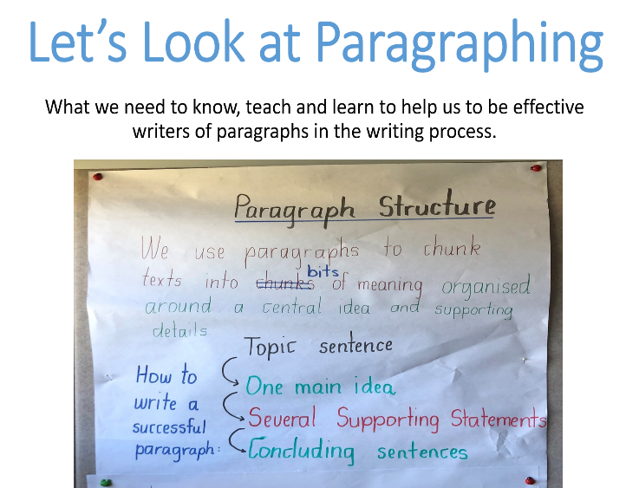  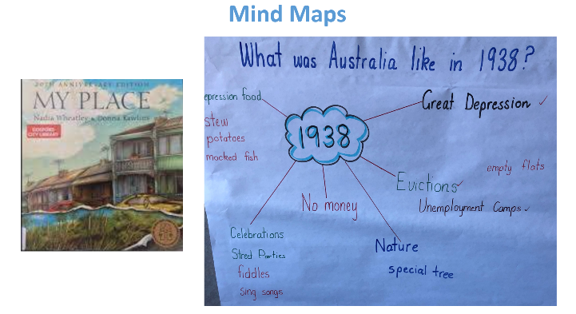  Excerpts from paragraphs student revision lesson PPT.
Stage 3 - Reading and viewing  identify the impact of first-person and third-person narration on the reader/viewer ACELA 1523)  Stage 3 - Speaking and listening  participate in and contribute to discussions, clarifying and interrogating ideas, developing and supporting arguments, sharing and evaluating information, experiences and opinions (ACELY1709)  Stage 3 - Writing and representing  Engage personally with texts  identify and explore underlying themes and central storylines in imaginative texts  plan, draft and publish imaginative, informative and persuasive texts, choosing and experimenting with text structures, language features, images and digital resources appropriate to purpose and audience (ACELY1704, ACELY1714)  Stage 3 - Reading and viewing  recognise the effect of multimedia elements, eg film techniques, animation, voice-overs, sound effects, framing, close-ups (ACELT 1617) | LI: Students will orientate to the text, The Glimme. Students will be familiar with the genre of quests.  -Introduce the text, The Glimme- Locate and discuss text setting, through perusing/ discussing the cover, back cover, endpaper maps, flypaper.  -T. explicitly states, “The text is a third person narrative, told through the eyes of an omniscient (all knowing) narrator, in the simple past tense”. Discuss, with examples.  -Discuss the title and its meaning. T. informs S., The Glimme is an old German/ Dutch word meaning radiance and light. Rodda uses it as the name of a magical world that exists just out of sight- one you might catch a glimpse of when the sun is setting (Rodda).  -Introduce the genre of quest- a plot device of narrative, similar to Greek myths and legends, with superhuman characters, magical, mythical creatures. However, in a quest; a hero makes a journey, has lots of setbacks along the way before finally achieving goal of infinite value.  -Discuss the definition of a quest: a story shaped by an over-riding imperative, a hero's journey.  -S. identify examples of quests they know and love.  -T. records quests identified by class on IWB.  -Watch Lord of the Rings: Return of the King video clip together. Identify the hero and discuss what they are seeking...  -T. model writes a paragraph on IWB on their favourite quest, modelling the SC for writing task.  -S. write their own paragraph about a quest they know and love. Share paragraphs with each other, provide peer feedback on writing. | Parts of a book: front cover, back cover, endpapers (which contain a map of The Glimme), flyleaf, title page, table of contents.  Third person omniscient narrative: This is a common form of third-person narration in which the narrator assumes an omniscient (all-knowing) perspective of the story being told, telling private thoughts, secret or hidden events.  Simple past tense explained  Genre- English Concepts (Stage 3)  "Students understand that texts may be categorised into genres. They learn that texts in the same genre have similar functions and ideas, forms and conventions and give rise to particular expectations. Genres are not fixed categories but may be adapted for interesting effects" Retrieved englishtextualconcepts.nsw.edu.au/content/genre  Etymology of quest:  paste in etymological map  What is a quest? A hero's journey.  Movie Clip- example of a contemporary movie quest.  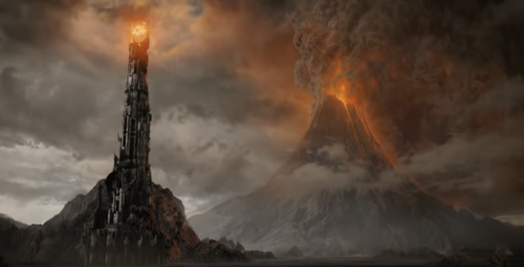Retrieved (93) The Lord of the Rings: The Return of the King (8/9) Movie CLIP - The Fall of Sauron (2003) HD - YouTube
Stage 3 - Spelling  understand how to use banks of known words, word origins, base words, suffixes and prefixes, morphemes, spelling patterns and generalisations to learn and spell new words, for example technical words and words adopted from other languages (ACELA1513, ACELA1514, ACELA1526)  understand how accurate spelling supports the reader to read fluently and interpret written text with clarity  use morphemic, visual, syntactic, semantic and phonological strategies, eg recognition of letter patterns of words, when composing texts  (ACELA 1500)  Stage 3 - Writing and representing  compose imaginative and informative texts that show evidence of developed ideas (ACELT 1610)  Stage 3 - Reflecting on learning  critically reflect on the effectiveness of their own and others' writing, seeking and responding to feedback  (ACELY 1705) | LI: Students will learn to spell unfamiliar words prior to reading text Chapters 1, 2, 3. Revise morphemic spelling skills, particularly prefixes and suffixes in text.  -Explicit teaching of tier 2 vocabulary words chapter 1, 2, 3. T. or S. to select challenging vocabulary with which to learn prior to reading text (p1-52). e.g.  - lollygagging  - mansion  - centaurs  - dilly-dally  - conservatory  - queasy  - echoing  - beckoning  - possessions  - wondrous  -S. locate prefixes, suffixes in chapter 1 and work out meaning of unknown words, using common prefixes and suffixes reference sheet.  -S. make list of words containing prefixes and suffixes located chapt 1-3. Make this a word find activity/ competition. Record words in spelling books.  -T. explains that morphology helps us to work out how to spell, and the meaning of unknown words, by breaking words into smaller parts of meaning, aiding comprehension.  -T. models an explanation of what is morphology on IWB and provides examples of 3 prefixes, suffixes located in chapter 1 The Glimme, including their meaning. T. is modelling the SC for the task.  -S. write an explanation of what is morphology in their own words, including three prefixes, suffixes they located in chapt. 1 text. Additionally, write a sentence using a Tier 2 word that they learned to spell during the lesson.  -S. peer assess/ provide feedback on each other's writing task. | Student spelling resource: common prefixes and suffixes reference sheet.  Morphology is the study of words and their parts. Morphemes, like prefixes, suffixes and base words, are defined as the smallest units of meaning. Morphemes are important for phonics in both reading and spelling, as well as in vocabulary and comprehension  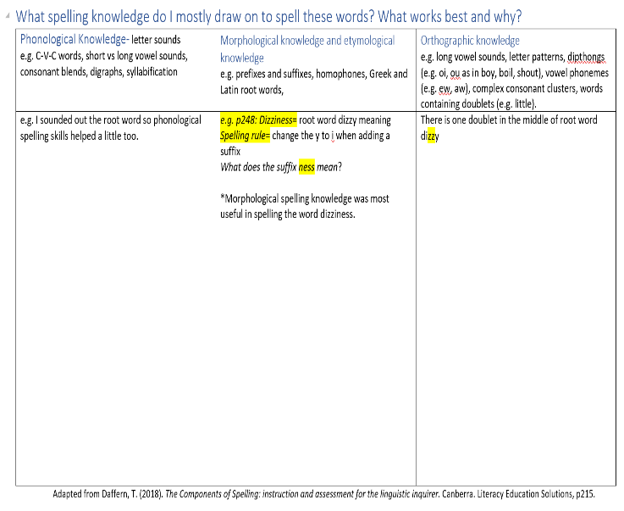
Stage 3 - Expressing themselves  make connections between students' own experiences and those of characters and events represented in texts drawn from different historical, social and cultural contexts (ACELT1613)  Stage 3 - Grammar, punctuation and vocabulary  understand that choices in grammar, punctuation and vocabulary contribute to the effectiveness of texts  understand the difference between main and subordinate clauses and that a complex sentence involves at least one subordinate clause (ACELA1507)  understand how noun groups/phrases and adjective groups/phrases can be expanded in a variety of ways to provide a fuller description of the person, place, thing or idea (ACELA1508)  understand how ideas can be expanded and sharpened through careful choice of verbs, elaborated tenses and a range of adverb groups/phrases (ACELA1523)  show how ideas and points of view in texts are conveyed through the use of vocabulary, including idiomatic expressions, objective and subjective language, and that these can change according to context (ACELY1698)  investigate how vocabulary choices, including evaluative language can express shades of meaning, feeling and opinion (ACELA1525) | LI: S. Class read, discuss and understand chapters 1-3.  -Read, enjoy and discuss the chapter together.  -T. models fluent, prosodic reading. Stop to explain figurative devices/ clarify chunks of meaning as you progress through text. S.s follow text using clear blue plastic strips as it is read to them to ensure they are actively engaged.  -S.s complete reading log at the end of each chapter (Summary of the chapter in reading book). Share some examples of S. writing at the conclusion of each lesson.  T. focus chapt 1:  -S. revise English concept of character, and how characters develop and change throughout the text  -S. begin a character map of protagonist, Finn. Handout 7: Stick person template. T. model template on IWB before completing task.  T. focus chapt 2:  Identifying language choices of composer / revising simple, compound, complex sentences in text.  -Investigate the types of sentences on p23 text together.  - Simple sentences: Finn could see the sky.  - Compound sentence: There were no plants in it and and the only furniture was a single chair. (two simple sentences joined by a coordinating conjunction- main ones are and, but, or)  - Complex sentence: His grandmother had been wrong when she said it was a conservatory (T. modelling)  -Identify the adverbial together on IWB. Identify why it is a phrase, and why it is a dependent (subordinate-cannot stand alone) phrase telling where. Talk about the main clause in the sentence. "His grandmother had been wrong". T. models moving the clause around in the sentence. KQ: "Does it change the meaning of the sentence?" Find other examples together in the text.  -Guide S. in identifying adverbials from sentences in the text. KQ: What is the function of adverbs/ adverbials? (provide more information about the verb, telling how, when, why, where)  -S.s choose a sentence p23, 24 text. Write it, colour code it then share the language choices made by the author with the class (random sample).  T. focus chapt 3:  Revise figurative language as a tool for writing. Identify fgurative language in text.  -T. asks S. what they know about figurative language and how to use it to improve their writing.  - Class work through Chapter 3 Figurative Language PPT revision lesson.  - Formative assessment task: S. describe a character/ characters in the text, using figurative language tools to describe them (p8 PPT).  -S. share their descriptions with peer. T. requests few S. share their character description around the room. | Reading log: S.s write a brief summary of text, following reading each chapter in back of English books. T. selects random S.s to share/ read summaries to class (reading- writing connection) at the conclusion of each chapter; consolidating the important reading- writing link with S.  Handout 7: Stick person template.  T. modelling chapter 2:  Let's look at noun groups p44 text:  - fragments of the other paintings  - the spires of a hidden palace  - a bloodstained market square  - a fiery mountain  - five brutish, hulking giants.  PPT T.& S. resource: A Grammar Helper including more building noun group activities (possible formative assessment task)  adverbials- give more information about the verb. They can be clauses (contain a verb) or phrases (no verb), and can move around the sentence for emphasis.  Colour coding (ref. Campbell,2020)  noun groups dark blue; adjectivals light blue; verb groups red; adverbials orange; conjunctions/ connectives yellow.  Chapter 3 Figurative Language PPT revision lesson  Teacher resource: English Textual concepts: Connotation Imagery and Symbol  Example of reading log for students to complete at the end of each chapter, reinforcing the reciprocity of the reading-writing process, and monitoring student writing growth (back of English books seems to work well):  My Reading Log The Glimme  Chapter Date-  The chapter was about-  Personal evalutive comment-
Stage 3 - Speaking and listening  use appropriate metalanguage to identify and describe relationships between and among texts  use metalanguage to describe the effects of ideas, text structures and language features on particular audiences (ACELT1795)  plan, rehearse and deliver presentations, selecting and sequencing appropriate content and multimodal elements for defined audiences and purposes, making appropriate choices for modality and emphasis (ACELY1700, ACELY1710)  Stage 3 - Thinking imaginatively, creatively, interpretively and critically  recognise and explain creative language features in imaginative, informative and persuasive texts that contribute to engagement and meaning  Stage 3 - Expressing themselves  respond to short films, documentaries and multimedia texts that express familiar and new aspects of the broader world  Stage 3 - Reflecting on learning  develop criteria for assessing their own and others' presentations (ACELY 1705) | LI: To identify the main features of quests across a different text; We're Going on a Bearhunt. To revise poetic devices.  T. focus:  To clarify the main features of the genre of quests. To revise common poetic devices evident in text.  - T. leads a discussion to revise what class knows about the genre of quest.  -T. explains that quests contain the same essential structure, these being:  - The call to action  - The journey (usually the hero is accompanied by their companion/s)  - Arrival and frustration / setbacks and challenges  - The final ordeal  - The goal  -Class view the text,  performed by the author, Michael Rosen.  KQ: What is the theme of this text? (e.g. We can achieve great things if we stick together).  -Identify/ discuss main features of quests identifiable in text. T. resource Features of quest may be useful here. This could be done collaboratively on IWB in table format or in small groups.  -Class identify the poetic devices in text together, including rhyme, rhythm, repetition, alliteration, assonance and onomatopoeia.  -S. practice reading the poem, with actions to build prosody.  -S. perform the text, with actions for a younger class. -S. teach younger students the actions and words of the text.  S. reflect on their performance. Seek T. feedback on performance. | Main features of quests:  - The call to action  - The journey (usually the hero is accompanied by their companion/s)  - Arrival and frustration/ setbacks and challenges  - The final ordeal  - The goal achieved Source: Booker (2009) p83.  performed by Michael Rosen and book, Rosen & Oxenbury (1989). We're Going on a Bearhunt. London, Walker Books.  e.g. T. resource:  Features of quest may assist teachers in formulating, completing a table on IWB to record student responses and guide class discussion.  Poetic devices evident in text:  Rhyme- repetition of syllables at end of words, often end of lines of poetry  Rhythm- the pattern of long/ short, stressed/ unstressed syllables in writing  Alliteration- repetition of a sound/ letter at the beginning of multiple words in a series.  Assonance-repetition of medial vowel sound in one or more consecutive words.  Onomatopoeia- the formation of a word from a sound associated with what it is named.
Stage 3 – Grammar, Punctuation, Vocabulary  uses knowledge of sentence structure, grammar, punctuation and vocabulary to respond to and compose clear and cohesive texts in different media and technologies (ACELA 1520)  Stage 3 - Spelling  Develop and apply contextual knowledge  integrate a range of spelling strategies and conventions to accurately spell most words, including words of many syllables, when composing imaginative and other texts  (ACELA1500, 1526)  Stage 3 - Responding and composing  identify and use a variety of strategies to present information and opinions across a range of texts (ACELY 1703)  Stage 3 - Expressing themselves  recognise that ideas in literary texts can be conveyed from different viewpoints, which can lead to different kinds of interpretations and responses (ACELT1610)  make connections between students' own experiences and those of characters and events represented in texts drawn from different historical, social and cultural contexts (ACELT1613)  Stage 3 - Responding and composing  identify the ways in which language use in imaginative texts, including use of figurative language, character development, events and setting, creates interest for the reader or viewer  analyse strategies authors use to influence readers (ACELY1801)  recognise the techniques used by writers to position a reader and influence their point of view (ACELT 1609)  Stage 3 - Reading and viewing  understand how texts vary in purpose, structure and topic as well as the degree of formality (ACELA1504)  navigate and read texts for specific purposes applying appropriate text processing strategies, for example predicting and confirming, monitoring meaning, skimming and scanning (ACELY1702)  interpret picture books, comic strips and sequences of digital images which do not contain written text  recognise and compare how composers use a range of language features, including connectives, topic sentences and active and passive voice, to achieve their purposes  Stage 3 - Grammar, punctuation and vocabulary  understand that choices in grammar, punctuation and vocabulary contribute to the effectiveness of texts  experiment using a range of language features, eg connectives, topic sentences, active and passive voice and nominalization (ACELA 1520, ACELA 1522) | LI: Students will learn to spell unfamiliar words prior to reading text, Chapters 4, 5, 6.  -Explicit teaching of tier 2 vocabulary words chapter 4, 5, 6. T. or S. to select challenging vocabulary with which to learn prior to reading text (p69-121). e.g.  - beacons  - valiantly  - possessions  - wreathed  - chieftain  - ferocious  - councillors  -T. focuses on using context to unlock the meaning of unknown words.  -S. locate target words in text and use context to comprehend their meaning.  T. focus Chapt 4: understand meaning through deep discussion about text.  KQ:  - What is a quinlin? What does it look like?  - What is happening in the Great Hall?  - What scrape did Finn and Lori find themselves in?  - What is a flicker? Who created it and why do you think they did so?  -S. use think, pair, share strategy to answer these questions, then share responses with the class. This activity could be a useful formative assessment task to assess comprehension of text.  T. focus Chapt. 5: descriptive writing  Task: "You are hiding behind the pillars with Finn and Lori, in the Great Hall. You watch the Chieftains take their places along the long table (pictures p90, 91, 100, 103). Describe the physical characteristics of one or more characters at the meeting. You may describe each character in such a way that it invites an emotional response in the reader, and/ or you may make a judgement about the character/s based on your description".  -T. models a description of a character at the Chieftains' meeting in the Great Hall (p90, 91), on the IWB. They use interesting noun groups and verb groups in their descriptive writing, as well as correct grammar and punctuation. In the example, T. models at least two examples of complex sentences for students and use a "think aloud" strategy so students can see why these sentences are complex, revising prior learning. In doing so, T. is modelling the SC of the lesson for S.  -T. points out a call to action (key feature of a quest) occurs p105, which is, Find Wizard Rune and return the Golden Dragon to her kin on Oran's Tor, a change of direction in the narrative. Previously, Finn just wanted to get back home to Wichant.  -S. choose a character from the long table (p90, 91) and write a description of the character they have chosen.  -S. read their description to a peer, who provides oral feedback on their descriptive writing.  T. focus Chapt. 6: To focus on cohesion in text through the use of cohesive devices, including conjunctions (within sentences), connectives (between sentences), reference words and collocations (words that often sit together).  -T. asks students to explain what are conjunctions and connectives, and the purpose of these language devices in a text. Make a class list of responses on IWB.  -T. distributes Conjunctions and connectives reference list. Discuss how, by connecting ideas in logical ways using these language devices, our writing makes more sense and it is easier for the reader to understand what we mean, in our writing.  -T. displays text excerpt p114, 115 on IWB.  -T. models where to find the conjunctions and connectives in paragraph 1, on IWB. Text mining activity sheet.  -S., with a peer, have 5 minutes to find as many conjunctions and connectives they can on p114, 115 from text. Students can refer to their Conjunctions and connectives reference list during this activity, to consolidate knowledge of conjunctions and connectives.  -Class re-read text and identify all conjunctions and connectives together. | Four Step Strategy- Inferring word meanings of unknown words from context:  - Play and question. Read carefully. Frequently ask, Does it make sense?  - Slow advance. Notice when you don’t know a word. Read the sentence again. Look for clues.  - Stop and rewind. Read the sentence before to see if there are any clues as to its meaning.  - When you figure out what it may mean, substitute your word in the sentence. If it makes sense, keep reading, if not rewind and try again.  *If you still don’t know, refer to an authoritative source e.g. internet search, dictionary, thesaurus, teacher.  Source: NSW DoE (2016). New Focus on Reading 3-6 module 4 p.7.  NB: Teachers need to model and jointly construct writing before expecting students to independently produce written texts. During this modelling and joint construction, explicit teaching is required in relation to the features of language, for example, sentence structure, text structure, correct grammar, spelling and punctuation. "Think Alouds" are useful metacognitive strategies for teachers to use to explicitly teach aspects of writing.  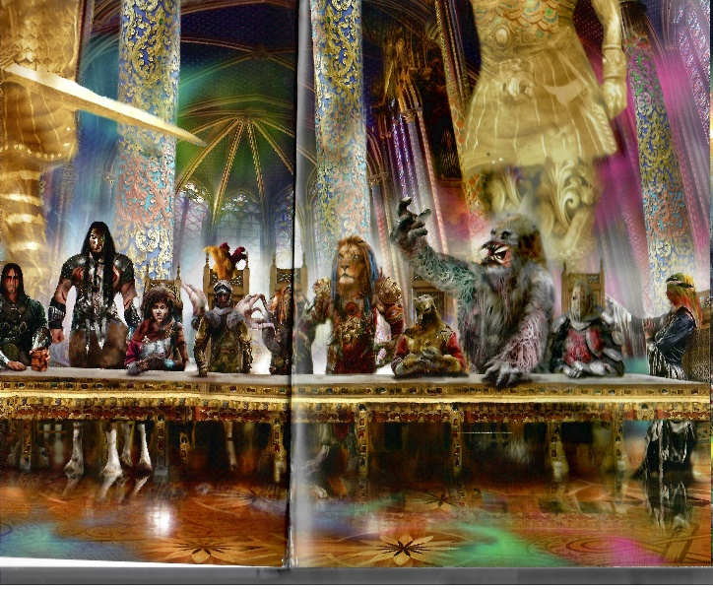  Source: The Glimme, p90, 91.  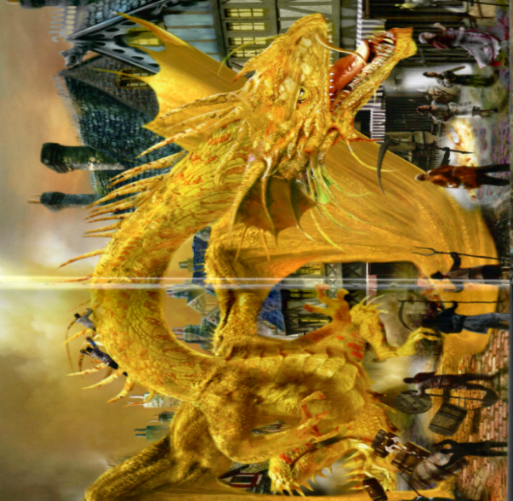  Source: The Glimme p366, 367.  Common Collocations words that often sit together to help the text to cohere, hang together in a logical way e.g. from text: battle scene (p92), sea breeze (p220), flag pole (p153).  Conjunctions and connectives  Connectives join two separate ideas in two sentences or paragraphs. They usually come at the start of a sentence. Conjunctions join two ideas in the same sentence. Connectives and conjunctions join ideas in logical ways.  Conjunctions and connectives reference list  Source: Adapted from Met. East DSP. (1989). The Discussion Genre. Retrieved https://trove.nla.gov.au/work/28171478  Handout 10: Conjunction and connectives text mining activity
Stage 3 - Speaking and listening  Understand and apply knowledge of language forms and features  use appropriate metalanguage to identify and describe relationships between and among texts  use metalanguage to describe the effects of ideas, text structures and language features on particular audiences (ACELT1795)  plan, rehearse and deliver presentations, selecting and sequencing appropriate content and multimodal elements for defined audiences and purposes, making appropriate choices for modality and emphasis (ACELY1700, ACELY1710)  Stage 3 - Reflecting on learning  discuss and reflect on the roles and responsibilities when working as a member of a group and evaluate the benefits of working collaboratively with peers to achieve a goal (ACELY 1705)  describe how skills in speaking, listening, reading/viewing and writing/representing contribute to language development | LI: To identify the main features of quests across a different text; Beware the Deep Dark Forest (Whiting & White, 2018). To prepare a creative response to the text through drama.  T. focus:  To clarify the main features of the genre of quests. To retell the text through dramatisation.  - T. leads a discussion to revise what the class already knows about the genre of quest.  -T. explains that quests contain the same structure as identified in previous texts.  -Class listens to T. reading of text with prosody. KQ: What is the theme of this text?  (e.g. With bravery and perseverance, we can overcome adversity.)  -Identify/ discuss main features of quests identifiable in text. This could be done collaboratively on IWB in table format or in small groups e.g. T. resource: Features of quest may assist teachers in formulating, completing a table on IWB to record student responses and guide class discussion.  -In small groups, S. plan, practise and perform a creative response/ dramatisation* of text for younger grades, should class wish to.  -S. reflect on their performance. Seek T. feedback on performance. | *It may be useful if T. scans text, Beware the Deep Dark Forest, onto IWB to aid discussion and for sharing with class.  T. resource: Features of quest  *Dramatisation suggestion- small groups of six students should cater for all characters in text e.g. narrator, Rosie, Tinky, dad, grandma, various monsters multi role.  Stress the importance of simple props to add atmosphere to the performance. These could be a scarf, a toy dog, monster mask, dad hat etc. Students may also need copy of text to write script for their group performance.  Possibly, characters read direct speech in text, narrator ensures text cohesion with linking words between characters.  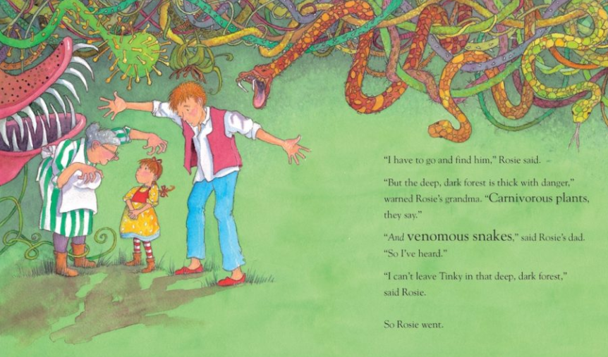  Source: Beware the Deep, Dark Forest p5,6.
Stage 3 - Spelling  understand how to use banks of known words, word origins, base words, suffixes and prefixes, morphemes, spelling patterns and generalisations to learn and spell new words, for example technical words and words adopted from other languages (ACELA1513, ACELA1514, ACELA1526)  understand that the pronunciation, spelling and meanings of words have histories and change over time (ACELA1500)  use morphemic, visual, syntactic, semantic and phonological strategies, eg recognition of letter patterns of words, when composing texts (ACELA 1797)  Stage 3 - Writing and representing  experiment with text structures and language features and their effects in creating literary texts, for example, using imagery, sentence variation, metaphor and word choice (ACELT1800)  Stage 3 - Reading and viewing  navigate and read texts for specific purposes applying appropriate text processing strategies, for example predicting and confirming, monitoring meaning, skimming and scanning (ACELY1702)  Stage 3 - Reading and viewing  understand, interpret and experiment with sound devices and imagery, including simile, metaphor and personification, in narratives, shape poetry, songs, anthems and odes (ACELT1611)  use comprehension strategies to interpret and analyse information and ideas, comparing content from a variety of textual sources including media and digital texts (ACELY1703, ACELY1713) | LI: Students will learn to spell unfamiliar words prior to reading text, Chapters 7, 8, 9, 10.  -Focus on phonological, morphemic and orthographic spelling knowledge. Explicit teaching of tier 2 vocabulary words chapters 7- 10. T. or S. to select challenging vocabulary with which to learn prior to reading text (p121- 166). e.g.  - pretence  - impatience, impatiently (adv. ending in ly)  - uncomfortably  - bogwights (nonsense word composed by author for effect- author style)  - unconscious  - ferocious  - councillors  - battle-reejos (nonsense word composed by author for effect- author style)  - extinguished  -Revise how we spell words using phonology, morphology and orthographic knowledge.  -T. differentiates class into small groups, based on similar spelling learning needs, as identified in student writing tasks.  -S. select a list of words from text. Discuss which form of spelling knowledge is most useful to spell each word. Record words on Linguistic Inquirer chart (adapted from Daffern, 2018, p215). Each group reports back to the class as to why they placed words in particular column of chart.  T. focus Chapt. 7-10 : comprehension  -Class discuss each chapter on completion of T. read. Stop and unpack any figurative language, challenging vocabulary during read.  -S. complete reading log at the end of each chapter, reinforcing the reciprocity of reading and writing, and evidence of student growth throughout the unit.  -T. selects random S. for sharing reading logs.  -T. provides Handout 11: Three level comprehension guide to students. Read/ work through guide together.  -T records questions from text (level 1, 2, 3) composed by students, when reflecting on each chapter, as a model prior to S. formulating their own 3 level comprehension questions from text.  -In small groups, S. write 3 level comprehension questions (one for each level) on each chapter. Swap questions with another group, who will answer questions and provide feedback.  -Class revise the events of chapters 7-10:  KQ:  - What complications did the companions face in these chapters?  - How did the hero and his helpers address these challenges? | Phonological knowledge- using letter sound knowledge (phonemes) to spell words  Morphemic knowledge- to identify and use the units of meaning in words, e.g. prefixes, suffixes, root words (including etymological knowledge- where words come from)  Orthographic knowledge- including orthographic processing (long and short vowel sounds), letter patterns, dipthongs, consonant clusters.  Differentiation- In groups, S. collaboratively choose a list of words from Chapt 7-10 that they wish to learn to spell.  S. record words in appropriate column on Linguistic Inquirer Chart (adapted from Daffern, 2018, p215).  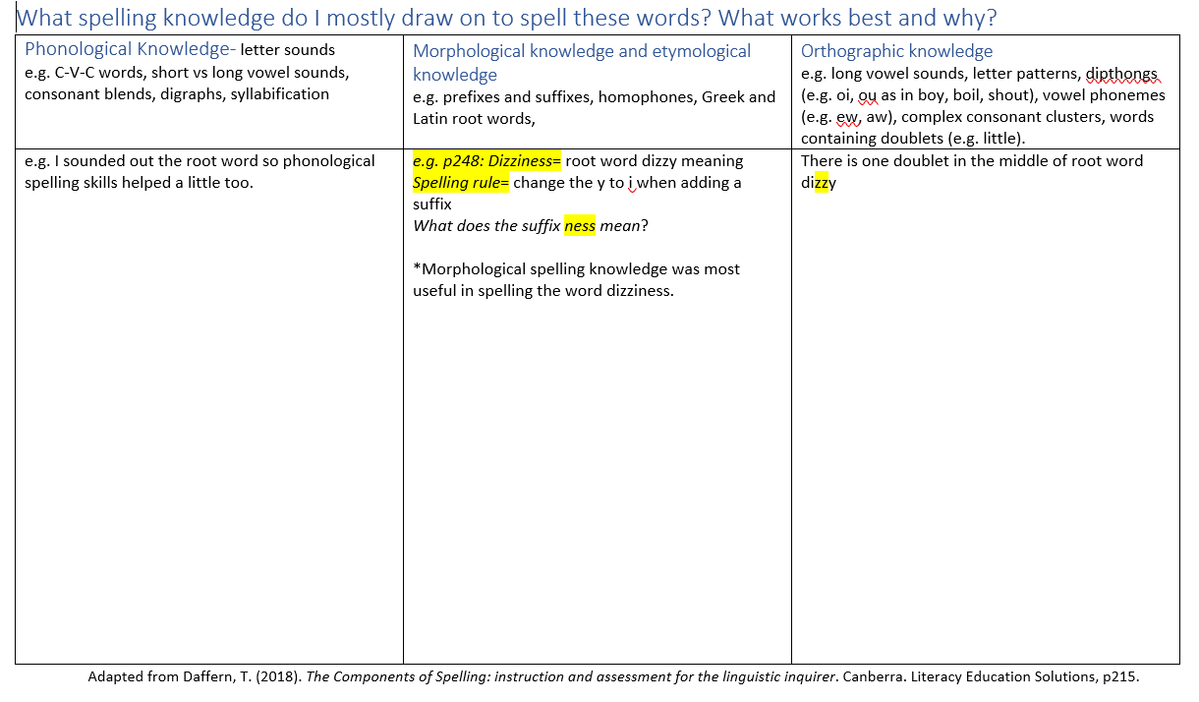  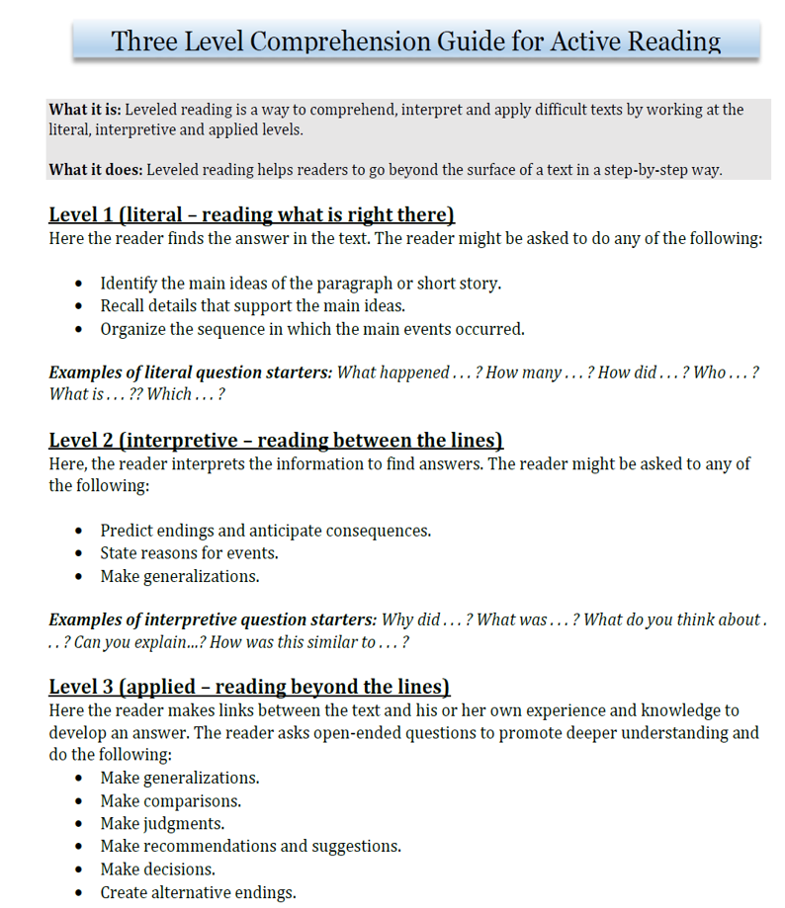  Handout 11: Three level comprehension guide  Retrieved: https://www.kent.edu/writingcommons/three-level-comprehension-guide-active-reading  Structure of Quest:  Complications faced by hero and his helpers so far e.g.  - Bogwight attack  - Covered in hard shell  - The castle of Leon  - Dragon attack  - Battle-reejos  - The battle of Leon  - Water roaring down the riverbed and quashing the dragons' flames  - Capturing Greenfire the dragon
Stage 3 - Spelling  integrate a range of spelling strategies and conventions to accurately spell most words, including words of many syllables, when composing imaginative and other texts  (ACELA 1500, ACELA 1513, ACELA 1797)  Stage 3 - Thinking imaginatively, creatively, interpretively and critically  interpret events, situations and characters in texts  adapt aspects of print or media texts to create new texts by thinking creatively and imaginatively about character, setting, narrative voice, dialogue and events (ACELT 1610, ACELY 1717)  Stage 3 - Responding and composing  identify the ways in which language use in imaginative texts, including use of figurative language, character development, events and setting, creates interest for the reader or viewer (ACELT 1601, ACELY 1707)  Stage 3 - Writing and representing  use increasingly complex research data from print and digital sources to compose short and sustained texts (ACELY 1703) | LI: Students will learn to spell and discuss the meaning of unfamiliar words prior to reading text, Chapters 11-15  -Explicit teaching of tier 2 vocabulary words chapters 11-15. T. or S. to select challenging vocabulary with which to learn prior to reading text (p188-278). e.g.  - earth-treaders, expressionless, repel  -S. may wish to use online dictionary or thesaurus to assist them to learn new words and determine their meaning.  T. focus Chapt. 11: Character Greenfire  -Class chat about Greenfire (illustration p190). Talk about what happened chapt 11 from Greenfire's point of view. Complete reading log Chapter 11, pretending you are Greenfire the Dragon.  -T. selects some students to share how Greenfire is feeling in Chapt. 11.  T. focus Chapt 12: Character Finn/ Penn  Finn's passion is drawing. T. asks, "What do you love? What is your personal passion?"  -Class discuss/ share things they are passionate about and why. (think-pair-share strategy may work well here for this task)  Construct a class Jamboard with each student contributing what they love. e.g.  https://jamboard.google.com/d/1L-nkfs_Fn0_C7aUUc9Ek4kgqvxJsht9Zf1CmOtp9iT4/edit?usp=sharing  T. focus Chapt. 13: Character Lori/ Lark, Professor Bravo, Lone Annie, Teller, The Magic Ship...  -Class chat about some of the other characters that interest them in the text.  -S. choose one character, and complete a character map showing the characteristics and salient features of the character they have selected. Illustrate character, using the text as a scaffold.  T. focus Chapt 14: Researching a topic using multimodal texts.  -T. & S. peruse/ discuss the sea monster p234-236, p242-243, who attacked the ship (another complication of the quest).  -In pairs, S. research sea monsters and find information about one creature to share with class. Include an illustration if available and do not forget to cite sources.  -Save research findings on school digital platform for all classes to access.  T. focus Chapt. 15: The Giants on the Isle of Hinde.  -T. refer S. to p258. This illustration in the text is the favourite of the illustrator, Marc McBride. He loves drawing giants (and dragons, and monsters...). His illustrations are rich in imagery, and he is renowned world-wide for his illustrations/ illustrator style (I saw his work on television in a horror movie advertisement).  -T. to model writing a paragraph on their favourite illustration in text on IWB, to explicitly show students how to complete writing task, modelling SC.  -In the reading log for Chapter 15, S. select their favourite illustration in the text. Use knowledge of visual grammar terms (e.g. salience, vectors, framing etc) to describe their illustration of choice and explain why this is their favourite (one paragraph).  -T. selects random pick of S. to share their favourite illustrations from text. | Jamboard is a digital collaboration tool on the Google suite of tools for education. Jamboard is a free app. An example of a jamboard that may suit this activity can be found at this link.  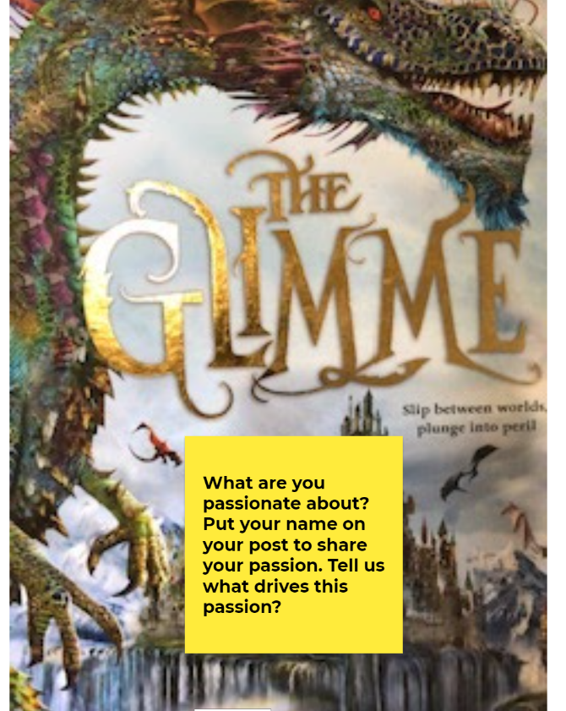  S3 Character  Characters may be complex with a range of characteristics or one salient feature. They may change as a result of events in text, as we have seen with Greenfire in Chapt 11, Professor Bravo throughout the text and Lone Annie.  Character map for Chapt 13 activity, however S. may wish to create their own.  Sea monsters are beings from folklore believed to dwell in the sea, often of immense size. Sea monsters can take many forms, including sea dragons, sea serpents, krakens or multi-armed beasts.  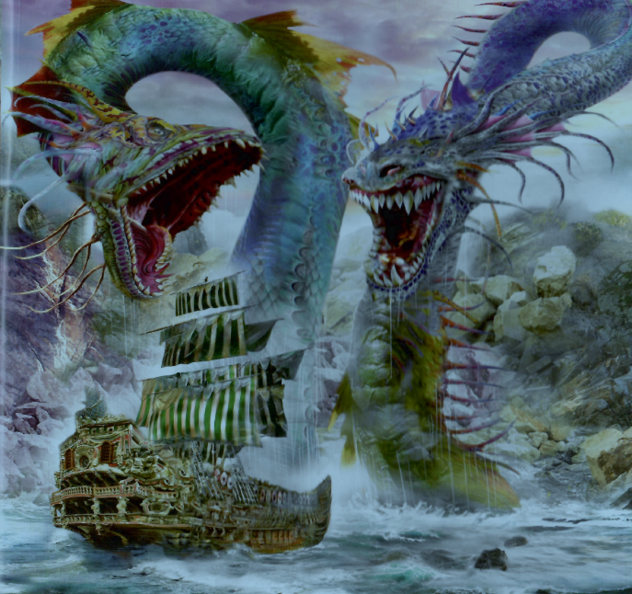Source: The Glimme p289.
Stage 3 - Reading and viewing  navigate and read texts for specific purposes applying appropriate text processing strategies, for example predicting and confirming, monitoring meaning, skimming and scanning (ACELY1702)  interpret picture books, comic strips and sequences of digital images which do not contain written text (ACELA1511)  Stage 3 - Thinking imaginatively, creatively, interpretively and critically  interpret events, situations and characters in texts  think critically about aspects of texts such as ideas and events (ACELY 1698)  Respond to and compose texts | LI: To identify the main features of quests across a different text; To The Bridge: the Journey of Lennie and Ginger Mick (Fenton & McLean, 2018). To introduce the genre of historical fiction. To revise narrative structure.  T. focus:  - T. leads a discussion to revise what the class already knows about the genre of quest.  -T. explains that quests contain the same essential structure, these being:  - The call to action  - The journey (usually the hero is accompanied by their companion/s)  - Arrival and frustration/ setbacks and challenges  - The final ordeal  - The goal  -Orientate S. to text through sharing sites that document the actual event on which the text is based through the genre of newspaper articles. Discuss.  -Read together the factual summary in back of book.  -Class listens to T. reading of text* with prosody.  -Identify the features of quests in text. e.g. T. resource: Features of quest To the Bridge : the journey of Lennie and Ginger Mick may assist teachers in formulating, completing a table on IWB to record student responses and guide class discussion.  -T. states, "this text has the features of quests, and it is clearly a narrative. We can easily identify traditional narrative structure". Revise narrative structure together.  -T. models a story map to retell the narrative/ structure of text.  -In groups, S. construct a story map that retells the narrative contained within the text.  -Display story maps in classroom. Annotate with key words from text. | *It may be useful if T. scans text, To the Bridge: the journey of Lennie and Ginger Mick, onto IWB to aid discussion and for sharing with class.  News articles about Lennie and Ginger Mick (links for class to select which are most relevant)  Factual summary with photos in back of book  Traditional narrative structure/ outline of events that occur in a story:  - Orientation (who, what, when, where)  - Complication/s (problem/s arise)  - Sequence of events  - Resolution  - Comment  - Coda  In this text, the narrative both entertains and informs. The text is based on the composer's perspective of events that actually happened.  The text has a degree of authority as there is a news article contained in the book with actual photos of Lennie and Ginger Mick from 1932. As well, the event is documented in the Sydney Morning Herald, a trusted Australian icon.  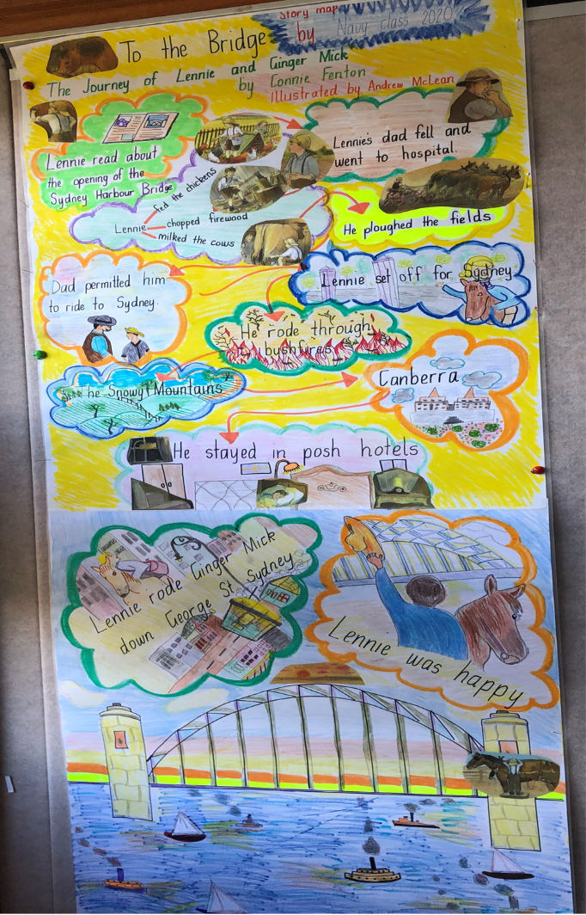  Digital version of story map to display in classroom.
Stage 3 - Thinking imaginatively, creatively, interpretively and critically  identify the relationship between words, sounds, imagery and language patterns in narratives and poetry such as ballads, limericks and free verse (ACELT1617)  Stage 3 - Responding and composing  recognise the techniques used by writers to position a reader and influence their point of view  consider and develop sustained arguments and discussions supported by evidence  Stage 3 - Thinking imaginatively, creatively, interpretively and critically  interpret events, situations and characters in texts  think critically about aspects of texts such as ideas and events (ACE 1709, ACELT 1613, ACELT 1617)  Stage 3 - Speaking and listening  use metalanguage to describe the effects of ideas, text structures and language features on particular audiences (ACELT1795)  use interaction skills, for example paraphrasing, questioning and interpreting nonverbal cues and choose vocabulary and vocal effects appropriate for different audiences and purposes (ACELY1796)  participate in and contribute to discussions, clarifying and interrogating ideas, developing and supporting arguments, sharing and evaluating information, experiences and opinions (ACELY1709)  Stage 3 - Thinking imaginatively, creatively, interpretively and critically  think imaginatively when engaging with texts, using prediction, for example, to imagine what happens to characters after the text  identify, describe, and discuss similarities and differences between texts, including those by the same author or illustrator, and evaluate characteristics that define an author's individual style (ACELT1616)  Stage 3 - Reflecting on learning  discuss how the reader or viewer can enjoy and discover a wide range of literary experiences through texts  critically reflect on the effectiveness of their own and others' writing, seeking and responding to feedback (ACELY 1705) | LI: Students will learn to spell and discuss the meaning of unfamiliar words prior to reading text, Chapters 16-20  -Explicit teaching of tier 2 vocabulary words chapters 16-20. T. or S. to select challenging vocabulary with which to learn prior to reading text (p279-376). e.g.  - absolutely  - frustration  *We have now covered most of the difficult vocabulary in the text. T. may like to find the compound words in these final chapters as a vocabulary/ spelling focus (there are not a lot). Alternately, students may enjoy creating a wordle from interesting vocabulary learned throughout the text, to display in the classroom.  T. focus Chapt. 16: focus on meaning  T. asks students to explain these expressions in their own words:  - the man who flies with fire (p279)  - perhaps talents become stronger in the Glimme (p283)  - "There is still time", Teller said doggedly (p286)  - "What in the Glimme!" (p290)  T. focus Chapt. 17: Character development  Professor Bravo has shown his true colours (figurative) in this chapter. How has the character developed throughout the text? How do you judge Bravo? How is Bravo judged by the other characters? In your reading log for Chapter 17, write your log from Bravo's perspective. S. write their logs in the first person, simple past tense. KQ:  - What was his motivation for wanting to destroy the dragons?  - What did he wish to achieve for himself?  - Why did he create the flickers and The Fire Beast?  - How is he responsible for his own demise (and how did he feel about this)?  -T. models reading log from Professor Bravo's perspective, on IWB. e.g. "I am Professor Bravo and I want to be ruler of the Glimme..."  -S. re-read chapter 17 independently, skimming and scanning text for answers to above KQ, prior to completing reading log.  -T. asks for a few S. volunteers to share reading logs with class. Provide peer feedback.  T. focus Chapt. 18: Retelling text using story paths (comprehension/ visual literacy)  -Class locates, unpacks and report on the meaning of story paths in text. Retell story following path with peer/ small group e.g p301-303; p306, p312, p331-333. And earlier chapters... opposite Table of Contents, p15-19, p47-49, p53-55, p71-73, p93-95, p168-173, p202-204, p234-236, p246-247, p257-259.  -T. allocates/ or students choose one story path for each group. Referring to particular pages in text, each group retells the story using the story path they have been allocated. The class locate and follow story paths as students retell events in text.  T. focus Chapt. 19, 20: the resolution  -T. unpacks the quest so far. Finn and his helpers have arrived- they have found the Golden Dragon Queen, however there is yet another complication... How is this final complication resolved? Use the think- pair- share strategy to discuss with peer, reflecting on conclusion of text.  KQ:  - Could there have possibly been another ending for this quest? Elaborate.  - What was achieved at the conclusion of the quest?  - What was the theme of this text? (e.g. overcoming adversity)  -T. and S. compare and contrast the 4 main texts in the unit. Discuss.  -Class compare main features of quests identifiable across all texts. This could be done collaboratively on IWB in table format or in small groups e.g. T. resource: Features of quest.  This may assist teachers in formulating, completing a table on IWB to record student responses and guide class discussion.  - S. reflect on the text, and tell what they learned. Use a collaborative online tool to orally reflect on the text e.g. Flipgrid- a free video and discussion platform from Microsoft.  https://shorts.flipgrid.com/watch/19667593369223929 | Compound Word: A word consisting of two or more words that has a meaning different from that of the individual words, for example mountainside (p220)  Example of Wordle:  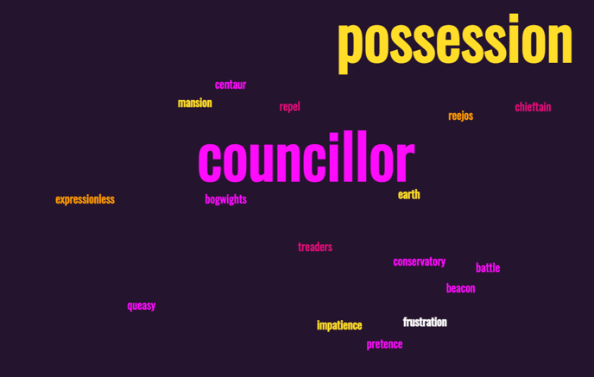  Source: https://monkeylearn.com/blog/wordle/  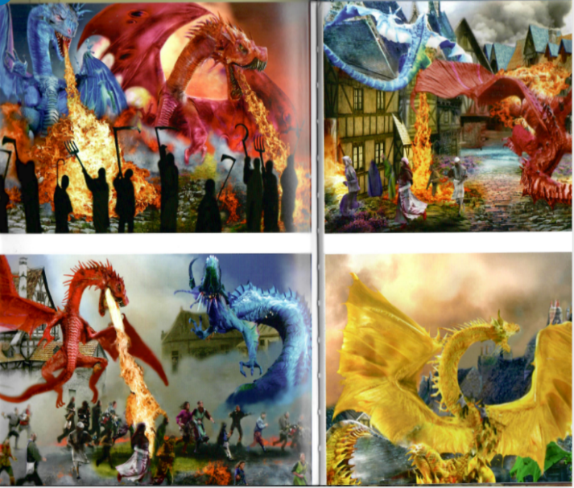  Source: The Glimme p364, 365.  Story paths: a series of pictures that tell a story. Story paths encourage re-reading and provide opportunites for deep discussion about texts.  Story paths in text:  Retell story following story paths with peer/ small group e.g: p301-303; p306, p312, p331-333. And earlier chapters... opposite Table of Contents, p15-19, p47-49, p53-55, p71-73, p93-95, p168-173, p202-204, p234-236, p246-247, p257-259. Class locate and follow each story path as students retell what is happening on these pages.  Development/ Enrichment Activity:  Interested students experiment with/ create a multimodal text of a quest using the software coding program Tynker.  https://www.tynker.com/  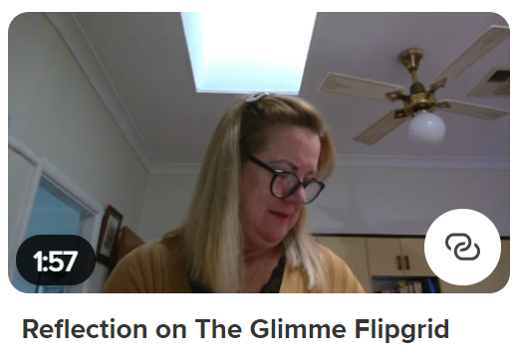  https://shorts.flipgrid.com/watch/19667593369223929

We’re Going on a …QUEST! | Evaluation
T. unit reflection sheet.
Assessment of Learning:
The unit concludes with students writing a quest scaffolded by the five common, defining features of quests that they will be familiarised with in authentic texts throughout the unit. The writing rubric formulated for the pre-test writing task will be used to self, peer and teacher assess student writing.
Use the structure of a quest to write a narrative which concludes with the achievement of a goal. Ensure that your quest has an identifiable theme.
The oral reading and fluency test will be re-administered as a post-test task, also the vocabulary activity to monitor student growth throughout the term. Suggest teachers record and graph student results pre and post assessment tasks on Excel as evidence of student learning.

