Unit Name: Celebrating the other

Introduction to unit
This 10-week integrated English unit focuses on context in texts, and how context and texts work together to make meaning. In this unit, S. will be encouraged to consider their own personal context, the context of the reader; in contrast to the context of the composer and the text; which impacts how S. respond to and compose texts. Other concepts in the unit include intertextuality. S. are invited to identify aspects of other stories evident in texts, stories within stories. Additionally, S. will revisit character and narrative; and discuss how characters change or remain the same, based on events in the story. They will be encouraged to identify and question stereotypes in texts. S. will discuss how characters carry the narrative (action and events) forward.
The main text in the unit, Runt (Silvey, 2022) is set in a country town. Students will investigate the situational, cultural, and historical context of the text. The story is about a girl, Annie Shearer, who “doesn’t quite fit in”, in the town where she lives, and her best friend, Runt, a stray dog who is despised in the town, which Annie adopts and grows to love. Her family are a mix of unique characters who share a loving steely bond, supporting each other in everything they do. An interesting, unexpected sequence of events ensues…
Subsidiary texts in the unit include The Magic Finger (Dahl, 1966) multimodal text; Summer Blue (Crosby-Fairall, 2022) picture book; Clancy of the Overflow (Paterson) poem/ song; and The Proudest Blue (Muhammad & Ali, 2020) multicultural picture book.
N.B. This unit comes with a teacher resource folder containing 15 handouts. It is neither expected nor encouraged that these be printed. Consider the trees and complete these activities digitally, wherever possible. Thank you. There is an award-winning audio version of this text, narrated by Genevieve Hegney, available Audible, useful for repeated reading and fluency activities.
Deep knowledge and understanding
Key concept | Focus question(S) | Curriculum content
Context  Intertextuality  Character  Narrative | -What is the audience and purpose of each text in the unit?  -How is context reflected in the texts?  -Which language features tell us about context?  -How does context impact characters’ beliefs, customs, language, and values?  -How does context influence the reader?  -Are aspects of other stories evident in the main text Runt?  -How have stories been appropriated to create Runt?  -Why do composers transform existing texts in the creation of new and original texts?  -Who are the main character/s in the texts and what characteristics make them unique?  -Have the character/s changed throughout the text? How?  -Are any stereotypes evident in characters in the texts?  -What conventions of narrative form can we identify in the texts?  -How is the plot organised?  -How does the composer create mood and atmosphere through language choices?  -How does the composer engage readers through characters, events, and places in the story? | EN3-UARL-01  EN3-OLC-01  EN3-VOCAB-01  EN3-CWT-01  EN3-UARL-01  EN3-UARL-01  EN3-UARL-01  EN3-OLC-01  EN3-VOCAB-01  EN3-REACOM-01

Other significant learning
Other knowledge, understanding and skills, attitudes and values | Curriculum content | Criteria for Assessment
VAS3.2 Makes artworks for different audiences, assembling materials in a variety of ways.  DRAS3.3 Devises, acts, and rehearses drama for performance to an audience.  MUS3.1 Sings, plays and moves to a range of music, individually and in groups, demonstrating a range of musical concepts.  EN3-OLC-01 Communicates to wide audiences with social and cultural awareness… by analysing and evaluating for understanding. | Draw/ compile a story map of the multimodal text, The Magic Finger (Dahl, 1966).  Devises drama in collaboration with others based on the short story, Facing Off Freddy O’Flynn.  Learning about context through music. Learn, sing, play the poem/ song Clancy of the Overflow. Discuss the historical context of Australia in the late 1890s when the text was composed.  Discuss the range of contexts across Australia in which S. live, through a quality text. S. identify that not all Australians live in country towns. Most S. live in cities, often in high rises, with people from across the globe, bringing together a range of values and customs, discussed through the lens of the text, Muhammad & Ali (2020) The Proudest Blue. Anderson Press. | Evidence of characters, sequence of events, places in story, plot.  Refines and performs drama work for an audience.  Joins into discussion about historical context of text and its relevance today.  Sings along with the song.  Identifies context in this text and other multicultural picture books in school library.

Abbreviations used in unit:
LI: learning intentions; KQ: key discussion questions; IWB: interactive whiteboard; T: teacher; S: students.
Assessment
Pretest / Post-test tasks
Reading: I minute oral reading fluency read from main text (handouts 2, 3).

Writing: Pre-test- write an engaging orientation of a narrative about a pet. Your orientation may be based on another story you know and enjoy. Introduce the main character/s and describe the context, including setting, including time and place. You may wish to elaborate on what comes next following the orientation… (handout 1).
S. complete their narrative for the post-test writing assessment task, ensuring an evident plot, complication, and resolution. S. elaborate on how their character/s change and develop throughout the narrative and how their story has remnants of other stories embedded in it.

Vocabulary: Pre and post-test vocabulary task (handout 4), a peer assessment task.

Formative Assessment tasks embedded in the unit
Curriculum content | Outline of task | Criteria for assessment
EN3-UARL-01  EN3-CWT-01  EN3-OLC-01 | -S. write a paragraph about their own personal contexts  -S. identify the context of the text, Runt (p4). | -S. outline where they come from and how this impacts how they view the world.  -S. outline the social, cultural, and historical context of Runt.
EN3-UARL-01  EN3-CWT-01 | -S. complete a multi paragraph outline of text (p8).  -S. peer-assess, provide feedback on outline. | S. provide feedback on:  - Introduction  - Sequence of events  - Sentence variety  - Punctuation  - Spelling, vocabulary  - Did the outline engage the reader?
EN3-CWT-01  EN3-RECOM-01 | -S. complete their summary sentence from text independently (handout 8).  -S. colour-code their completed sentences (p11). | Did S. correctly colour-code:  - Processes (verbs/ verb groups) green?  - Participants (nouns/ noun groups) red?  - Adverbials telling how, where, when, why etc blue?
Resources
Main text: Runt (Silvey, 2022). Recommend class set.
Subsidiary texts: Summer Blue (Trewin, 2022); The Proudest Blue (Muhammad & Ali, 2020); Clancy of the Overflow (Patterson, 1889); The Loaded Dog (Lawson).

Unit overview
All texts are set in a particular context that impacts meaning. The composer’s context, and the responder’s (reader’s) context, work together with the text to make meaning. I want students to understand that context (both our personal context as readers and the context of the composer/s) is present in all texts and colours how we read and understand them; based on the social, literary, cultural, and historical environments of both the composer and responder.

In the unit, Celebrating the other, we look at texts comprising characters (some quirky) who may or may not be different from ourselves. Differences may include when and where they live, their actions and/ or values. The varying contexts of composers and responders influence meaning in a text, how it is understood. Not all responders will understand a text the same way, based on their personal contexts.

The main text, Runt, is a narrative, set in a country town. The protagonists, Annie Shearer and her dog, Runt; have personality traits that set them apart in the town of Upson Downs. It is an extremely funny tale of friendship, which promotes the message of being proud of who you are, with a pervading theme of hope and happiness.

Unit title
Celebrating the other: !0-week English (Creative Arts) integrated unit Stage 3

Body of unit

Period of time | Curriculum content | Teaching, learning and assessment | Adjustments, extensions,  resources | Registration/T. reflection
1 lesson  Pretest writing task | EN3-CWT-01  EN3-OLC-01 | LI: S. complete pretest writing task.  -T. reads S. the story of The Loaded Dog (Henry Lawson). Discuss.  -T. model-writes an orientation to text.  -Peruse/ discuss marking rubric (handout 1).  -T. guides students in completing pre-writing task.  -S. self-assess their writing tasks based on rubric.  -T. collects writing sample for S. to complete for post- test writing task, at the conclusion of the unit. | Picture book version, The Loaded Dog  or,  Jack Thompson reads excerpt, The Loaded Dog Jack Thompson reading Henry Lawson - Bing video  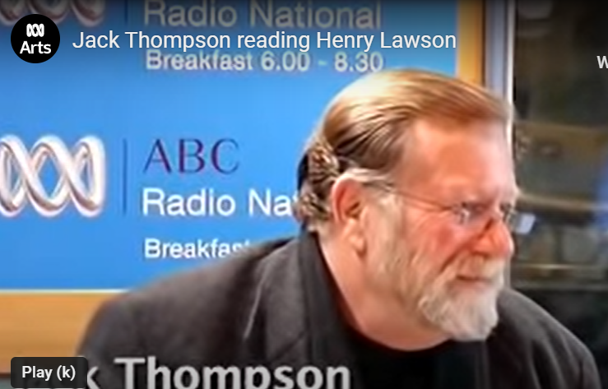
1-2 lessons  Pretest vocabulary, reading task | EN2-REFLU-01 | LI: T. assesses student oral reading pretest task 1-1 (handouts 2,3).  -T. record S. pretest data including CWPM, reading rate, vocab score and writing score on Excel class spreadsheet; to use with post test data as evidence of reading/ writing growth over the term.  -S. complete vocabulary assessment task in pairs (handout 4). | -T. request time from non-teaching executive to enable T. to complete 1-1 pre-reading reading record (about an hour)  -Alternately T. assess S. using 1 min read during independent class activities.  -N.B. It is important that the class T. assesses S. oral reading as it provides valuable student background knowledge.
1-2 lessons | EN3-UARL-01  EN3-OLC-01  EN3-CWT-01 | LI: S. write a paragraph about their own personal contexts.  -K.Q. What is context?  -S. watch context video (5 mins). -Decide on a definition together. Record a shared definition on IWB. Eg: “The context of a text is the circumstances in which a text is written and read that impacts meaning”  -T. distributes texts. Share cover of text. KQ: What is a runt? Why might this be the title of the book? Discuss. -S. flick through book and Think-pair-share from illustrations what the context of the text may be.  -Listen to the author interview discussing context/ why he set the story in Upson Downs (18-21). Discuss.  -Listen to the author discuss the books he loves that influenced him when writing Runt (26-31). Discuss.  -S. briefly record the context of Runt in English books. They may wish to appropriate an illustration from text.  -S. think about their own personal contexts-where they grew up, what they see going on, what they value.  -T. model writes a paragraph about their personal context on IWB.  -S. independently write a paragraph outlining their personal context.  -Share with the class. | -Context video for students Textual concepts (nsw.gov.au)  -'Ben's Book Club: Ben Hobson interviewing Craig Silvey, author of Runt' - YouTube  Break video into small snippets over a few lessons. Watch and discuss each segment with varying foci from text. One hour total (numbers are counters)  18:47-21:20 Why he set the story in a rural town (authorial context).  26:35-30:28 Books that influenced him Charlotte’s Web, Goodnight Mr Tom, All Creatures Great and Small, Roald Dahl, The Loaded Dog. Elements of intertextuality in text, but all link to context- texts set in rural communities.  40:50 Audience and purpose  50:40 Structure of text  55 Character.  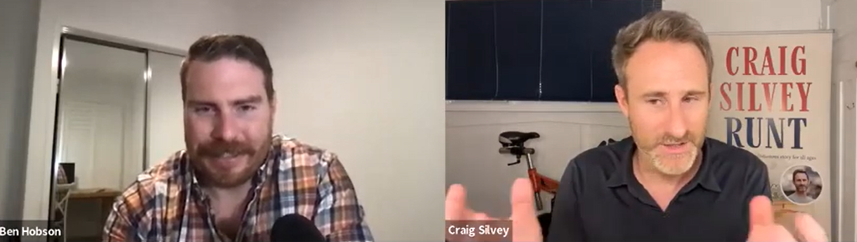
2 lessons | EN3-UARL-01  EN3-VOCAB-01  EN3-RECOM-01  EN3-RECOM-01  EN3-OLC-01  EN3-CWT-01  DRAS3.3 | LI: Revise character and context in a short story. Murray, M (2016). Facing off Freddy Flynn.  -T. frontloads (a) unfamiliar vocabulary in text: sabotaged, jalopy, miraculous.  (b) figurative language:  Face off, blood boil, scared as a rabbit, take a clean line, like a pro, lost his smirk.  -S. locate in text. Highlight and discuss meaning in context.  -T. reads aloud text and S. follow using transparent blue rule, cut from clear blue plastic folder (one per student).  K.Q. What is the context of this story? (Time, place, circumstance)  What words tell us about the characters in the text?  - Narrator (“I” first person point of view)  - Freddy O’Flynn  - Georgia  -S. shade language describing each character in 3 different colours, one at a time.  -Discuss language highlighted from a functional view, which describes character traits of each of the main characters.  -T. models how each part of the clause has a different function e.g.  Georgia slipped past me.  I could sense him leering at me.  It bounced into the bush.  -Through oral questioning, S. identify information about what is going on, who/ what is taking part and any circumstances surrounding the activity, on IWB.  -T. models and guides students writing a short script based on a favourite part of the story on IWB.  -In small groups (2-3 students), S. write their own short script from story. Ensure it contains dialogue between characters.  - S. refine and perform drama work for an audience. | Handout 5: Facing off Freddy Flynn. Printed. One per student, back-to-back.  Rule cut from transparent blue folder, approx. 12cmx 2.5cm. At a glance, T. can see S. are following during read-aloud, and they don’t lose the place when T. stops to explain a teaching point in-context, a scaffold for reluctant readers.  Language used to describe main characters in text e.g:  Narrator (first person “I”):  -feel my blood boil  -I wanted to win so badly  -couldn’t pass up a challenge  Freddy O’Flynn  -my arch enemy  -boasting about his new billycart  -he taunted  -someone sabotaged my billycart, and I knew who!  Georgia  -My fried Georgia  -The billycart that Georgia and I had put together  -Geogia slipped past me  -Georgia was first  N.B. Traditionally, green is used to colour process, red for participants, blue for adverbials telling how, where, why, when etc.  (Derewianka.(2022). A New Grammar Companion. 3rd Ed. PETAA, p11)  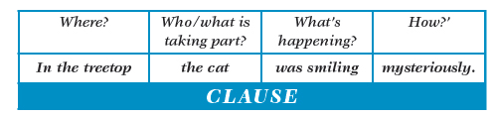
1-2 lessons | EN3-UARL-01  EN3-OLC-01  VAS3.2 | LI: S. investigate intertextuality in narrative texts.  -T. talk about how stories are often based on other stories.  -Watch intertextuality video together. S. provide examples of texts they know that refer to other texts.  -Revise the composer, Craig Silvey’s favourite texts from his interview, viewed and discussed in the previous lesson.  -T. tells S., “As we read the text, Runt, we will look for evidence of intertextuality”.  -S. watch, discuss and summarise The Magic Finger multimodal text on Youtube.  -K.Q. What is the context of this multimodal text? How do you know? (English countryside, farming community, related values of characters to Runt?)  -Peruse a class’s story map from a different text. Unpack main features.  -S. (independently or in pairs) draw a story map of multimodal text, The Magic Finger. Label with actions and events in narrative. Display in classroom. | English concepts Intertextuality video Textual concepts (nsw.gov.au)  The Magic Finger by Roald Dahl - Bing video  Example storymap: To the Bridge (Fenton, 2020).  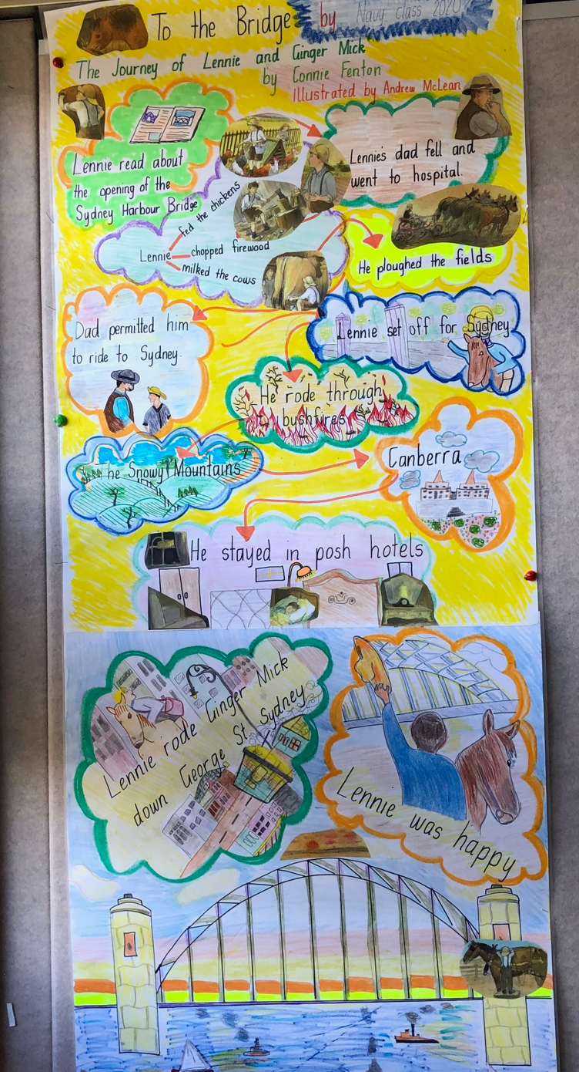  With thanks Fennell Bay PS.
1 lesson | EN3-UARL-01  EN3-UARL-01 | LI: Identify main characters, context in text  -T. reads-aloud p1-17 Runt while S. follow on.  -Following chapt 1, S. identify the language that tells us about Annie Shearer.  -Following chapt 2 K.Q. What’s it like living in Upson Downs? Describe the context of the text including the situational, cultural, and historical context.  -Following Chapt 3, The Collector, S. find the language in the text that describes Earl Robert Baron.  -S. complete a character map, identifying a character of choice from text, their traits and evidence (language used to describe them) handout 6.  -S. share and discuss their maps with class. | Example character map: handout 6 (students may wish to construct their own map using digital tools/s of choice) e.g. avatar.  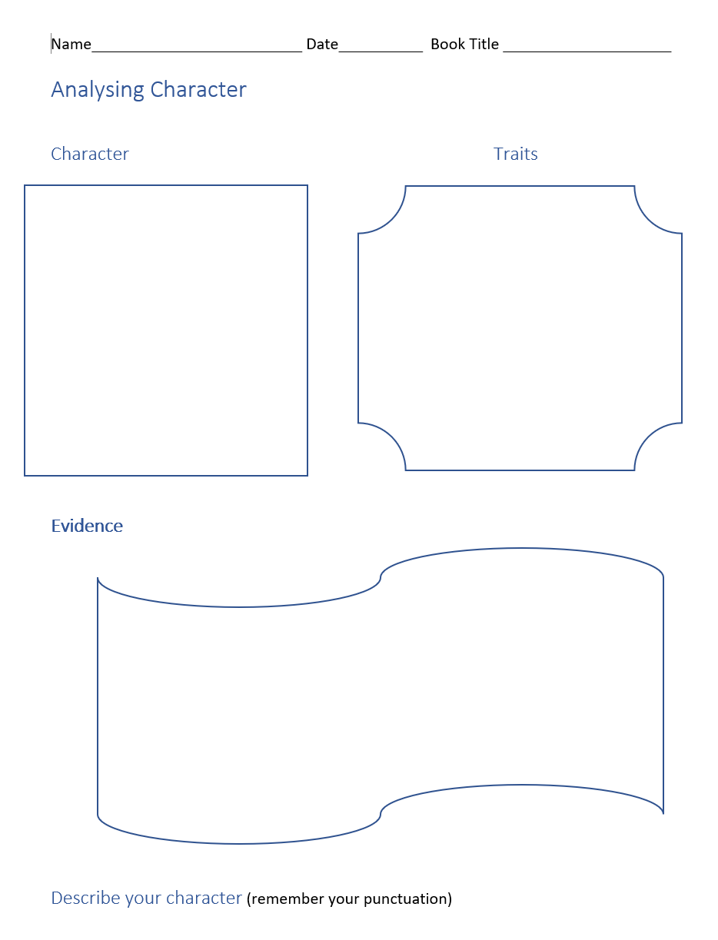
1-2 lessons | EN3-UARL-01  EN3-OLC-01  VAS3.4  VAS3.1  EN3-OLC-01 | LI: Investigate text illustrations.  -Revise intertextuality (stories within stories). Look for similar illustrator styles. KQ: Do the illustrations look like any you have seen on other texts?  -S. peruse illustrator Sarah Acton’s webpage. Find 2 interesting things to share with class.  -S. research Sarah Acton’s online portfolio. Find a favourite illustration to share.  -Compare/ contrast Sarah’s illustrations in Runt with a range of Quentin Blake illustrations in Roald Dahl texts. KQ: How are they the same/ different? Do you think Sarah has a similar illustrator style to Quentin Blake? How?  -Divide an art sheet in half. S. draw an illustration by Acton from Runt on one side of page, and a Blake illustration from a Dahl text on the other side. Compare and contrast illustrations. T. models how to correctly reference the illustrations which they appropriated, respecting academic property.  -S. share illustrations/ tell the class how the illustrations are the same/ different. | sara acton illustration - Home  Range of Roald Dahl texts from school library  Welcome to the official website of Sir Quentin Blake | Quentin Blake  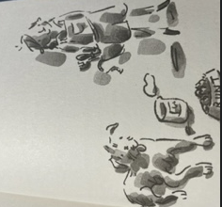  E.g. Silvey, C. (2022). Runt. Allen & Unwin, p343.  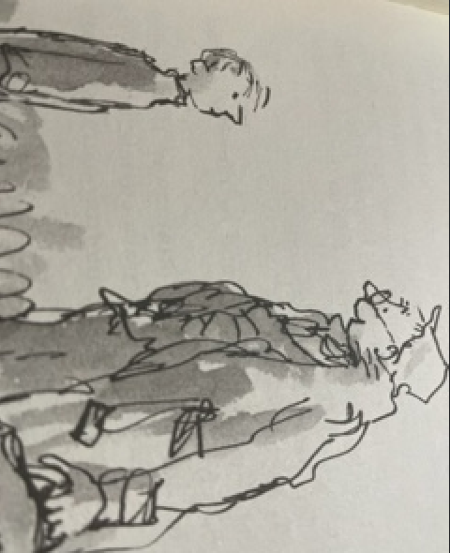  Dahl, R. (1975). Danny the champion of the world. Penguin, p87
1-2 lessons | EN3-UARL-01  EN3-VOCAB0-01  EN3-OLC-01  EN3-SPELL-01  EN3-RECOM-01  EN3-CWT-01  EN3-OLC-01 | LI: Investigate character  -T. frontloads unfamiliar vocabulary in text: Gastric Bypass, tarpaulin, outrageous, parachute, extraordinary, peachummery, bioluminescence, pedigree.  -T. sets the scene. Talk about who has been the Show. Who, when, how, what, when, why…  -T. reads-aloud p50-116 Runt while S. follow on.  -Identify interesting noun groups from text whilst reading eg: a smorgasboard of delicious treats; potential love interest.  -Identify, unpack figurative language in-context e.g., humble pie; pucker up; shenanigans afoot; a sticky wicket;  -KQ: Why don’t people buy mum’s humble pies? Why does Dolly Shearer man the kissing booth? What is the Canine Agility Course Competition?  -S. research whether this is a real competition, as it sounds suspect. Share what they find with the group.  -In pairs, S. choose a character and find words in the text that tell us about that character, e.g. mum, gran (Dolly), dad (Bryan), Max etc  -S. explain to the class what the language they located in text, tells us about the character that they chose, and the context in which they live. | -Portmanteau: a word formed by blending two others e.g. peachummery = peach flummery (desert); overdraft.  -Morphology: bio=life (Greek); by=near(preposition).  Lumi=light; escence=becoming.  -Orthography: practice/ practise p104.  -Teacher tip: Beck, McKeown and Kucan (2013). Bringing Words to Life; provide useful strategies for introducing meanings of unfamiliar words (p40-45).  -Language used by the composer to describe characters.  e.g. Fergus Fink:  -“tall man wearing a purple velvet tracksuit  -fifteen times national runner-up  -stands like a matador, proud and dramatic  -nobody pays Fergus Fink any attention”.  (Illustration of Fergus Fink p66 Runt)
1-2 lessons | EN3-UARL-01  EN3-OLC-01  EN3-CWT-01 | LI: Revise narrative structure  -T. asks, K.Q: What’s happened in the story so far? Where are we up to? What is your opinion of what we’ve read so far?  -T. model-writes a multi paragraph outline of story so far, on IWB.  -T. guides S. in the independent completion of their multi 3 paragraph outline (handout 7)  -S. provide feedback on peer’s multi paragraphs outline, including:  - Introduction  - Sequence of events  - Sentence variety  - Punctuation  - Spelling, vocabulary  - Did the outline engage the reader? Why or why not? | 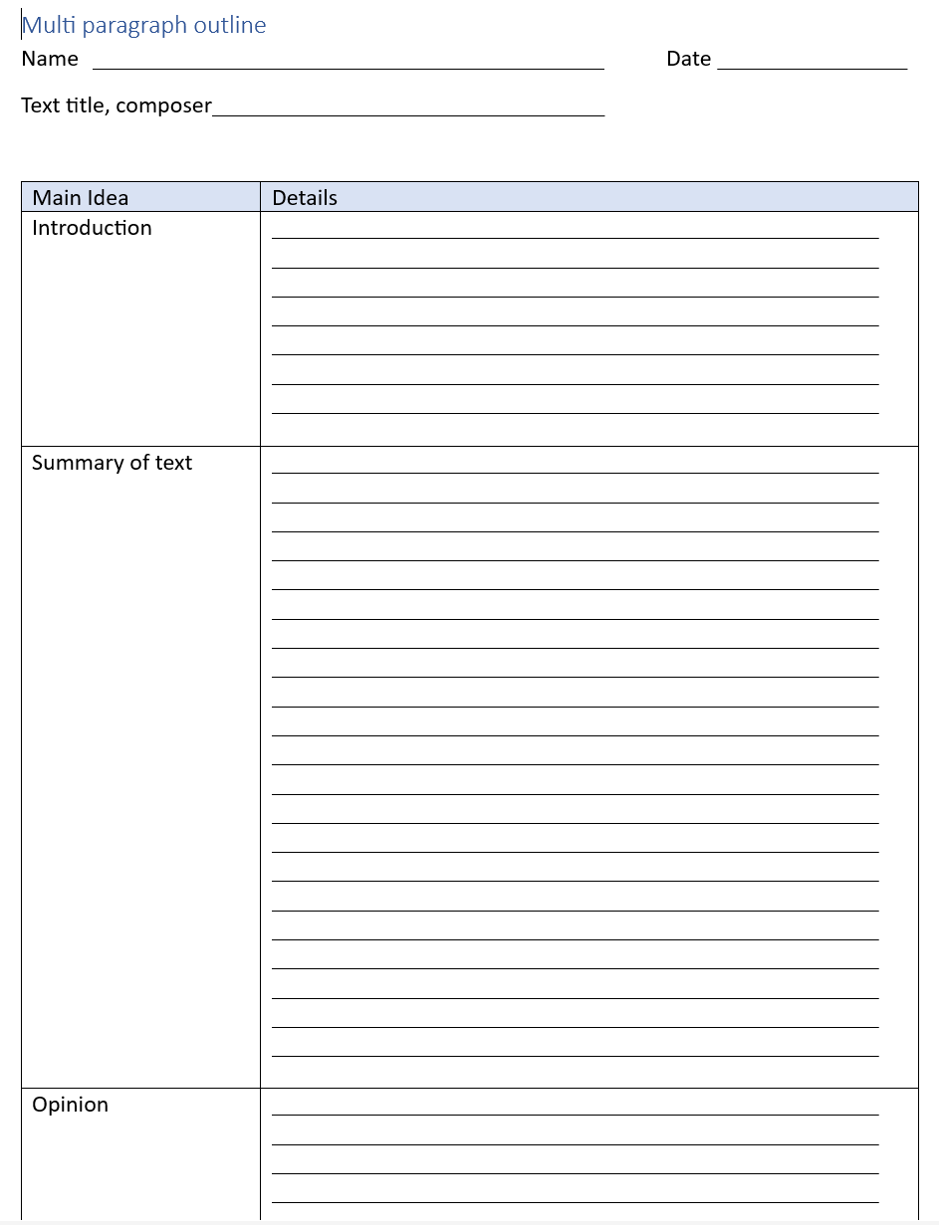  Amended from: Hochman & Wexler (2017). The Writing Revolution. Jossey-Bass, p256.
1-2 lessons | EN3-VOCAB-01  DRAS3.3  DRAS3.4 | LI: Use the elements of drama to convey meaning from text  -T. frontloads unfamiliar vocabulary in text: ballistic, holistic, cautiously; figurative language bee’s pyjamas, tumbling thoughts. T. stops reading and the class discuss any unfamiliar vocabulary, figurative devices in text as they appear.  -T. reads-aloud p117-144.  -S. choose a humorous scenario from text and with 2-3 friends, act out the text. E.g:  Scenario 1- Dr Guyere p121-22  Scenario 2- Pearl Fernleaf p123-25  Scenario 3- Bernadette Box p126-29  -S. devise, act and rehearse drama for performance to an audience.  -Class respond critically to performances. | Words ending in ly: eg cautiously describe a verb (adverb). Make a family list of ly words.Discuss meaning.  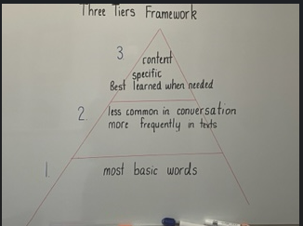  Example vocab. chart to display and add to (from text) in class.  Amended from: Beck, McKeown & Kucan (2013). Bringing Words to Life. Guilford Press, p9-10.
1-2 lessons | EN3-VOCAB-01  EN3-UARL-01  EN3-OLC-01 | LI: Build reading fluency through repeated practice  -T. frontloads unfamiliar vocabulary in text: surreptitiously, diabolical, irrefutable, impasse, petrified; figurative language twinkling gibbon, devil in detail.  -T. reads aloud p145-200 with prosody.  -Class discuss sequence of events, characters, events, and dialogue.  -S. choose a favourite page in segment. Practise reading text with prosody. Underconfident readers may wish to read with a peer.  -S. choose to read their practised, polished page for an audience.  -Class provide feedback on S. oral reading. | Teacher tip:  “Fluency is made up of three core components: Accuracy is the reading of words correctly. Rate is the speed of word identification. It is usually recorded as words read per minute. Prosody is the sound of the reading. This can be explained as the expression used when reading”.  Source: NSW DoE. (2023). Fluency (nsw.gov.au)
1 lesson | EN3-VOCAB-01  EN3-OLC-01  EN3-CWT-01  EN3-RECOM-01 | LI: Read for enjoyment and understanding  -T. reads-aloud p.201-222  -T. revises meaning of pedigree from the point of view of the composer throughout text. Discuss language in text that supports this view.  -Class discussion. K.Q. The name of this unit is “Celebrating the other”. It is figurative in that the meaning is not literal. Why is our English unit called this? Evidence from text?  -K.Q. What dilemma does Annie Shearer face in this segment of the text? How do you think she will solve it?  -T. models “Summary sentence strategy” on IWB, colour-coding completed sentences from a functional grammar view.  -S. complete their summary sentence independently.  -S. colour-code their completed sentences.  -T. uses S. summary sentences for formative assessment (handout 8). | Pedigree:  -P12,13 Earl Robert-Barron believes he is superior to the township of Upson Downs.  -P88 paragraph 3 Fergus Fink is “running down” Annie and Runt.  -P112, 113 Fergus Fink is brimming with misplaced self-importance.  -P150 text: discussion about Runt’s questionable pedigree.  Summary sentence strategy:  Amended from: Hochman & Wexler The Writing Revolution. Jossey-Bass, p248.  Revision functional grammar:  Traditionally, green is used to colour process, red for participants, blue for adverbials telling how, where, why, when etc. Source: Derewianka. (2022). The New Grammar Companion. 3rd Ed. PETAA, p11.
1-2 lessons | EN3-UARL-01  EN3-OLC-01  EN3- RECOM-01  EN3-OLC-01 | LI: Investigate connotation, imagery and symbol in text  -T. reads-aloud p222-289  -Class talk about how words and images can represent more than what they denote (they say and we see), providing additional layers of meaning to the reader.  -Watch video together. Discuss.  -Peruse poster. Discuss its meaning, analysing visual text.  -In pairs, S. mine the text segment for symbols of London. Have a class competition, students working in pairs if they wish, to see who can locate the most symbols.  -S. research virtual tours of London. Share what they discovered/ viewed with group. | -Symbols of London:  London taxis, Paddington Station, London Bridge, Buckingham Palace, Piccadilly Circus, bangers and mash, Kew Gardens.  -Figurative language: kind lies, enviable heritage, down under, humble pie, meaning of life, stop and smell the flowers.  -Video: Textual concepts (nsw.gov.au)  -Poster english-s3-s4-s5-textual-concepts-poster-connotation-imagery-and-symbol.pdf  -Key word search: “virtual tour” & “London”
1-2 lessons | EN3-UARL-01  EN3-OLC-01  VAS3.2  VAS3.4  EN3-OLC-01 | LI: Investigate how character, context changes throughout the text  -T. reads aloud 289-321.  -class discussion/ dialogic teaching. KQ: How does Annie feel when they don’t win the competition. Who took the binders? What does this tell us about the character Annie? How is Runt feeling? How are they different from the beginning of the story? (refer: The Big Moment). How has the rain impacted Earl Robert Barren?  -S. draw pictures denoting how a character has changed throughout the text. They may choose to show how the context of the text has changed at this point in the text.  -T. organises a gallery walk where students share their illustrations, in sequence, with class, telling how the character or context changed throughout the text, reflected in their illustrations. | Pictures denoting change from text e.g:  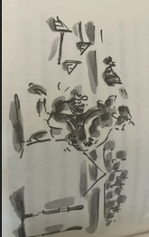  Annie carries Runt from the stage, feeling defeated (p294).  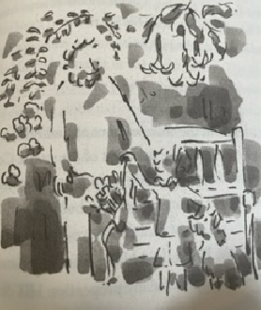  Annie no longer needs the crutch of her tool belt and hands it to her dad (p325).  Upson Downs is filled with water. The township is no longer dry. Its people are safe (p297-303).
1-2 lessons | EN3-UARL-01  EN3-OLC-01  EN3-CWT-01  EN3-OLC-01 | LI: To identify how context has changed throughout the text  -S. read final chapter independently. Discuss how the town has changed from the beginning of text and why.  -In small groups, S. make an advertisement for Upson Downs, encouraging tourists to visit, focusing on context. This can be digital using favourite IT tools, or a TV ad, pamphlet, any format students wish to use to create the advertisement. Display advertisements in classroom.  -S. share digital versions of advertisements with the class. | 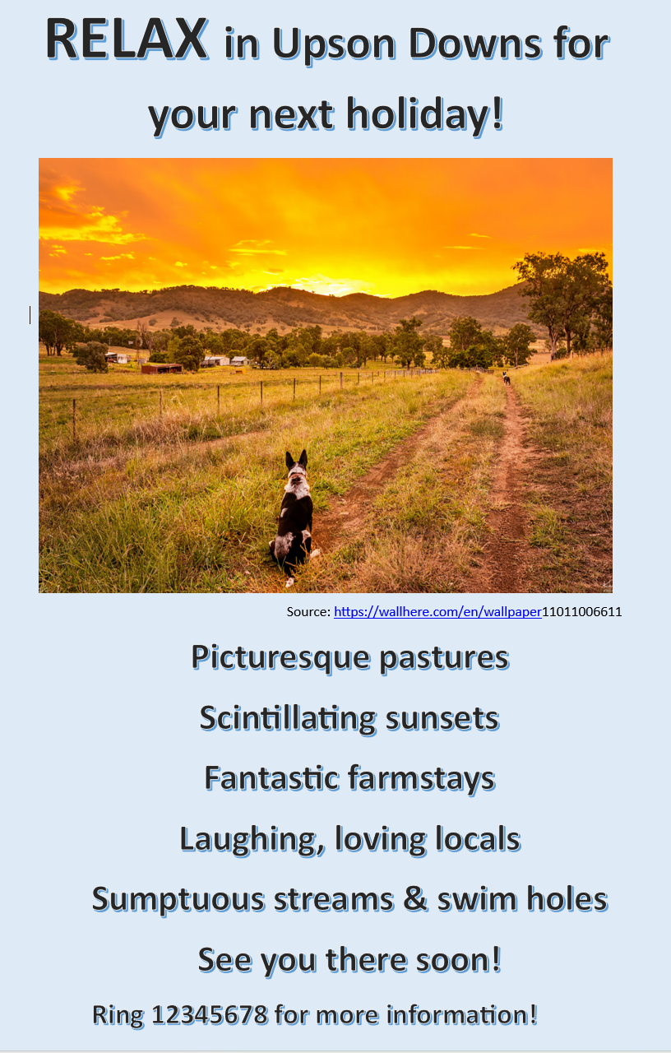e.g. handout 9
1 lesson | EN3-UARL-01  EN3-OLC-01  EN3- RECOM-01  EN3-CWT-01 | LI Identify context in multicultural picture book/s  -T. reads text, The Proudest Blue to class.  -Discuss audience and purpose.  -Identify context together.  -Ist person narrative. The text is being told through the eyes of a character- Asia’s little sister.  Discuss the characters. K.Q: What is a hijab? Why is it significant? What does it symbolise to people of the Muslim faith? Why have the boys been drawn as shadows (p.14, 20, 22, 23)? What are they saying? Why? What authorial perspective is evident here?  -S. volunteer to read author’s notes to class, in addition to about the authors and illustrators at the back of the book to class. Discuss.  -T. models a brief book review on IWB., including context, using a book Review scaffold for those S. who wish to use it (handout 10).  -S. write/ create their own book review in any form they wish.  -S. use rubric to self-assess their writing progress (handout 1).  -S. who wish to, share with the group. | Text: Muhammad & Ali (2020). The Proudest Blue. Anderson Press.  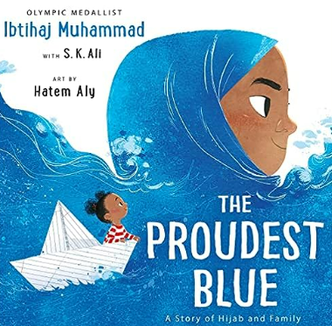
1-2 lessons | EN3-OLC-01  EN3-UARL-01  EN3-RECOM-01  MUS3.1 | LI: Identify context across a range of genres  -T. introduces S. to picture book, “Clancy of the Overflow” (Lawson, 1889). Discuss illustrations. K.Q. What do they tell us about cultural, historical context? (Life on the land, farming, horses- Clancy; lawyer, office worker- Banjo Patterson).  -Peruse famous text (poem) on IWB. Identify/ discuss the language used by poet that suggests social, cultural, historic context.  -S. learn to sing and play the song version using a range of available bush rhythm instruments (e.g., spoons, lagerphone, eucalyptus leaf, tambourine).  -Perform song for an audience. | -Picture book versions of text from School library  -Poem: Clancy of The Overflow [poem by Banjo Paterson] (australianculture.org)  -Song: Clancy of the Overflow - Bing video  Australian bush ballads are poems and songs that tell stories about bush culture.  Language choices of composer suggesting social, historical, cultural context:  e.g. just “on spec”, thumbnail dipped in tar, gone droving, stock slowly stringing, Clancy rides behind them singing etc.
1-2 lessons | EN3-OLC-01  EN3-UARL-01  EN3-CWT-01  EN3-CWT-01 | LI: Building noun groups  -T. sets the scene by talking about life on the land and how rural people are ruled by the seasons/ climate. Children on farms have different lives from their city cousins. Show scanned illustrations from text, Trewin & Crosby-Fairhall, Summer Blue. Scholastic; on IWB. Talk about audience, purpose, context of text.  -Using sentence stems from text, the class build noun groups on IWB (handout 11).  -S. build their own noun groups using sentence stems from text. Students who wish to, share with the group.  -T. concludes the lesson by emphasising the language choices we make as composers impact meaning. By elaborating on noun groups, we add complexity to our writing, providing more information to the reader about character and context. | -T. to scan illustrations for close study on IWB.  Building noun groups:  -Clause: Marley and Moses played.  -Add adjectival before/ after noun group e.g.,  Two bush urchins, Marley and Moses, who lived on an outback farm, played (where) in the rain, (when) when the heavens opened, and raindrops galloped from roof to roof. (See handout 11)  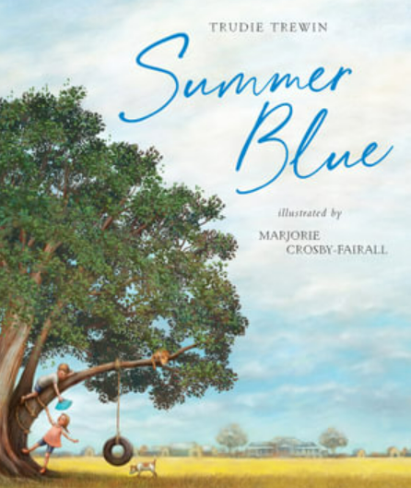
1-2 lessons  Post-test vocabulary, reading task | EN2-REFLU-01  EN3-RECOM-01 | LI: Peer assess vocabulary task  -S. complete vocabulary assessment task in pairs (handout 4).  -T. assess student oral reading post-test task 1-1 (handouts 2,3).  -T. record S. post-test data including CWPM, reading rate, vocab score and writing score on existing Excel class spreadsheet; to calculate S. reading/ writing growth over the term. This information contributes to school-based English data. | -T. request time from non-teaching executive to enable T. to complete 1-1 post- test reading record (about an hour)  -Alternately T. assess S. using 1 min read during independent class activities.  -N.B. It is important that the class T. assesses S. oral reading as it provides valuable student background knowledge.
1-2 lessons  Post-test writing task | EN3-CWT-01 | LI: To complete pretest narrative.  -T. distribute pretest writing samples where S. wrote an orientation to text, for completion.  -T models how to use writing scaffold tool (handout 12).  -T. guides S. in using edit/ reflection check using model-write (handout 15).  -S. plan their narratives, using the Writing scaffold tool.  -On completion, S. complete their narrative about the text.  -S. use edit/ reflection check to self- assess their writing (handout 15)  -T. uses writing rubric (handout 1) to assess student writing growth over the term. | Differentiation:  -Some students will not wish to use writing scaffold tool and may prefer to plan/ write independently.  -The tool is useful for reluctant writers to guide them in the completion of their writing task.  -Encourage S. to use reflection/ edit check (handout 15) on their own writing, to make corrections and help them to see where they are at/ where to next in their writing development, prior to submission.  -Allow S. to draw on the text if they wish to use it while writing, as an authoritative source for vocabulary and spelling, to build writing confidence, especially for reluctant writers.
1 lesson  -T. reflection and evaluation.  -S. reflection PMI. | EN3- OLC-01 | -T. completes unit reflection and evaluation to guide future implementation of unit and support nuanced changes to address emerging student learning needs (handout 13).  -S. complete a PMI thinking tool about the unit in its entirety, as feedback to teacher and reflection on their learning (handout 14).

