This Photo by Unknown Author is licensed under CC BY-NC
Cracking the code
Introduction to unit
Unit overview
In this Stage 2 unit, based on the NSW English K-10 Syllabus (2022), students investigate the concept of Genre. Using The Word Spy as a model text, they explore how composers adopt elements of different genres to create hybrid texts, then apply this learning in the key assessment task. The unit also serves as a soft introduction to the concept of Code and convention, which is not required for study until Stage 4 but is amply evident in the notions of language and genre as code. The Word Spy is a challenging text for Stage 2 students, but the unit provides different reading pathways to accommodate differences in reading ability. Other than The Word Spy, the unit promotes wide reading, including Aboriginal languages/English bilingual texts, sample informative and imaginative texts, and a range of other hybrid texts. A key pedagogic feature of the unit is the use of ‘literature circles’ - see PETAA Paper 197: ‘Responding to literature: Talking about books in literature circles’, by Alyson Simpson (Primary English Teaching Association Australia, 2014).

Resources
The Word Spy, written by Ursula Dubosarsky and illustrated by Tohby Riddle (2008)
Range of texts provided by library: Aboriginal languages/English bilingual texts; informative and imaginative texts; other hybrid texts.
‘Waltzing Matilda’, written by Banjo Patterson, and ‘little tree’, written by e. e. cummings

Key concepts: deep knowledge and understanding
Key concepts | Focus questions | Syllabus content
Genre | What features distinguish informative texts?  How and why do composers play with the genre of informative texts?  How can students play with the conventions of genre to create their own hybrid texts? | Understanding and responding to literature  Identifies and describes how ideas are represented in literature and strategically uses similar representations when creating texts EN2-UARL-01  Genre  - Understand that genre refers to texts that are grouped according to purpose, subject matter, form, structure and language choices, and that a type of text can differ in mode and medium  - Identify different text genres when a text is characterised by more than a single genre  Reading comprehension  Reads and comprehends texts for wide purposes using knowledge of text structures and language, and by monitoring comprehension EN2-RECOM-01  - Identify different structures and features of persuasive, informative and imaginative texts  - Identify and describe how text structure, features and language work together to achieve a text’s purpose  Creating written texts  Plans, creates and revises written texts for informative purposes, using text features, sentence-level grammar, punctuation and word-level language for a target audience EN2-CWT-02  - Create informative written texts that include headings, paragraphs beginning with topic sentences, and may conclude information in a final paragraph  - Create written texts that describe experiences and observations to connect with and inform an audience  Plans, creates and revises written texts for imaginative purposes, using text features, sentence-level grammar, punctuation and word-level language for a target audience EN2-CWT-01  - Create imaginative texts to engage an audience, using first person or third person narrative voice  - Experiment using second person narrative voice for effect
Code and convention | How does an understanding of the codes of language facilitate communication?  How does playing with the conventions of language deepen understanding of language? | While Code and convention is not a concept set for study in Stage 2, the English Textual Concepts framework describes learning about Code and convention for Stage 2 students in this way:  Students appreciate that codes of communication are rules which provide access to information and ideas as well as opportunities for expression.  Students learn that  - there are choices of language and structure for expressing information and ide  - codes and conventions vary according to mode, medium and type of text  - all texts go through stages of refinement of language and structure for accuracy and effectiveness.  The focus on Code and convention in this unit provides a soft introduction to a concept that will be studied in a more focused way in later stages.
Context | How do the meanings of codes vary over time and place? How do other cultures, such as Aboriginal cultures, use language and art as codes? | Understanding and responding to literature  Identifies and describes how ideas are represented in literature and strategically uses similar representations when creating texts EN2-UARL-01  Perspective and context  - Describe how Aboriginal and/or Torres Strait Islander authors use language to build cultural understanding and context

Other significant learning
Focus area | Curriculum content
Oral language and communication | Communicates with familiar audiences for social and learning purposes, by interacting, understanding and presenting EN2-OLC-01  Interacting  - Identify contexts in which social conventions can vary and influence interactions  - Demonstrate appropriate language use when interacting in different social and learning contexts  Listening for understanding  - Identify language features in spoken texts that contribute to own or others’ enjoyment and understanding
Vocabulary | Builds knowledge and use of Tier 1, Tier 2 and Tier 3 vocabulary through interacting, wide reading and writing, and by defining and analysing words EN2-VOCAB-01  Learning and using words  - Build personal Tier 1, Tier 2 and Tier 3 vocabulary through social and learning interactions, reading and writing  - Understand that Aboriginal English is a recognised dialect and that Aboriginal English words are used in multimodal, spoken and written texts  - Understand that many words derive from other languages, including Aboriginal and Torres Strait Islander Languages, and that the pronunciation and spelling of words may reflect their etymology  - Understand and use language associated with digital texts  Defining and analysing words  - Understand and use word play including puns and spoonerisms
Reading fluency | While this unit has no explicit focus on reading fluency, it could easily be adapted to allow such a focus.
Reading comprehension | Reads and comprehends texts for wide purposes using knowledge of text structures and language, and by monitoring comprehension EN2-RECOM-01  Reading for interest and wide purposes  - Build topic knowledge, including key vocabulary, and activate background knowledge prior to and during reading  - Identify similarities and compare differences within and between texts by making text-to-self, text-to-text and text-to-world connections  - Locate, select and retrieve relevant information from a print or digital text and consider accuracy of information presented  - Determine the relevance of a text for a specific purpose  Comprehending text structures and features  - Understand that literal information can be sourced directly from a text and that inferences can be made by using multiple sources of information  Comprehending language  - Use morphemic knowledge to read and understand the meaning of words  - Adjust own mental model as reading presents new words and understanding  - Use key words from a text to visualise events, characters and settings when making inferences and confirming predictions  - Identify different types of connectives used by the author that support inference  - Use knowledge of homonyms to understand metaphor and to support inference  - Link the meanings of words and phrases across consecutive sentences to support local inferencing  - Clarify and link the meanings of key words across a text to support global inferencing  - Identify and describe the difference between subjective and objective language in texts  Monitoring comprehension  - Identify how their background knowledge is used to actively build and adjust a mental model prior to and during reading  - Identify where meaning breaks down when reading  - Identify and use strategies to repair reading when meaning breaks down  - Ask questions to clarify meaning and promote deeper understanding of a text  - Make gist statements and record them to monitor understanding  - Use information from paragraphs or chapters to group related ideas and support summarisation of the whole text  - Reflect on reading experiences and identify texts of personal significance and pleasure  - Reflect on own understanding of texts and monitor own goals for reading
Creating written texts | Plans, creates and revises written texts for imaginative purposes, using text features, sentence-level grammar, punctuation and word-level language for a target audience EN2-CWT-01  Plans, creates and revises written texts for informative purposes, using text features, sentence-level grammar, punctuation and word-level language for a target audience EN2-CWT-02  Text features for multiple purposes  - Use language to create imagery or humour, including idioms, puns, simile and personification  - Select and use multimodal features to add meaning  Sentence-level grammar  - Use declarative sentences to provide facts or state a viewpoint  - Use exclamatory sentences to emphasise a point or express a strong emotion  - Use interrogative sentences to ask a direct question, or for rhetorical effect to engage the reader with a viewpoint  - Use simple, compound and complex sentences of varying lengths for variation and readability  Punctuation  - Use capital letters to indicate the beginning of a sentence, proper nouns, headings and subheadings, to indicate the beginning of a poetry line, for emphasis, and when using acronyms  - Use commas between words in a list or to separate adjectives when more than one is used  - Use a comma to separate a dependent clause before a main clause  - Use bullet points or numbering to list items or a sequence of steps  - Use apostrophes for contractions, and to show singular and plural possession  Planning, monitoring and revising  - Plan structures and language to suit the purpose of a text  - Research, summarise and list topic-related ideas when planning  - Create texts by drawing on personal and others’ experiences, and texts read, viewed and listened to for inspiration and ideas  - Reflect on and monitor texts according to given criteria, and respond to feedback from others  - Proofread, revise and edit written texts to refine language, correct spelling and ensure cohesion and engagement for the reader
Spelling | Selects, applies and describes appropriate phonological, orthographic and morphological generalisations and strategies when spelling in a range of contexts EN2-SPELL-01  Phonological component  - Explain how to segment multisyllabic words into syllables and phonemes, and apply this knowledge when spelling  - Identify differences in vowel phonemes (short, long, diphthong and schwa vowels)  - Recognise stressed and unstressed syllables in multisyllabic words and apply this knowledge when spelling  - Understand that the schwa occurs in an unstressed syllable and apply this knowledge when spelling  Orthographic component  - Understand that some graphemes are dependent on their position in a word in English and apply this knowledge when spelling  - Understand that graphemes can be explained by their etymology  - Apply knowledge of taught vowel graphemes when spelling  - Proofread, identify and correct misspellings when creating written texts  - Use spelling reference tools where required and recognise that spellcheck accuracy may depend on understanding the word  Morphological component  - Identify inflected suffixes, explaining when and how to treat base words when they are affixed, and apply this knowledge when spelling  - Identify derivational suffixes such as -able, -ness, -ian and -ment, explaining when and how to treat base words when they are affixed, and apply this knowledge when spelling  - Identify prefixes that require no change to the base word or root when they are affixed, and apply this knowledge when spelling  - Correctly spell irregular plural words across a range of written contexts  - Correctly spell taught homophones when creating written texts
Handwriting and digital transcription | While this unit has no explicit focus on handwriting and digital transcription, it could easily be adapted to allow such a focus.

Assessment
This unit provides a range of assessment opportunities. A writing activity in Week 1 could be utilised as a pre-test to help teacher and students identify aspects of writing that require attention before the key writing assessment task in Weeks 8/9. In Week 5, students work in groups to develop and present a simple PowerPoint and lead the class in a fun language activity. Students read widely, reporting to the class or their group and writing a review. They contribute to discussion at both group and whole class level, conduct and report on an interview, and contribute to a class blog using texting language. The main assessment task, outlined in more detail below, involves researching information, writing first an information text and then a hybrid text with both informative and imaginative elements, before explaining the similarities and differences between the two texts to their teacher.

Key assessment task
Curriculum content | Outline of task | Criteria for assessment
Understanding and responding to literature  Identifies and describes how ideas are represented in literature and strategically uses similar representations when creating texts EN2-UARL-01  Genre  - Understand that genre refers to texts that are grouped according to purpose, subject matter, form, structure and language choices, and that a type of text can differ in mode and medium  - Identify different text genres when a text is characterised by more than a single genre  Creating written texts  Plans, creates and revises written texts for imaginative purposes, using text features, sentence-level grammar, punctuation and word-level language for a target audience EN2-CWT-01  Plans, creates and revises written texts for informative purposes, using text features, sentence-level grammar, punctuation and word-level language for a target audience EN2-CWT-02  Imaginative purposes  - Create imaginative texts to engage an audience, using first person or third person narrative voice  - Experiment using second person narrative voice for effect  - Sequence ideas and actions into paragraphs aligned to the stages of the text, to provide elaborated details about settings, character motives and actions  Informative purposes  - Create informative written texts that include headings, paragraphs beginning with topic sentences, and may conclude information in a final paragraph  Text features for multiple purposes  - Use language to create imagery or humour, including idioms, puns, simile and personification  - Select and use multimodal features to add meaning  Punctuation  - Use capital letters to indicate the beginning of a sentence, proper nouns, headings and subheadings, to indicate the beginning of a poetry line, for emphasis, and when using acronyms  - Use commas between words in a list or to separate adjectives when more than one is used  - Use a comma to separate a dependent clause before a main clause  - Use bullet points or numbering to list items or a sequence of steps  - Use apostrophes for contractions, and to show singular and plural possession  Spelling  Selects, applies and describes appropriate phonological, orthographic and morphological generalisations and strategies when spelling in a range of contexts EN2-SPELL-01  Phonological component  - Explain how to segment multisyllabic words into syllables and phonemes, and apply this knowledge when spelling  - Identify differences in vowel phonemes (short, long, diphthong and schwa vowels)  - Recognise stressed and unstressed syllables in multisyllabic words and apply this knowledge when spelling  - Understand that the schwa occurs in an unstressed syllable and apply this knowledge when spelling  Orthographic component  - Understand that some graphemes are dependent on their position in a word in English and apply this knowledge when spelling  - Understand that graphemes can be explained by their etymology  - Apply knowledge of taught vowel graphemes when spelling  - Proofread, identify and correct misspellings when creating written texts  - Use spelling reference tools where required and recognise that spellcheck accuracy may depend on understanding the word  Morphological component  - Identify inflected suffixes, explaining when and how to treat base words when they are affixed, and apply this knowledge when spelling  - Identify derivational suffixes such as -able, -ness, -ian and -ment, explaining when and how to treat base words when they are affixed, and apply this knowledge when spelling  - Identify prefixes that require no change to the base word or root when they are affixed, and apply this knowledge when spelling  - Correctly spell irregular plural words across a range of written contexts  - Correctly spell taught homophones when creating written texts | - Research one of the many famous people mentioned in The Word Spy  - find out when and where the person lived  - find 5 interesting facts about this person’s life  - find out how they played a part in the history of the English language.  - Write a three-paragraph information text:  - write a brief introductory paragraph about when and where the person lived  - combine the five interesting facts about the person into a second paragraph  - explain how they played a part in the history of the English language in the third paragraph  - use the person’s name as the title of the information text  - add an appropriate photo or diagram.  - Write an imaginative text: a profile of the person that is more fun and engaging:  - feel free to express your feelings and opinions, but still include some of the facts from your information text  - include three paragraphs in your writing – you decide where they begin and end  - give the profile an engaging title  - draw an original picture to illustrate your profile.  - Revise and edit the two draft texts:  - Students use a checklist to help them identify areas for improvement, then make improvements as much as possible  - Students get feedback through peer assessment, then use this feedback to make further improvements.  - With the two texts side by side, explain to the teacher how the two texts compare:  - Note general similarities between the two texts  - Identify significant differences between the two texts  - Explains differences in terms of purpose, text features and their effects. | Information text:  - includes five or more facts about a famous person  - uses objective language  - presents information effectively  - consists of three correct paragraphs  - uses correct spelling and punctuation  Imaginative text:  - uses subjective language, eg uses first person  - engages readers, eg catchy title, asks question, uses second person  - appeals to the imagination  - consists of three correct paragraphs  - uses correct spelling and punctuation  Oral review of texts:  - identifies general similarities between the two texts  - identifies significant differences between the two texts  - Explains differences in terms of text purpose, text features and their effects

Body of unit

Week | Curriculum content | Teaching, learning and assessment | Registration
1 | Reading comprehension  Reads and comprehends texts for wide purposes using knowledge of text structures and language, and by monitoring comprehension EN2-RECOM-01  - Build topic knowledge, including key vocabulary, and activate background knowledge prior to and during reading  - Use key words from a text to visualise events, characters and settings when making inferences and confirming predictions  - Ask questions to clarify meaning and promote deeper understanding of a text  Creating written texts  Plans, creates and revises written texts for informative purposes, using text features, sentence-level grammar, punctuation and word-level language for a target audience EN2-CWT-02  - Create informative written texts that include headings, paragraphs beginning with topic sentences, and may conclude information in a final paragraph  - Maintain noun–pronoun referencing across a text for cohesion  - Use temporal, conditional and causal conjunctions within sentences, and as connectives to link ideas across sentences for cohesion  - Use definite articles for particular things and indefinite articles for general things for cohesion  - Use simple, compound and complex sentences of varying lengths for variation and readability  - Use capital letters to indicate the beginning of a sentence, proper nouns, headings and subheadings, to indicate the beginning of a poetry line, for emphasis, and when using acronyms  - Use commas between words in a list or to separate adjectives when more than one is used  - Use a comma to separate a dependent clause before a main clause  - Use apostrophes for contractions, and to show singular and plural possession  - Plan structures and language to suit the purpose of a text  - Proofread, revise and edit written texts to refine language, correct spelling and ensure cohesion and engagement for the reader  Spelling  Selects, applies and describes appropriate phonological, orthographic and morphological generalisations and strategies when spelling in a range of contexts EN2-SPELL-01 | Codes and spies  - Show students the following photos in turn and ask them to identify what message is being communicated and how it is being communicated:  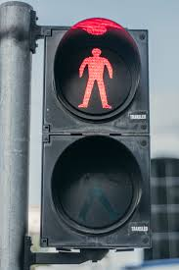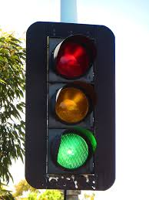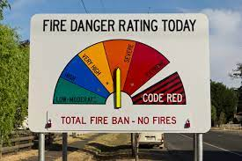  - Talk about the concept of codes. Note that codes communicate information in a way that is widely recognised and understood by people. How are the codes in the photos designed to make us safe? What might happen if a person didn’t understand the codes? Why do these codes communicate visually (mostly) rather than with words? Can you think of other codes…at school, at home or in the community? Think about school bells, sound and visual cues notifying of email or text messages, codes for programming computers, QR codes, numbers, language. Make a picture board with examples of everyday codes.  - Teacher tells students they will be reading a book called The Word Spy. What is a spy? Why do spies sometimes send messages in code? How could you send a message in code? Can you guess what a ‘word spy’ might be?  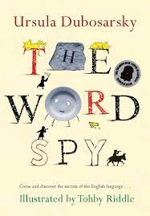  - Now imagine that you are a spy. Your mission is to use all the clues available, without actually reading the book, to work out what this book will be about. Does the front cover give you any clues? Is this a story or something else? Now read the blurb on the back of the book and the letter to readers that prefaces the book…do these bits make things clearer? Finally, read through ‘Contents’, a list of chapter titles and subheadings. Now discuss what kind of book this is and what it is about.  - Write a letter back to the Word Spy. Explain who you are, suggest what you think the book will be about and ask any questions you have before you start reading. The teacher could use this writing activity as a pre-test to assess these writing skills, a focus in this unit, and determine which of these aspects of writing might need particular attention leading up to the key assessment task:  - Punctuation: capital letters and full stops, commas, apostrophes  - Vocabulary and spelling  - Sentence construction: simple, compound and complex sentences  - Paragraphing  - Textual cohesion: eg noun-pronoun referencing, connectives  - Revising and editing  - Writing for purpose and audience
2 | Oral language and communication  Communicates with familiar audiences for social and learning purposes, by interacting, understanding and presenting EN2-OLC-01  - Contribute to discussions with peers and stay on topic, build on others' ideas and express own ideas  - Demonstrate appropriate language use when interacting in different social and learning contexts  - Pose and respond to open-ended questions about literature that contribute to own or others’ enjoyment  - Pose and respond to specific questions to clarify or follow up on information  Reading comprehension  Reads and comprehends texts for wide purposes using knowledge of text structures and language, and by monitoring comprehension EN2-RECOM-01  - Build topic knowledge, including key vocabulary, and activate background knowledge prior to and during reading  - Identify where meaning breaks down when reading  - Identify and use strategies to repair reading when meaning breaks down  - Ask questions to clarify meaning and promote deeper understanding of a text  - Use information from paragraphs or chapters to group related ideas and support summarisation of the whole text  Understanding and responding to literature  Identifies and describes how ideas are represented in literature and strategically uses similar representations when creating texts EN2-UARL-01  Perspective and context  - Understand that literature is created by drawing upon personal, social and cultural contexts and perspectives  - Describe how Aboriginal and/or Torres Strait Islander authors use language to build cultural understanding and context  Vocabulary  Builds knowledge and use of Tier 1, Tier 2 and Tier 3 vocabulary through interacting, wide reading and writing, and by defining and analysing words EN2-VOCAB-01  - Understand that Aboriginal English is a recognised dialect and that Aboriginal English words are used in multimodal, spoken and written texts  - Understand that many words derive from other languages, including Aboriginal and Torres Strait Islander Languages, and that the pronunciation and spelling of words may reflect their etymology | Language as code  - Distribute copies of The Word Spy to students – at least one between two, but preferably one per student. Talk about their responsibility for looking after books.  - Before commencing reading, talk about the different ways we communicate.  - Note that people have been talking for about 150,000 - 200,00 years but writing developed only about 6,000 years ago. This was the time when some people first started to live in towns and cities. What did they need writing for?  - Show students the English alphabet. How many letters are there? Which ones are vowels, and which are consonants? In what ways is the alphabet a type of code? Compare to other codes considered in Week 1.  - Teacher reads Chapter 1 aloud, students following in their copies. Stop at the heading ‘Let’s change the alphabet’ on p12. Pause to discuss and check understanding of meaning as required.  - Ask students to find information from the text to complete this summary:  Writing first started in a part of the world now called __________. This writing, made up with wedge shapes, is called __________. Soon after, the ancient Egyptians invented a type of writing made up of little pictures, called __________.  The first real alphabet was used by the __________. This was a true alphabet because the letters stood for ___________. The ancient Greeks improved the alphabet by adding letters for ___________ sounds. This alphabet was further improved by the ____________, who passed it on to many countries, including England, where the ___________ language began 1,500 years ago.  - Consider this diagrammatic summary of the information:  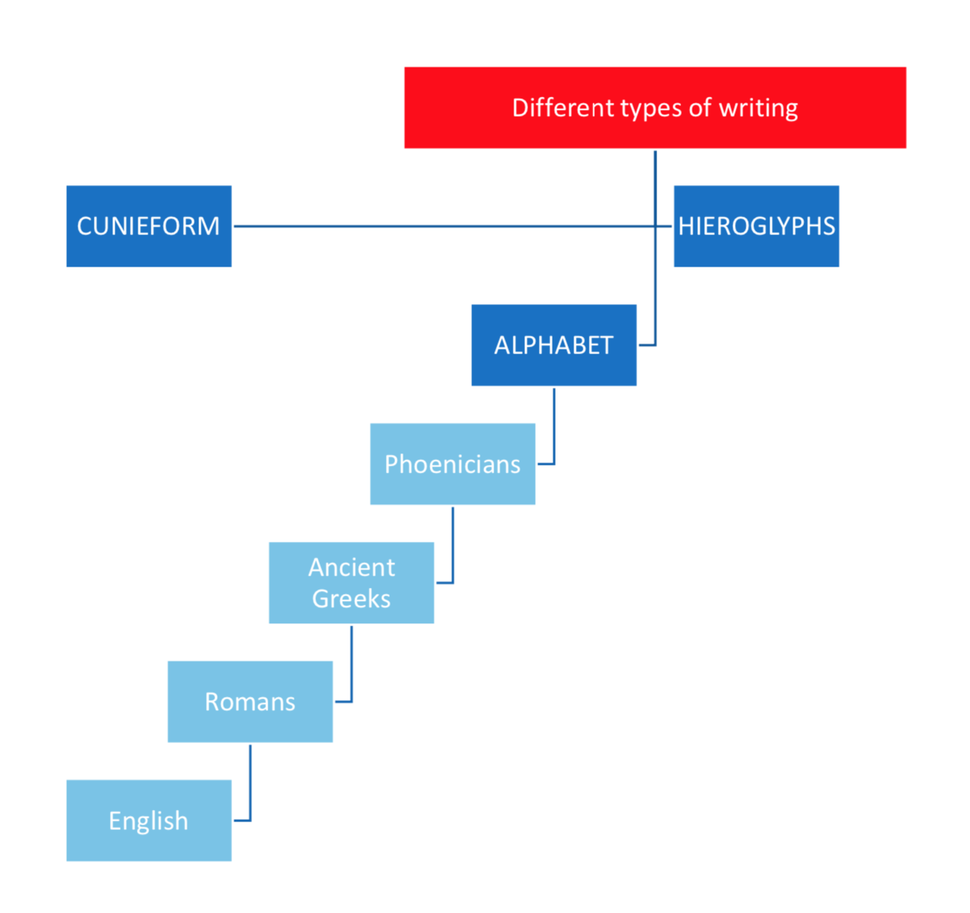  - Add pictures to illustrate the different types of writing – see the text for ideas.  - Use this diagrammatic summary to help you retell the story of how English got its alphabet in your own words.  - What is the advantage of a diagrammatic summary over one written in sentences?  - Look at the timeline before the start of Chapter 1. This is another way to summarise the information.  - What extra information does a timeline provide?  - Try making a timeline of your own life, eg to the scale of 1cm = 1 year  - Briefly review Phonic knowledge from Stage 1 and how this knowledge helps ‘to decode and encode words when reading and creating texts’ – another type of code! Teacher reads the next section in Chapter 1, ‘Let’s change the alphabet’. Discuss: What is the big problem with the English alphabet? Why have so many people tried to change it? Hint: There are 40 different sounds in spoken English. How many letters can be used to represent these sounds? Therefore, some sounds do not have a single letter to represent them, eg th, sh, ch, ng.  - Conduct a class survey of languages spoken at home. Do any of these languages use the same alphabet as English? Do any use another alphabet? Do any home languages not use a true alphabet (where symbols represent phonemes, or distinct sounds), but use symbols that represent syllables, morphemes or whole words, rather than morphemes?  - Discuss Aboriginal and Torres Strait Islander languages. Look at map of Australia showing the 250+ languages. Note that Aboriginal and Torres Strait Islander peoples had a spoken language, not a written language - explore the reasons for that. Of course, since European contact, written forms of these languages have been developed using the English alphabet. Divide class into literature circles.  - Provide literature circles with a selection of bilingual ATSI language/English picture books. Check out your library or this site for some possibilities: Abbeys ATSI language/English bilingual books . Answer these questions in groups and share findings with class:  - Identify where the ATSI language is used in the book.  - Which ATSI language is used?  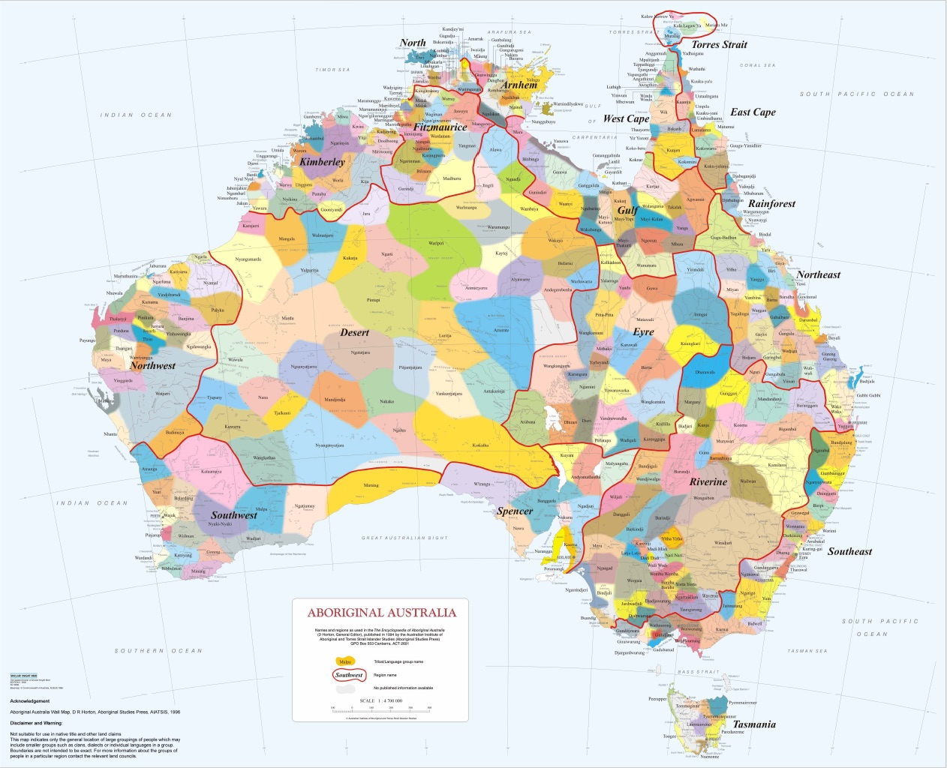  This Photo by Unknown Author is licensed under CC BY  - Locate this language on the map.  - How does the use of Aboriginal language add to the impact of the book?  - Why might such bilingual texts be important for both Indigenous and non-Indigenous children?  - What happens when a group of people all share the same language code? How does this make them feel?  - Because ATSI people did not have written language, they often used art to record stories of cultural significance. They didn’t have access to canvas or paper to make art until the arrival of Europeans. Use this website to find answers to the following questions.  https://www.aboriginal-art-australia.com/aboriginal-art-library/the-story-of-aboriginal-art/  - For how long have ASTI people been telling stories through their art?  - What materials did ATSI people use to make their art traditionally?  - What kinds of symbols are often used in ATSI art? Draw five examples of these symbols and the meaning of each.  - In what way are these traditional symbols a kind of code?  - Find one interesting example of ATSI art on the site and explain what you think it is communicating.  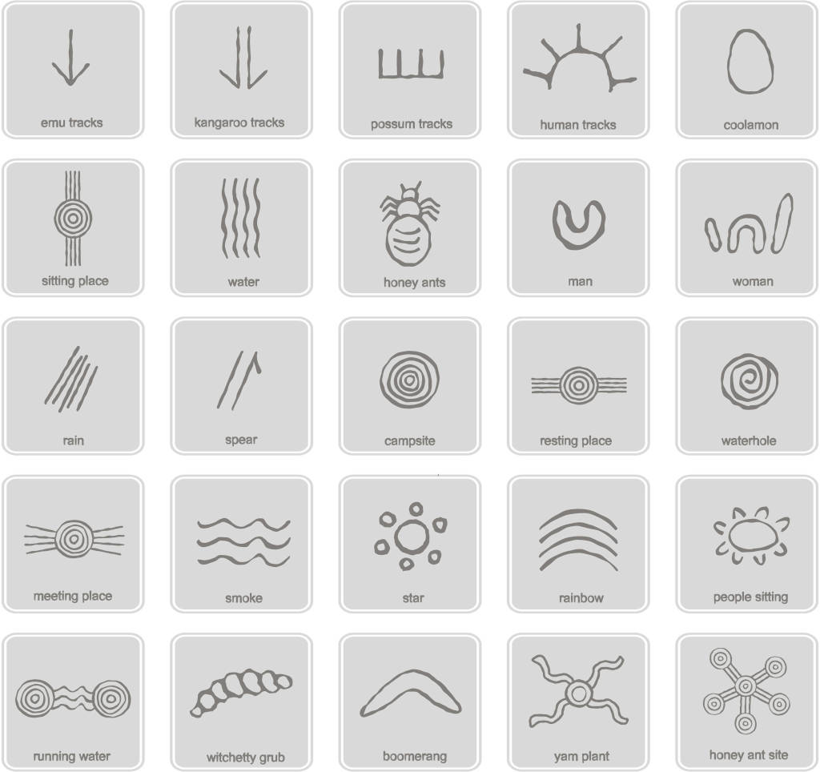  This Photo by Unknown Author is licensed under CC BY-SA  - Teacher reads the next section, ‘Invent your own alphabet’. Students work in pairs to make up their own alphabet. Write this message using the new alphabet: Here is our amazing, new alphabet. Can you break the code? Good luck, friends! Next write a secret message using the same code. Give both messages to another pair which tries to break the code. Now that students have become expert code-breakers they could decode the message on page 21.  - The last section of Chapter 1, ‘Shorthand’, is optional. Let students decide if they want to read it or not.
3 | Vocabulary  Builds knowledge and use of Tier 1, Tier 2 and Tier 3 vocabulary through interacting, wide reading and writing, and by defining and analysing words EN2-VOCAB-01  - Build personal Tier 1, Tier 2 and Tier 3 vocabulary through social and learning interactions, reading and writing  - Understand that many words derive from other languages, including Aboriginal and Torres Strait Islander Languages, and that the pronunciation and spelling of words may reflect their etymology  - Understand and use language associated with digital texts  - Use a thesaurus to locate synonyms and antonyms or to clarify dictionary meanings, to expand vocabulary  Oral language and communication  Communicates with familiar audiences for social and learning purposes, by interacting, understanding and presenting EN2-OLC-01  - Contribute to discussions with peers and stay on topic, build on others' ideas and express own ideas  Reading comprehension  Reads and comprehends texts for wide purposes using knowledge of text structures and language, and by monitoring comprehension EN2-RECOM-01  - Locate, select and retrieve relevant information from a print or digital text and consider accuracy of information presented  - Use morphemic knowledge to read and understand the meaning of words  - Adjust own mental model as reading presents new words and understanding  - Use key words from a text to visualise events, characters and settings when making inferences and confirming predictions  Spelling  Selects, applies and describes appropriate phonological, orthographic and morphological generalisations and strategies when spelling in a range of contexts EN2-SPELL-01  - Explain how to segment multisyllabic words into syllables and phonemes, and apply this knowledge when spelling  - Identify differences in vowel phonemes (short, long, diphthong and schwa vowels)  - Recognise stressed and unstressed syllables in multisyllabic words and apply this knowledge when spelling  - Understand that the schwa occurs in an unstressed syllable and apply this knowledge when spelling  - Understand that some graphemes are dependent on their position in a word in English and apply this knowledge when spelling  - Understand that graphemes can be explained by their etymology  - Apply knowledge of taught vowel graphemes when spelling  - Proofread, identify and correct misspellings when creating written texts  - Use spelling reference tools where required and recognise that spellcheck accuracy may depend on understanding the word  - Identify inflected suffixes, explaining when and how to treat base words when they are affixed, and apply this knowledge when spelling  - Identify derivational suffixes such as -able, -ness, -ian and -ment, explaining when and how to treat base words when they are affixed, and apply this knowledge when spelling  - Identify prefixes that require no change to the base word or root when they are affixed, and apply this knowledge when spelling  - Correctly spell irregular plural words across a range of written contexts  - Correctly spell taught homophones when creating written texts | Why is English so strange?  - Read the letter from the Word Spy before Chapter 2. Notice that a letter like this one occurs before each chapter. What is the point of these letters?  - Review vocabulary from Chapter 1 and preview vocabulary from Chapter 2:  - Tier 3 vocabulary: code, cuneiform, hieroglyph, rune, alphabet, vowel, consonant, language, bilingual, spelling, dictionary, phonology, graphology, morphology, etymology, plural, Renaissance, translation.  - Use a dictionary to help write brief definitions of each word, followed by a sentence demonstrating its use  - Add each new word to a digital Language Glossary with entries listed in alphabetical order  - Add unfamiliar Tier 3 words to the glossary as they are encountered in subsequent chapters  - Use the Language Glossary to clarify meaning when talking or writing about aspects of language.  - Tier 2 vocabulary: century, tribe, wither, adventurous, sensible, invent, strange, squiggle, exception, espionage, pronounce, knight, complication, standard, disappear, billion, quote, publish, dazzling, translate.  - Use a dictionary and thesaurus to help write brief definitions of each word, followed by a sentence demonstrating its use  - Add each new word to a digital Personal Dictionary with entries listed in alphabetical order  - Add unfamiliar Tier 2 words to the dictionary as they are encountered in subsequent chapters  - Use the Personal Dictionary when engaging in a range of writing activities.  - Using the vocabulary lists previously developed, review the three key spelling strategies and discuss how they can be used to get the correct spelling for these and other words added to the list:  - phonological strategies  - orthographic strategies  - morphological strategies.  - Read Chapter 2, ‘Why is English so strange?’. Teacher might read the first section, then ask students to read subsequent sections in ‘literature circles’. Here, as elsewhere in this unit, literature circles provide opportunities for less able readers to work with the teacher and more able readers to read with increasing independence. If possible, there should be a gradual release of teacher control across the term in the reading of The Word Spy: modelled guided independent  - After reading Chapter 2, students work through the following activity sets in literature circles:  - ‘Silent letters’  - How many silent letters could you find in the sentence on page 25?  - In the text, what is one reason used to explain why there are so many silent letters in English?  - Make a list of 10 - 20 words with silent letters. You could start with the examples in this section. Circle the silent letter(s) in each word.  - ‘The invention of printing’  - What is a printing press? Research to find pictures of old and new printing presses.  - In the text, find a word with a silent letter that was added by printers.  - What kind of text made by the printing press helped spelling to become more standard?  - ‘American spelling’  - Can you name three countries where English is the official language? Read page 35.  - Why did some Americans want to change English spelling?  - Complete this table with words that have different English and American spellings. Research and add some other examples.  English spelling American spelling  colour  humor  dialogue  gray  pajamas  theatre  - ‘Plurals’  - What is the usual rule for making a plural in English?  - Why do we have some unusual plurals in English, like children, geese and wolves?  - Complete the table by writing the plural form of each word:  Singular Plural  Book  Spy  mouse  woman  Fish  hero  knife  larva  Series  crisis  - ‘Hurray for Anglo-Saxon!’  - What is another name for Anglo-Saxon?  - What days of the week are named after Anglo-Saxon gods?  - Anglo-Saxon words are the oldest words in English. Draw a circle around the ten Anglo-Saxon words in the box. (Hint: Use the Anglo-Saxon word list on page 45 to help you).  Morning chair love table  Light adventure garage friend  internet discuss decide water  earth Safe fun afraid  honey Thunder smile cheese  - ‘Shakespeare and the Bible’  - How many people speak English today?  - Write down five words invented or first written by William Shakespeare.  - Write down five common expressions that have come to us from the first English translations of the bible.  - Just for fun, organise a spelling bee in class, then challenge other classes to send their best for a year final. Having spelling teams of two or three reduces the focus on individual ability and allows all students to be included.  - Some students might enjoy reading a novel here by Deborah Abela called  The Stupendously Spectacular Spelling Bee.  - Use your knowledge of silent letters to decode the next part of the secret message from the Word Spy – see page 51.
4 | Oral language and communication  Communicates with familiar audiences for social and learning purposes, by interacting, understanding and presenting EN2-OLC-01  - Contribute to discussions with peers and stay on topic, build on others' ideas and express own ideas  - Demonstrate appropriate language use when interacting in different social and learning contexts  - Follow agreed-upon protocols and assigned roles for classroom interactions in person and through the use of technology  Reading comprehension  Reads and comprehends texts for wide purposes using knowledge of text structures and language, and by monitoring comprehension EN2-RECOM-01  - Locate, select and retrieve relevant information from a print or digital text and consider accuracy of information presented  - Use morphemic knowledge to read and understand the meaning of words  - Adjust own mental model as reading presents new words and understanding  - Use key words from a text to visualise events, characters and settings when making inferences and confirming predictions  - Understand that literal information can be sourced directly from a text and that inferences can be made by using multiple sources of information  - Link the meanings of words and phrases across consecutive sentences to support local inferencing  - Clarify and link the meanings of key words across a text to support global inferencing  Creating written texts  Plans, creates and revises written texts for informative purposes, using text features, sentence-level grammar, punctuation and word-level language for a target audience EN2-CWT-02  - Use capital letters to indicate the beginning of a sentence, proper nouns, headings and subheadings, to indicate the beginning of a poetry line, for emphasis, and when using acronyms  - Use commas between words in a list or to separate adjectives when more than one is used  - Use a comma to separate a dependent clause before a main clause  - Use bullet points or numbering to list items or a sequence of steps  - Use apostrophes for contractions, and to show singular and plural possession  - Understand and use quoted and reported text or speech in own writing | The punctuation code  - Review what we have learned so far about language as a code.  - Spoken language is a code: sounds make words that are put together to make meaning.  - Written language is a system of codes as we have already discovered.  - The alphabet is a code where letters represent the sound of words  - Spelling is a code that helps us to recognise a word from the order of letters  - In Chapter 3 of The Word Spy we will learn about another code of written language: punctuation.  - Read the letter from the Word Spy before the start of Chapter 3.  - Have we always had punctuation in the English language?  - What types of punctuation does the Word Spy use in her letter?  - Read Chapter 3, ‘Dots and dashes, interrobangs and cat’s claws’, from page 55 to the heading ‘Punctuation in other languages’, in literature circles. Groups can decide if they want to read aloud or quietly. As students read, they should work in pairs to complete the punctuation table below:  Type of punctuation Symbol Example of its use in Chapter 3  - Read the section, ‘Punctuation in other languages’.  - Do all languages use the same punctuation?  - If any students or the teacher use another language at home, they might like to share examples of punctuation in their home language.  - Read the last section, ‘Punctuation: do we need it?’  - Before reading this section, try a ‘vote with your feet’ activity, where students position themselves in a line to show how much they agree or disagree that punctuation is needed.  - Read this section, highlighting arguments for punctuation in green and arguments against punctuation in red as you come across them.  - Working in pairs, ask students to find a piece of text with a variety of punctuation – about 10 lines should be plenty. Take out all the punctuation, but leave spaces between words. Ask another pair to read the text aloud. How well did they do? Could they make sense of it? Then show them the text with punctuation. Is this easier to follow?  - Then do another ‘vote with your feet’ in the light of these activities. Students can explain why they did or did not shift position.  - Talk about the song ‘Waltzing Matilda’ and its important place in Australian culture. Note that many regard it as Australia’s ‘unofficial’ national anthem. Listen to and sing the song. Teacher could give students the first stanza and ask them to punctuate:  once a jolly swagman camped by a billabong  under the shade of a coolabah tree  and he sang as he watched and waited till his billy boiled  wholl come a-waltzing matilda with me  Next read the lyrics of the song, written by the bush poet, Banjo Paterson – for example, quoted and discussed in What is poetry? The essential guide to reading and writing poems, by Michael Rosen. Did you punctuate the first stanza correctly? Does paying attention to the punctuation used in the lyrics make the meaning clearer? What extra rules are often used in punctuating poetry, beyond normal sentence punctuation?  - Some writers choose not to use punctuation. For example, look at this poem written more than 100 years ago by E. E. Cummings (also known as e. e. cummings):  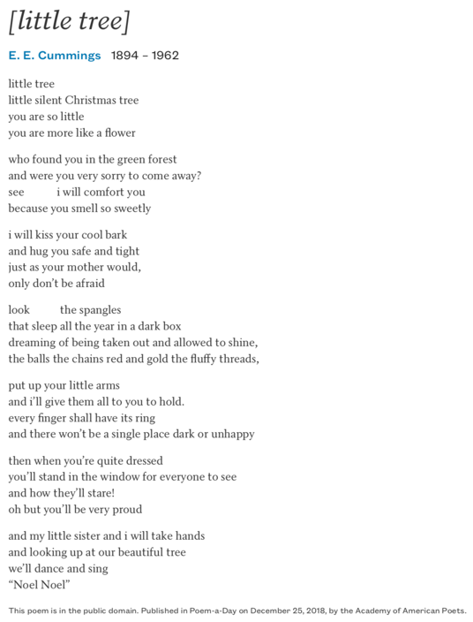  - Read the poem aloud, then quietly.  - What is happening to the little tree in the poem?  - How does the person speaking in the poem try to make the little tree feel better about what is happening?  - How would you feel if you were the Christmas tree?  - What punctuation has been used in the poem?  - What punctuation has been left out?  - What is the effect of having so little punctuation in the poem?  - Can you crack the ‘punctuation code’ to work out the next part of the secret message from the Word Spy? See page 72.
5 | Reading comprehension  Reads and comprehends texts for wide purposes using knowledge of text structures and language, and by monitoring comprehension EN2-RECOM-01  - Locate, select and retrieve relevant information from a print or digital text and consider accuracy of information presented  - Adjust own mental model as reading presents new words and understanding  - Understand that literal information can be sourced directly from a text and that inferences can be made by using multiple sources of information  - Link the meanings of words and phrases across consecutive sentences to support local inferencing  - Clarify and link the meanings of key words across a text to support global inferencing  Oral language and communication  Communicates with familiar audiences for social and learning purposes, by interacting, understanding and presenting EN2-OLC-01  - Contribute to discussions with peers and stay on topic, build on others' ideas and express own ideas  - Plan and deliver spoken presentations using language and structure to suit purpose and audience  - Adjust volume, pace and intonation to enhance meaning when presenting and reciting  - Include multimodal features in planned and delivered presentations, to expand meaning and engage an audience  - Reflect on and monitor own presentations according to given criteria | Fun and games with language  - Divide the class into six literature circles. Allocate one of the chapters to each group:  - Chapter 4: ‘Letters, letters, letters’  - Chapter 5: ‘Is that another Greek word?’  - Chapter 6: ‘Who likes playing games?’  - Chapter 7: ‘Say that again!’  - Chapter 8: ‘Hmm, I wonder what you’re really saying…’  - Chapter 9: ‘Is that a real person?’  - Ask each group to read the allocated chapter – aloud or quietly. Each group talks about what was interesting in that chapter, then prepares a four-slide presentation featuring the title of the chapter and the three most interesting things they learned in that chapter. Add a relevant picture or graphic to each slide. In a 10-minute presentation to the rest of the class, each group should:  - present its slideshow  - lead the class in a fun language activity suggested in the chapter  - share its solution to the decoding puzzle at the end of the chapter.  - More able readers should be encouraged to read all six chapters, not just the one they were allocated in the group work.
6 | Oral language and communication  Communicates with familiar audiences for social and learning purposes, by interacting, understanding and presenting EN2-OLC-01  - Contribute to discussions with peers and stay on topic, build on others' ideas and express own ideas  - Pose and respond to specific questions to clarify or follow up on information  - Listen actively to identify spoken information, acknowledging the value of others’ contributions  - Make notes when listening to spoken texts, asking questions to clarify or follow up on information and seeking assistance if required  - Identify the evidence a speaker provides to support a particular point of view  Reading comprehension  Reads and comprehends texts for wide purposes using knowledge of text structures and language, and by monitoring comprehension EN2-RECOM-01  - Locate, select and retrieve relevant information from a print or digital text and consider accuracy of information presented  - Adjust own mental model as reading presents new words and understanding  - Use key words from a text to visualise events, characters and settings when making inferences and confirming predictions  - Understand that literal information can be sourced directly from a text and that inferences can be made by using multiple sources of information  - Link the meanings of words and phrases across consecutive sentences to support local inferencing  - Clarify and link the meanings of key words across a text to support global inferencing  Creating written texts  Plans, creates and revises written texts for persuasive purposes, using text features, sentence-level grammar, punctuation and word-level language for a target audience EN2-CWT-03  - Create written texts that argue a viewpoint using rhetorical devices to persuade an audience  - Use facts or opinions to reinforce a viewpoint  - Create texts by drawing on personal and others’ experiences, and texts read, viewed and listened to for inspiration and ideas  - Create texts using digital technologies | New (and changing) codes of language  - Ask students to think of the oldest person they know – someone who would be happy to answer a few easy questions. Interview this person about how they communicated with family and friends when they were kids. Share the results of your interview with the class. Here are some suggested questions, but feel free to vary these:  - In what decade were you about my age? (eg 1950s, 1960s, 1970s)  - How did you mostly communicate with family and friends?  - How did you communicate if you were meeting up with friends somewhere?  - How did you communicate with people living in other states or countries?  - Do you think technology has made communication better today? Why, or why not?  Class discussion: How has communication changed over the last 50 years? How has language used to communicate also changed?  - Read the last chapter, ‘Back to the future’. It might be fun to read the whole chapter aloud. Students could volunteer to read sections in turn. Stop to do activities as they occur in the chapter.  - Note that this classic children’s book was published in 2008. Since then there have been further developments in technology of course. Can you think of any new examples of online language not mentioned in the book?  - Label each of these emoticons with its meaning. Try inventing some of your own!  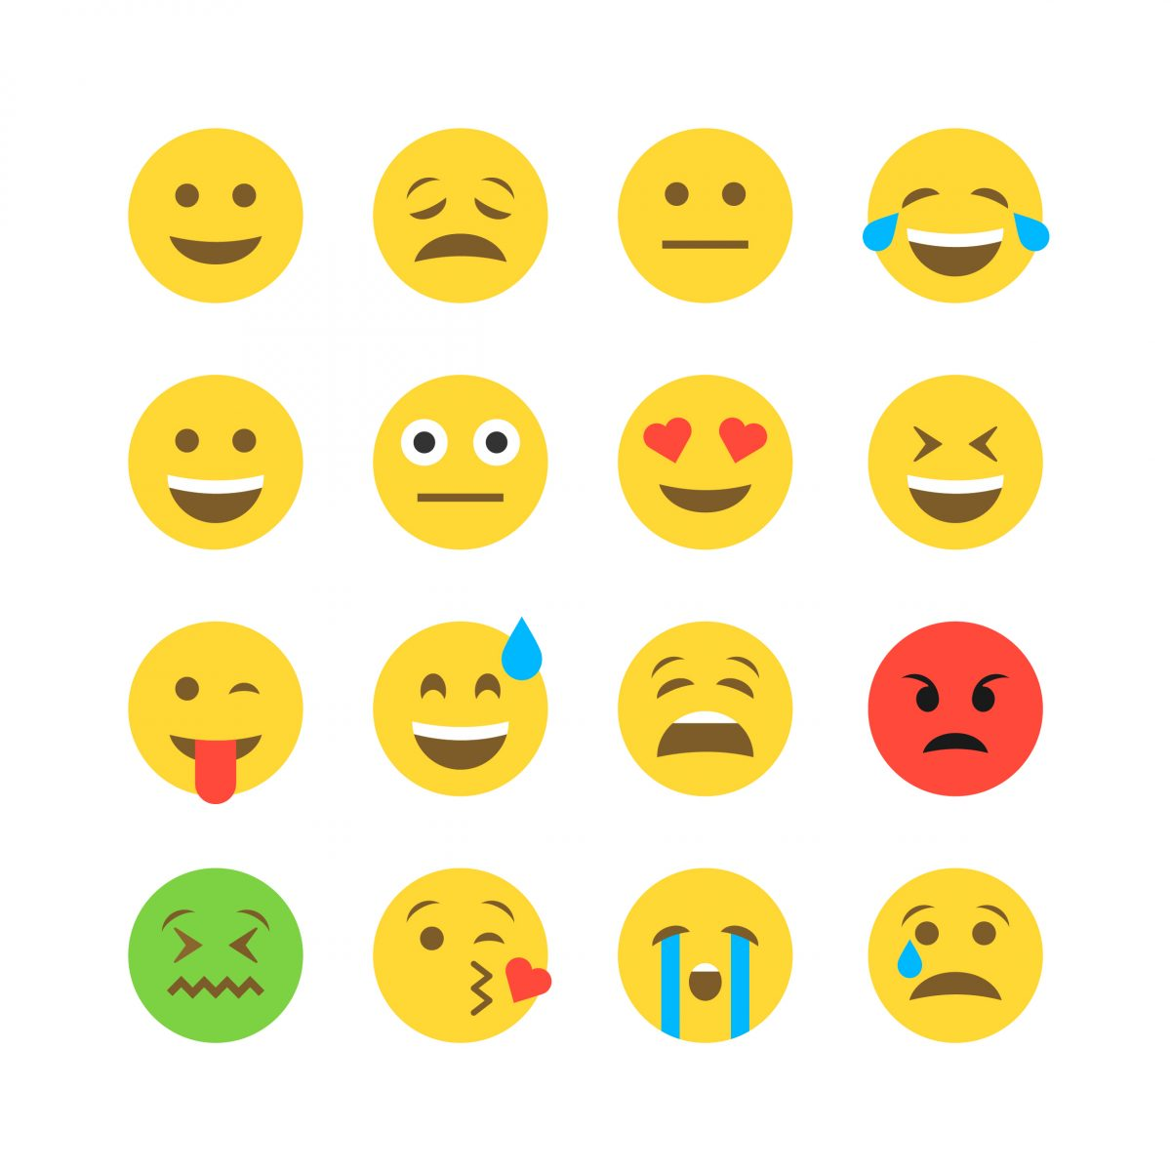  - Create a class blog to express and share opinions about The Word Spy using texting language. At the end of a 24-hour period, review the blog. Could we understand all of the messages? Were there any interesting language inventions along the way? Any interesting insights to The Word Spy?  - Solve the final code – page 232. Now put all the solutions together to work out the Word Spy’s message. Note that all solutions are at the back of the book – but don’t bring this fact to the attention of students!
7 | Understanding and responding to literature  Identifies and describes how ideas are represented in literature and strategically uses similar representations when creating texts EN2-UARL-01  Genre  - Understand that genre refers to texts that are grouped according to purpose, subject matter, form, structure and language choices, and that a type of text can differ in mode and medium  - Identify different text genres when a text is characterised by more than a single genre  Reading comprehension  Reads and comprehends texts for wide purposes using knowledge of text structures and language, and by monitoring comprehension EN2-RECOM-01  - Identify similarities and compare differences within and between texts by making text-to-self, text-to-text and text-to-world connections  - Identify different structures and features of persuasive, informative and imaginative texts  - Identify and describe how text structure, features and language work together to achieve a text’s purpose  - Identify and describe the difference between subjective and objective language in texts  Oral language and communication  Communicates with familiar audiences for social and learning purposes, by interacting, understanding and presenting EN2-OLC-01  - Contribute to discussions with peers and stay on topic, build on others' ideas and express own ideas | Genre as code  - Divide students into literature circles. Provide each group with several age-appropriate texts from the school library on a range of subjects. Half of the books should be information texts and half should be imaginative texts (including, but not only, narratives); some might be well known and others less familiar. Without too much prompting, ask students to separate the books into two types, then ask each group to explain how they divided the texts. Most likely groups will identify the two genres of information texts and imaginative texts, but if not guide them towards this response. Explain that a genre is simply a family of texts, mostly sharing common purpose and features.  - Co-construct a Venn diagram showing the features of information texts and imaginative texts, noting any common features in the intersection of the two circles. Ask students to refer to the texts they used in the activity above to provide examples of the features of each genre. See examples of blank and completed Venn diagrams below.  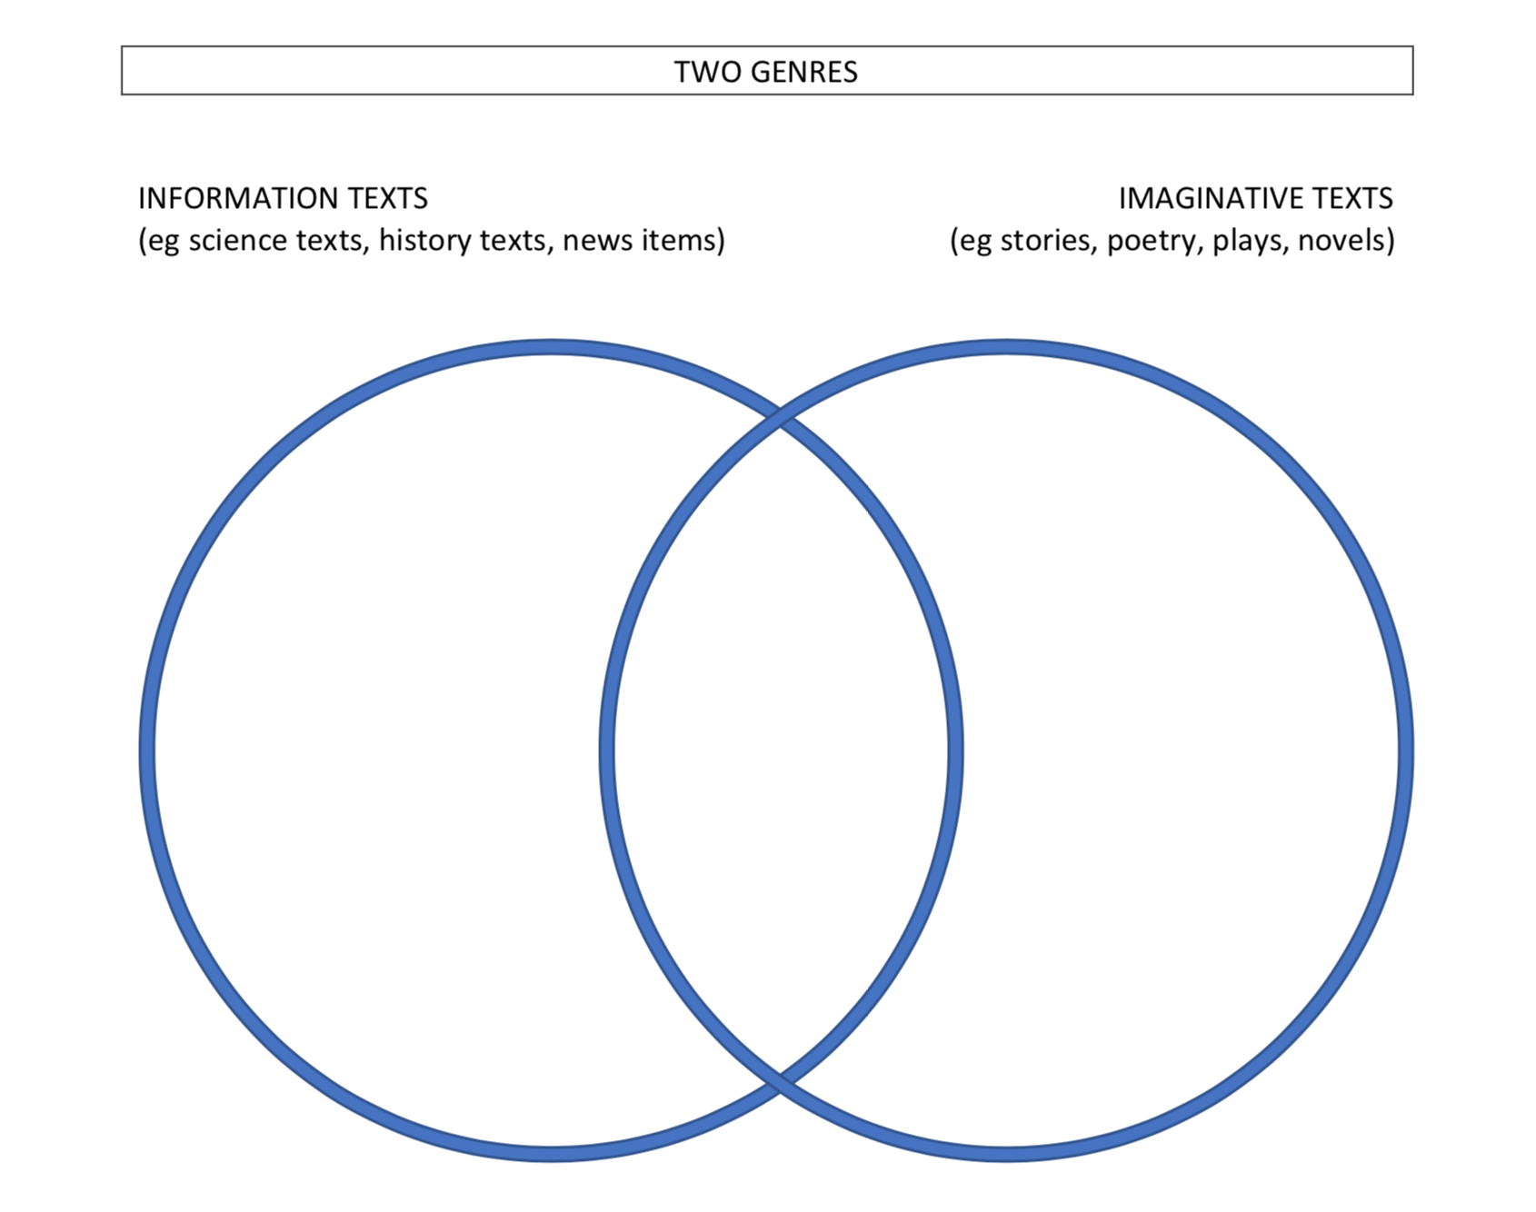  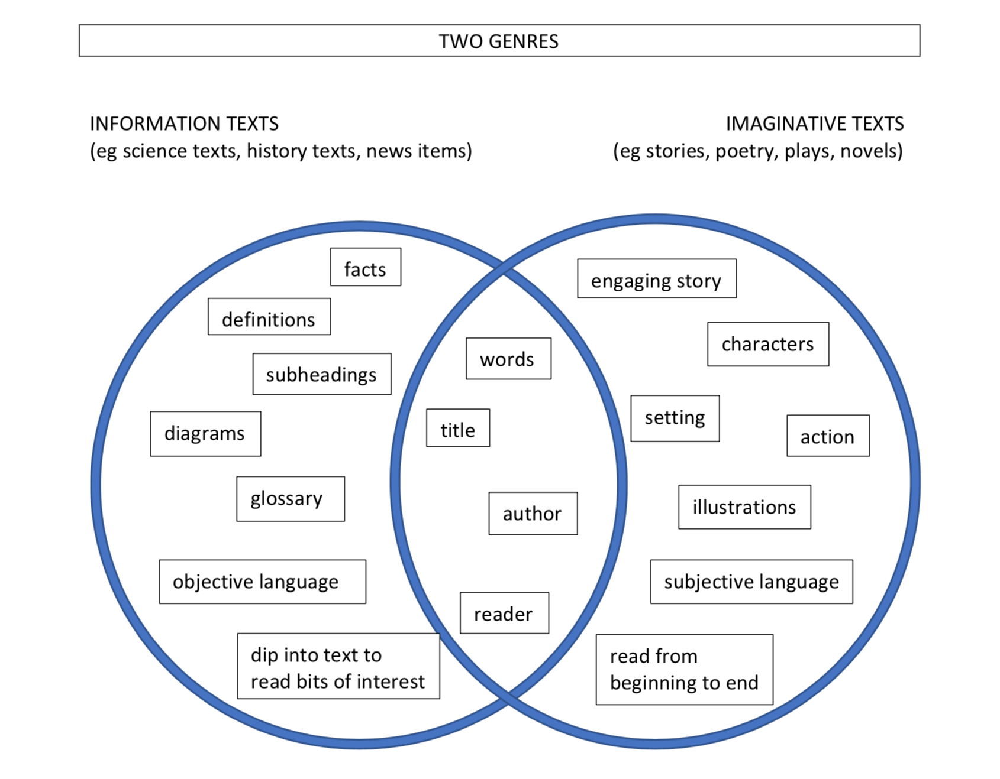  - Talk about two key words used to describe language: ‘objective’ and ‘subjective’. Check their meanings: ‘objective’ refers to language which sticks to the facts, free from any feelings or opinions; ‘subjective’ refers to language which is personal, where feelings and opinions colour the facts, often in an entertaining or imaginative way. Find sentences in the two genres of texts investigated earlier to illustrate the idea of ‘objective’ and ‘subjective’ language, noting that information texts tend to be objective, while imaginative texts like narratives tend to be ‘subjective’. Add these words to the Venn diagram.  - Talk about how The Word Spy fits into this Venn diagram. Note that it is basically an information text, but that it has some of the features of an imaginative text. Introduce the idea of a hybrid text.  - Discuss: In what ways is genre a type of code? Each genre has its own set of typical features. When a composer creates a text in a particular genre, he/she is following the code of that genre. However, some composers, like Ursula Dubosarsky, the author of The Word Spy, might choose to play with the genre code, to have fun with it and not follow it strictly. Why might Ursula Dubosarsky have taken this approach?
8-9 | Reading comprehension  Reads and comprehends texts for wide purposes using knowledge of text structures and language, and by monitoring comprehension EN2-RECOM-01  - Locate, select and retrieve relevant information from a print or digital text and consider accuracy of information presented  - Build topic knowledge, including key vocabulary, and activate background knowledge prior to and during reading  - Use information from paragraphs or chapters to group related ideas and support summarisation of the whole text  Creating written texts  Plans, creates and revises written texts for imaginative purposes, using text features, sentence-level grammar, punctuation and word-level language for a target audience EN2-CWT-01  Plans, creates and revises written texts for informative purposes, using text features, sentence-level grammar, punctuation and word-level language for a target audience EN2-CWT-02  - Create imaginative texts to engage an audience, using first person or third person narrative voice  - Experiment using second person narrative voice for effect  - Create informative written texts that include headings, paragraphs beginning with topic sentences, and may conclude information in a final paragraph  - Maintain noun–pronoun referencing across a text for cohesion  - Use temporal, conditional and causal conjunctions within sentences, and as connectives to link ideas across sentences for cohesion  - Use definite articles for particular things and indefinite articles for general things for cohesion  - Use language to create imagery or humour, including idioms, puns, simile and personification  - Use simple, compound and complex sentences of varying lengths for variation and readability  - Use capital letters to indicate the beginning of a sentence, proper nouns, headings and subheadings, to indicate the beginning of a poetry line, for emphasis, and when using acronyms  - Use commas between words in a list or to separate adjectives when more than one is used  - Use a comma to separate a dependent clause before a main clause  - Use apostrophes for contractions, and to show singular and plural possession  - Plan structures and language to suit the purpose of a text  - Use personal pronouns to suit purpose and to connect personally with the audience  - Use adjectives to develop descriptive features  - Use synonyms to replace words to avoid repetition and engage the reader  - Proofread, revise and edit written texts to refine language, correct spelling and ensure cohesion and engagement for the reader  Oral language and communication  Communicates with familiar audiences for social and learning purposes, by interacting, understanding and presenting EN2-OLC-01  - Plan and deliver spoken presentations using language and structure to suit purpose and audience  - State a reasoned argument in a presentation about learning area content, to a familiar audience  - Reflect on and monitor own presentations according to given criteria | Key assessment task  - Research one of the many famous people mentioned in The Word Spy. Each of these people contributed in some way towards the history of the English language. Here are just twenty of them – there are more!  William Shakespeare (timeline, p46-47) Julia Donaldson (p151-152)  Dr Samuel Johnson (timeline, p33-34) Charles Dickens (p173-174)  Noah Webster (timeline, p13, 36) Richard Sheridan (p207-208)  Benjamin Franklin (p13) Lemony Snicket (p79)  George Bernard Shaw (p14-15, 61, 67) Jane Austen (p213)  Johannes Gutenberg (p30) George Eliot (p213-214)  William Caxton (p30) Henry Handel Richardson (p214)  William Tyndale (p48-49) Jonathon Swift (p78-9)  Lewis Carroll (p61-62, 129, 142) Silvia Wright (p145-146)  Roald Dahl (p152) Reverend Spooner (p200-203)  In your research,  - Find out when and where the person lived  - Find 5 interesting facts about this person’s life  - Find out how the person played a part in the history of the English language  Before you get started with your research, you might want to check what The Word Spy has to say about them! See the page reference after the name of the person you choose.  - Write a three-paragraph information text:  - Write a brief introductory paragraph about when and where the person lived  - Combine the five interesting facts about the person into a second paragraph  - Explain how they played a part in the history of the English language in the third paragraph  - Use the person’s name as the title of the information text  - Add an appropriate photo or diagram.  - Then write an imaginative text: a profile of the person that is more fun and engaging:  - Feel free to express your feelings and opinions, but still include some of the facts from your information text  - Include three paragraphs in your writing – you decide where they begin and end  - Give the profile an engaging title  - Draw an original picture to illustrate your profile.  - Revise and edit the two draft texts:  - Students use a checklist to help them identify areas for improvement, then make improvements as much as possible, particularly focusing on these aspects of writing identified in the Week 1 writing activity:  - Punctuation: capital letters and full stops, commas, apostrophes  - Vocabulary and spelling  - Sentence construction: simple, compound and complex sentences  - Paragraphing  - Textual cohesion: eg noun-pronoun referencing, connectives  - Revising and editing  - Writing for purpose and audience  - Students get feedback through peer assessment, then use this feedback to make further improvements  - With the two texts side by side, explain to the teacher how the two texts compare:  - Note general similarities between the two texts  - Identify significant differences between the two texts  - Explain differences in terms of purpose, text features and their effects  - The teacher could model this process using the author, Ursula Dubosarsky, as the subject of research, drawing on student input where possible.  - Read the ‘bio’ of Ursula Dubosarsky at the front of the book.  - Choose a reliable website to find further information about Ursula Dubosarsky, eg her own website  http://ursuladubosarsky.squarespace.com/longer-biography  - Find the required information and write a draft of the three-paragraph information text, including some errors that will need correcting. Add to text a photo or diagram.  - Next, write the draft of a fun and engaging imaginative text about Ursula Dubosarsky. Create an illustration and add to text.  - Revise and edit both draft texts, making any necessary improvements.  - Compare the two texts, noting similarities and identifying significant differences, explaining differences in terms of purposes, text features and their effects.  - Do a ‘gallery walk’ of students’ writing. Some students might like to present their two texts to the class; others could suggest what they have achieved and what they have learned.
10 | Oral language and communication  Communicates with familiar audiences for social and learning purposes, by interacting, understanding and presenting EN2-OLC-01  - Contribute to discussions with peers and stay on topic, build on others' ideas and express own ideas  Reading comprehension  Reads and comprehends texts for wide purposes using knowledge of text structures and language, and by monitoring comprehension EN2-RECOM-01  - Select and read texts of personal interest and to gather information for learning  - Build topic knowledge, including key vocabulary, and activate background knowledge prior to and during reading  - Identify similarities and compare differences within and between texts by making text-to-self, text-to-text and text-to-world connections  - Locate, select and retrieve relevant information from a print or digital text and consider accuracy of information presented  - Determine the relevance of a text for a specific purpose | Wrap-up  - Discuss the achievement of Ursula Dubosarsky’s book, The Word Spy. Compare with a traditional grammar book - there might be examples of these lurking at the back of the book room! How is it different? Can you explain why The Word Spy is still in print many years after it was first published in 2008? Most books don’t stay in circulation that long!  - In this unit you have read a range of other print texts apart from The Word Spy. Write a review of one text you particularly enjoyed.  - Reflect on what we have learned about the key concepts of Genre and Code and convention in this unit.  - In their literature circles, students read other examples of hybrid texts that combine elements of both information texts and imaginative texts. Some possibilities include:  - Python by Christopher Cheng  - Bilby: Secrets of an Australian marsupial by Edel Wignell  - Big red kangaroo by Claire Saxby  - Emu by Claire Saxby  - Starry messenger: Galileo Galilei by Peter Sis  - The pilot and the little prince: The life of Antoine de Saint-Exupery by Peter Sis  - Mammals who morph: The universe tells our evolution story by Jennifer Morgan  - Dear Mr Blueberry by Simon James  - One small island by Coral Tucker and Alison Lester  - Camp Canberra by Krys Saclier and Cathy Wilcox  Each group shares one such hybrid text with the rest of the class, reading a section, talking about the features of information and imaginative text genres, saying why they liked it.

