Name of unit: Make a Wish
Introduction to unit
Fairy tales help young children make sense of their world. Stretching across the realms of time and cultures; stories and songs entertain, inform, and imbue in young children important life lessons. Many traditional fairy tales are stories about wishes, in which characters reveal and search for their heart’s desire. Sometimes, the greedy, dark side of human nature impacts the way characters behave when they seek to have their wishes granted.
In this unit for Foundation students, we peruse several fairy tales, across a range of genres including multimodal texts, aural storytelling, musical scores, drama, and musical poetry. The common, magical thread is that the stories in the unit “Make a wish” comprise characters who, after some, oftentimes many challenges, have undergone positive life changes, resulting in important life lessons being learned.
It is expected this unit is best suited for implementation Term 3, 4 in the Foundation year, when S. have some alphabetic knowledge and they would benefit from consolidation. Additionally, it is envisaged the integrated English/ music unit would be implemented alongside existing synthetics phonics programs in the school.
Deep knowledge and understanding NSW K-10 (2022)outcomes in blue
Key English concept | Focus question(s) | Curriculum content
character | “Who are the main characters in the text?”  “What are they like? How do you know?” (Based on what they say, think and do in the story) | AC9EFLE02-respond to stories and share feelings and thoughts about events and characters.  ENE-UARL-01
narrative | “Is the story real or imagined? How do you know?”  “What happens in the beginning, middle, and end of the story?”  “What is the story about?” | AC9EFLA07-explore the contribution of images and words to meaning in stories and information texts. ENE-UARL-01  AC9EFLE01-share ideas about stories, poems, and images in literature… ENE-UARL-01  AC9EFLE05-retell and adapt familiar literary texts through play, performance, images, or writing. ENE-UARL-01
code and convention | “What phonemes and graphemes help us to read and write words in the text?”  “What punctuation marks help us to make meaning in the text?”  “How is the text organised?” | AC9EFLA04- understand conventions of print and screen, including how books and digital texts are usually organised. ENE-PRINR-01  AC9EFLA09-Identify punctuation as a feature of written texts different from letters… EN1-CWT-01

Other significant learning
Other knowledge, understanding and skills, attitudes and values | Curriculum content
-Identifying and producing rhyme and rhythm in texts.  Alliteration, syllables.  -Read and write unknown words by using phonic decoding and knowledge of high frequency words, identifying initial, end and medial phonemes in words.  -Retelling and sequencing events in stories, predicting what might happen next; using picture cues to retell stories.  -Understand that words are made up of meaningful parts.  -Exploring how voice can communicate emotions  -Singing songs that help teach content or concepts  -Exploring how illustrations/ images in texts help to convey narrative and character/ setting/ mood.  -Playing games to develop subject- specific practices such as pitch, beat, and or rhythm recognition. | AC9EFLE04-explore and replicate the rhythms and sound patterns of literary texts e.g., poems, rhymes, and songs; MUES1.1  AC9EFLY09-rhyme, alliteration, syllables.  AC9EFLY04-Read texts using developing phonic knowledge, monitor meaning using context and emerging grammatical knowledge; ENE-REFLU-01, ENE-PHOKW-01, ENE-RECOM-01  AC9EFLY10-encoding and decoding words; AC9EFLY12-read and write C-V-C words; AC9EFLY13- use phonic knowledge to spell words. ENE-PHOKW-01  AC9EFLY05-use comprehension strategies … to understand and discuss texts listened to, viewed, or read independently. ENE-RECOM-01  AC9EFLY15-understand words are comprised of units of meaning ENE-SPELL-01  AC9AMUFE01-explore how and why the arts are important for people and communities  AC9AMUFD01-play games to develop subject specific practices such as pitch, beat and or rhythm activities  AC9AMUFC01-extending and varying known songs, chants, or rhymes  AC9AMUFP01-performing songs, chants/ raps. Sharing their work with peers. MUES1.1

Assessment
English:
Pre-test tasks: vocabulary task, oral reading. See appendix 1. Writing task.
Formative assessment tasks: interspersed throughout the unit e.g., sequence 6: (assesses narrative); sequence 7: (code and convention); sequence 8: (decoding) and sequence 9: (morphemic knowledge).
-Vocabulary: assess students’ knowledge of high frequency words in main text
-C-V-C blending, decoding, and encoding phonemes and graphemes to form words
-Reading: students read an excerpt from main text, Mackinlay & Karmazina (2021) Ribbit, Rabbit, Robot.
-Post-test tasks, writing: Draw a picture and write a story about a fictional character that makes a wish. Illustrate story showing main attributes of character. Read story to class.
Music (formative assessment tasks):
Sequence 2: Demonstrate beat, rhythm of “Star Light, Star Bright”.
Sequence 2, 3, 4, 10: Join in modelling Solfège signs, showing auditory discrimination between high and low notes (pitch) in simple songs.
Sequence 10: S. create artwork in response to symphonic text e.g., drawing, story, movement sequence, simple percussion response.

Assessment task that addresses the key concept
Curriculum content | Outline of task | Criteria for assessment
AC9EFLE02-respond to stories and share feelings and thoughts about their events and characters.  AC9EFLE05-retell and adapt familiar literary texts through play, performance, images, or writing.  AC9EFLA09-Identify punctuation as a feature of written texts different from letters… | - Vocabulary test  - Oral reading assessment.  - Students create a fictional character.  - Draw them.  - Describe the character and tell what they wished for.  - Tell/ write a simple narrative about the character you have created including a beginning, middle and end. | Writing rubric:  -Evidence of punctuation. (0,1)  -Full stops, capital letter to begin sentences. (0,1,2)  -Evidence of imagined story in text and/or illustration. (0,1,2)  -Share feelings about the character. (0,1) Total: /6.

Resources
Mackinlay, S. & Karmazina, S. (2020). Ribbit, Rabbit, Robot. Omnibus Books.
T-Series Kids Hut. Aladdin and the Magic Lamp. YouTube. https://youtu.be/u7ZHUii5b50
Waterford Institute. This little pig e-book. 75.pdf (waterford.org)

Unit overview
“Make a wish” provides many opportunities for students to practise their emerging alphabetic knowledge and skills, as well as focusing on meaning across multiple texts/ types of texts. S. will investigate the English concepts of character, narrative and code and convention throughout the unit.
The main text is about three colourful characters, a frog, a rabbit, and a robot, who are friends. They find an old lamp in an antique shop and a genie appears, an intertextual link to the famous fairy tale, Aladdin. The characters each wish for their heart’s desire, and instead of choosing to cooperate with each other, (human) greed intercedes, and an engaging narrative ensues.
Abbreviations in unit: T.=teacher, S.= students, IWB= interactive whiteboard, LI=learning intention, KQ= key discussion questions.

Unit title
Make a wish

Body of unit

Time / learning sequences | Curriculum content | Teaching, learning and assessment | Adjustments and extensions
Pre-test  5-10 minutes per child. | AC9EFLA08  ENE-VOCAB-01  AC9EFLA06  ENE-REFLU-01 | -Pre-test vocabulary, high-frequency words from text.  -Pre-test oral reading passage from text (appendix 1)  -Map S. oral reading NLLPV3 PKWp25, FlY p28. | T. assesses S. 1-1. Choose a time S. are engaged in independent group activities.
1:  2 lessons  1 lesson the story of Aladdin’s Lamp.  1 lesson modelled, guided independent writing about story (pre-test writing task). | AC9EFLE01  ENE-OLC-01  AC9EFLE02  ENE-UARL-01  AC9EFLE05  ENE-OLC-01  AC9EFLY02  ENE-VOCAB-01  AC9EFLA07  ENE-UARL-01  AC9EFLA08  ENE-CWT-01  AC9AMUFP01 | LI: Retell story of Aladdin in words/ pictures.  -Talk about the role of fairy tales and how they convey a message/ lesson.  -Ask children if they have any favourite fairy tales. “Why do they like that fairy tale?”  -Tell the story of Aladdin’s Lamp to the class or view from YouTube. -Discuss, “What did Aladdin wish for? What did his uncle wish for?” -Identify the beginning/ middle/ end of story.  Pre-test writing task: -Orally retell story of Aladdin. Discuss story.  -T. models a short, written text, retelling Aladdin, on IWB.  -T. discusses, writes a list of vocab. from text on IWB, as an authoritative source for S. writing.  -Read text together.  -Guide S. in writing a short text together.  -S. independently draw/ write/ read/ share their texts about Aladdin. | -Aladdin is a traditional tale. Choose an oral retelling, book or multimodal text version that suits you/ your students.  -T-Series Kids Hut. Aladdin and the Magic Lamp. Youtube. https://youtu.be/u7ZHUii5b50  -Extension/ additional activity: 3 Little Pigs digital text  -S. who are not yet writing independently may require 1-1 scaffolding. They may draw and talk about their drawing or compose a combination of pictures and letters/ words.  -S. stories may be a combination of drawing and writing (Mackenzie & Scull, 2018).  -S. drawing can be an important symbolic meaning making process (Klein, 2018).  -Map S. individual writing progress using NLLP CrTp41.
2:  1 lesson plus lots of repeated reading/ singing/ performing “Star Light, Star Bright” to build fluency.  Lots of practice performing Solfège hand signs from low to high (like a ladder) during lesson breaks etc. | AC9EFLE04  Using music and actions to enhance appreciation of chants and songs.  MUES1.4  AC9AMUFD01  -Exploring singing voices  -Improvise rhythmic patterns  -Extend and varying known songs e.g., using hand signs MUES1.4  -Play games to develop subject specific practices e.g., pitch.  MUES1.1 | LI: Tell the difference between beat and rhythm in a song.  -Teach the song, “Star Light, Star Bright”. Teach the words, identify the beat, rhythm of song.  -Show S. the Solfège hand signs. Practise together. Sing song in solfège.  -Explain there are only two notes in Star Light, one high (Sol) and one low (mi)  -Teach S. the Solfège hand signs, time names of song.  -Play “Make a wish” circle game.  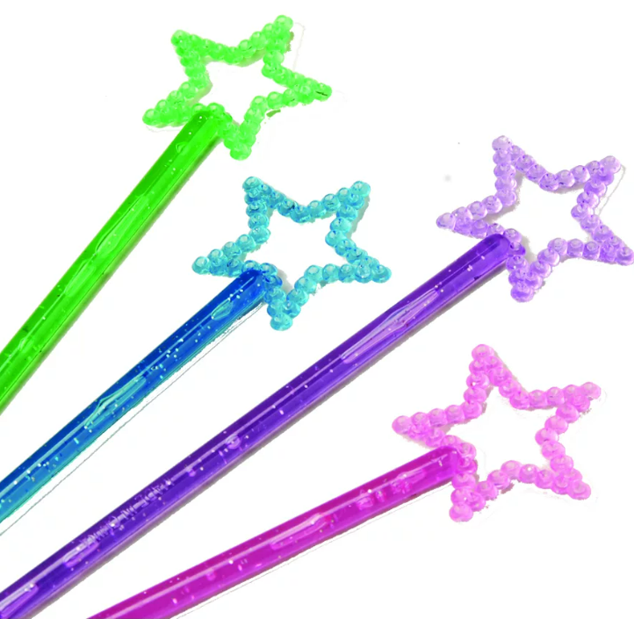  -T. observe which S. can identify the beat/ join in with rhythm/ play game.  -When S. are confident, introduce instruments as in arrangement appendix 2. Practise, perform musical score together. | Appendix 2 “Star Light Star Bright”. Identify high and low sounds in song. Model how Solfège hand signs go from low (Do) to high (Do), like climbing a ladder.  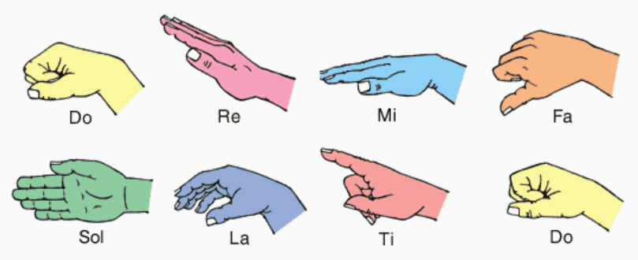  Solfege hand signs video  (one or two hands for signing- both ways are fine).  Make a wish circle game:  -Pass a magic wand around circle to the beat, as children sing. S. holding star at end of song, makes a wish. Repeat song until every child has made a wish.  -Only S. who can identify the rhythm will be ready to play simple percussion.  Taa taa taa taa taa ti-ti ti-ti taa  Solfege Ladder to display in classroom
3:  1 lesson | AC9AMUFE01  -Sing songs that help teach content eg. pitch, beat, rhythm -Improvise rhythmic patterns, inventing movements for familiar action songs.  AC9EFLE02  -Discuss events and characters in texts, connecting them to their own experience.  -Use drawing/ writing to express responses to stories.  ENE-UARL-01  AC9AMUFP01-Sharing work with class.  MUES1.2 | -Start with a song, revise Solfège signs and “Star Light Star Bright”.  -Learn “Teddy Bear” together. T. performs Teddy Bear at the front of the room with a real teddy.  LI: Describe characters in a story in words and/ or pictures.  -Introduce text, Ribbit Rabbit Robot. Look at cover, identify three characters. Describe them. Discuss.  K.Q. “Is the text real or imagined?”  -S. orally identify what else they see on the cover. T. records S. responses on vocabulary chart on IWB.  -Read back cover together. -Unpack new vocabulary e.g. enchanted, genie, meanie; short fuse (figurative language); discover (syllabify).  -S. writing. Draw one of the characters and write something about them. Share writing with class. | -Sing song whilst performing Solfège signs (Sol, mi) to music.  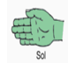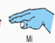  -Appendix 3 “Teddy Bear”.  -S. perform the actions of Teddy Bear in a free space. Originally a skipping chant, for when children have the fine motor skills to try it.  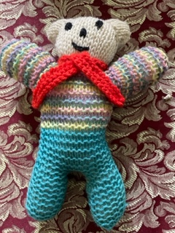  -T. makes one scanned copy of text for class use on IWB.  -Morphology: en + chant + ed; friend + ly, friend/ship  Wish + es  -Genie: soft g sound (magic)  Rhymes with meanie  -Decoding grant, found.  -Revise hf words on back cover e.g. is, and, I, am, all, your etc. Make a list of hf words from text cover to drill next lesson on IWB.
4:  1 lesson | AC9EFLA07 Explore the contribution of images and words to meaning in stories and informative texts.  ENE-UARL-01  AC9AMUFC01  -Extending and vary known songs, adding movement/ actions.  MUES1.2  AC9EFLA08 recognise/ develop awareness of vocabulary  ENE-VOCAB-01 | -Begin with hf word drill from previous lesson, appendix 4.  -Revise vocab list from prior lesson.  -LI: Learning about the text through the illustrations.  -Talk about what’s happening on each page.  -Point out intertextual links between Ribbit Rabbit Robot and Aladdin.  -Add any interesting words from text to class vocab chart.  -Discuss S. favourite illustrations in text and why.  -Choose an illustration that tells an interesting story.  -T. models a sentence about illustration, using vocabulary from text.  -T. guides S. in writing a sentence about illustration  -S. draw/ write independently about their favourite illustration from text.  -Gallery walk to share pictures and stories with each other. Display in classroom. | -Sing the song dum dum diddle. Repeat song using hf words inserting/ drilling HF words in melody, from previous lesson.  Solfege hand signs for song:  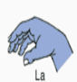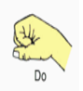  -Appendix 4  -Show scanned version of text on IWB.  -Range of writing implements required.  -Support reluctant writers in drawing/ annotating their character artworks.
5:  2 lessons  1 lesson text reading, discussion of characters.  1 lesson visual arts activity to decorate character outlines in small groups. | AC9EFLE02  -Discuss events and characters in texts and connecting them to their own experiences.  ENE-UARL-01  AC9AMUFD01  -Imagining how characters in a story might dress, move and making images to about characters.  MUES1.4 | LI: Describing characters through how they look, what they say and what they do.  -T. reads text to group with prosody.  -Class discuss what we learn/ know about the characters from text. KQ: “What did they do? Why did they do that? What words tell us about them? What actions make us think this?”  -Make a robot, frog and rabbit using paper skills in small groups, to label and display in classroom.  -S. reflect on text and share their feelings about the book with the class. KQ: “How does the book make you feel? What do you think about each character? Why do you say that?” | -Sofya Karmazina website has simple pencil sketches of text illustrations for T. to copy for character outlines. -Additionally, the website contains beautiful blown-up versions of illustrations from text, to facilitate minute observation and class discussion.  -Alternately, class may choose to make a robot out of boxes (or a child may like to bring a robot toy from home). Label soft toys to help S. learn vocabulary, as a tactile retrieval device.
6:  1 lesson | AC9AMUFE01  -Using dramatic play to explore ideas or understandings.  AC9EFLE04  -Use music and actions to enhance appreciation of rhymes, chants, and songs.  -Identify features of fairy tales.  ENE-UARL-01  AC9EFLE05  -Retell familiar literary texts through images or writing.  ENE-OLC-01 | LI: Identify beginning, middle, end of narrative.  -T. orally retells the story of Goldilocks and the Three Bears, with S. input. (Appendix 5).  -Teach S. the words of song.  -Recite and perform song with actions devised by S.  -T. models, re-reads main text to students with prosody. -Encourage S. to revise and elaborate on main events in text.  -Through discussion identify main aspects of narrative. KQ: “How did the story begin? What happens next? What is happening in this picture? How does the story end? What did you think about the story? How did the characters make you feel?”  -Discuss the story map on the inside cover of text. KQ: What does the picture tell us about the text?”  -T. models drawing and annotating a story map from text on IWB (including events from beginning, middle, end).  -T. provides a scaffold on which S. complete 3 boxes to show beginning, middle and end of story.  -S. reflect on/ share story maps with class. | -Song, “When Goldilocks went to the House of the Bears”.  -Appendix 5.  -Repeated reading of text to aid fluency development. -Students practise reading text to peers/ in small groups.  -Guided reading activities from text to familiarise students with text.  -T. provides feedback on S. reading.  Story map scaffold -Appendix 6.  -Some S. will orally provide feedback on their drawing. They may need encouragement/ support to write.  -Encourage students to use vocabulary word banks and labelled artworks/ toys on display in classroom, when drawing/ writing.
7:  2 lessons  1 lesson punctuation in text.  1 lesson introducing musical notation and playing consolidation games (memory, snap). | AC9AMUFC01  -perform chants/ raps using music skills they have learnt and practised e.g. staying in time, performing with a group and following an agreed plan.  AC9EFLA09  -identify punctuation as a feature of written text different to letters.  ENE-PRINT-01, ENE-CWT-01  AC9AMUFE01  -exploring simple musical notation. MUES1.2 | LI: Identify punctuation in text, “Ribbit, Rabbit, Robot” and understand how it informs the reader.  -T. revises punctuation in text using flash cards.  -Learn to dance “The punctuation rap”.  -Encourage S. to use correct terminology for punctuation including capital letters, full stops, commas, speech (talking) marks, question marks, exclamation marks.  -T. re-reads text to class, pointing to each word as they read. Encourage S. to join in. When they come to a punctuation mark, S. perform the matching actions from “punctuation rap”.  -T. models punctuation in text, guides S. in acting out punctuation in text, as they read text together.  -S. independently act out punctuation whilst joining in and reading text.  -T. shows musical notation chart and explains musical symbols to S.  -S. play memory, snap in small groups to reinforce musical metalanguage. | -Teach S. the punctuation rap.  -Punctuation flash cards (copied on A4 card)  -Appendix 7.  -Appendix 8: Punctuation Rap.  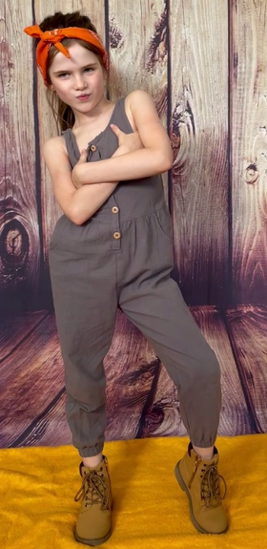  Appendix 8a: Musical notation chart  Appendix 8b: Memory cards master for T. to copy, laminate.
8:  1 lesson with ongoing revision | AC9AMUF01  -sing songs to develop pitch, beat, rhythm recognition  MUES1.1  AC9EFLA09  -identify punctuation as a feature of written text.  ENE-CWT-01  AC9EFLY05  -attempt to work out unknown words by using phonic decoding.  ENE-PHOKW-01  AC9EFLY09  -recognise and generate rhyming words, syllables, and sounds in spoken words.  ENE-PHOAW-01 | -Learn the action song, “Da Gloonk”. S. make up actions to match song. Identify beat and rhythm. Add untuned percussion when S. are familiar with song.  LI: Make new words from words in text.  -S. read text inside speech marks, with expression/ loud/ soft voices. Encourage S. to read punctuation, including question marks, commas. T. reads linking text between direct speech with prosody.  -Class practise performing text together.  -T. models how to blend words e.g. /f/ /r/ /o/ /g/. (Beck & Beck, 2013)p73.  -S. word building activities in small groups. S. use letter tiles to make words from text (e.g. wish, row, rev, beep.)  -S. record and share new words they have created. | -Multimodal text, “Da Gloonk”.  Word building from text: -Using letter tiles, in pairs, S. make the word frog.  -Stretch the letters. Identify the phonemes in frog (4) -Blend phonemes together, decoding written word into speech sounds.  -In pairs, S. make new words from the word frog, by changing the beginning, medial and end phonemes.  -S. record new words formed on mini whiteboards.  -From student word lists, class identify the words that rhyme with frog, together.  -Discriminate between the real and pseudo (nonsense) words in S. word lists.
9:  1 lesson with ongoing revision | AC9EFLY15  -Recognise that words are units of meaning and can be made of more than one meaningful part.  ENE-SPELL-01 | LI: Break words into smaller parts (morphemes). Break words from text into syllables.  -T. models syllabification of multisyllabic words from text on IWB.  -S. identify syllables in spoken words, clapping the rhythm e.g. riveting, wishes, Ribbit, granted, meanie, discovered.  -S. identify the number of syllables in words in syllable guessing game (e.g., How many syllables in…) | -Syllabification: rivet/s, riv/et/ing, wish/es, Rib/bit, grant/ed, mean/ie  -Identify morphemes: s, ing, es, ed. We find these bound morphemes at the end of words. They are added to base words and change their job in a sentence. e.g.  -rivet is the name of a small bolt, but rivet/ing is a describing word (adjective) meaning very interesting.  -wish is one wish but wish/es means more than one wish etc.
10:  2 lessons  1 lesson- 2 songs focusing on pitch  1-2 lessons  “The Sorcerer’s Apprentice” (Dukas, 1897) | AC9AMUF01, AC9AMUFC01  -use dramatic play to tell about characters and events.  -creating works in response to sources such as classical music.  MUES1.4 | -Revise beat, pitch, and rhythm.  -Learn the words and Solfege hand signs for I can sing up high and see saw.  -S. enjoy performing songs together.  LI: Hear, discuss, and create artworks in response to texts with music only, a different type of text/ genre.  -T. orally retells the story of the Sorcerer’s apprentice, a symphonic poem written by French composer Paul Dukas in 1897.  -Listen to music together.  -S. create body percussion / actions for each section of story. -S. draw/ write about their favourite section of text. | Appendix 9: I can sing up high (one streamer for each child)  Appendix 10: See Saw partner game.  Appendix 11: Summary of The Sorcerer’s apprentice by Paul Dukas (1897).  Music: Sorcerer’s Apprentice: Spotify, (85) The Sorcerer's Apprentice - Leopold Stokowski & The Philadelphia Orchestra - YouTube  Movie: Fantasia (Disney, 1940) 10 minute excerpts YouTube "The Sorcerer's Apprentice" Paul Dukas - Fantasia (1940) Soundtrack - Bing video. Full movie available Amazon, Disney Plus streaming service.
Post-test  5-10 minutes per child  vocab, oral reading sample from text.  Writing sample untimed. | AC9EFLA08  ENE-VOCAB-01  AC9EFLA06  ENE-REFLU-01  VAS1.4 | -Post-test vocabulary, hfw, oral reading from text.  (Appendix 1)  -Post-test writing task: Draw a picture and write a story about a fictional character that makes a wish. Illustrate story showing main attributes of character. S. read story to class.  -Map S. oral reading NLLPV3 PKWp25, FlY p28.  -T. complete appendix 12, reflection and evaluation. | T. assesses S. 1-1. Choose a time S. are engaged in independent group activities.  -Appendix 1.  -Post-test task writing: Draw a picture and write a story about a fictional character that makes a wish. Illustrate story showing main attributes of character. Read story to class.  -T. map S. growth on NLLP PKW, FIY throughout unit.  -Appendix 12: T. reflection and evaluation.

References:
Beck, I., & Beck, M. (2013). Making sense of phonics (2nd ed.): Guilford Press.

