Name of unit: Sing, play, learn
Introduction to unit
This integrated English and music unit targets Foundation students early in their first formal year of education, whilst they are learning and consolidating their alphabetic knowledge. It is anticipated the unit will be taught alongside the school synthetics phonics program, each mutually reinforcing the other. As students learn the alphabetic code, at the same time they are learning about key English and music concepts through quality literature and music.
Sing, play, learn is an integrated English unit that includes content descriptors from Australian Curriculum: English 9.0 Foundation, and the Arts- Music V9 Foundation. Children have learned through singing and play throughout human history as evidenced by archaeological and cross-cultural records.
The social and academic skills that music and play brings to children’s learning is well documented (Sandberg & Heden, 2013). Music and play are highly engaging activities in the early reading classroom.

Deep knowledge and understanding NSW outcomes in blue
Key concept | Focus question(S) | Curriculum content
Perspective | “What do you think about the main text, Sing me the summer?” “Why?”  “Why do you think the composer/s chose this title?”  What do the characters do in summer, autumn, winter, and spring?  How is the story the same/ different from your life?  What is your favourite season? Why? | AC9EFLA01- Ask relevant questions and expressing requests and opinions in ways that suit the contexts. ENE-OLC-01  AC9EFLA02- Recognise how feelings and preferences may be communicated in speech and gestures. Respond to stories and share feelings and thoughts about events and characters. ENE-UARL-01  AC9EFLA03- Understand that many first Nations’ stories are oral narrations and cultural accounts and may be represented as or with images.  AC9EFLE01- Share ideas about stories, songs, rhymes, and poems. ENE-UARL-01  AC9EFLE02- Respond to stories and share feelings and thoughts about events and characters. ENE-UARL-01  AC9EFLE04- Explore and replicate the rhythms and sound patterns of literary texts such as poems, rhymes and songs. ENE-PHOAW-01  AC9EFLY05- Use comprehension strategies such as visualising, predicting, connecting, summarising and questioning to understand and discuss text listened to, viewed or read independently. ENE-UARL-01

Other significant learning
Other knowledge, understanding and skills, attitudes, and values | Curriculum content
-Navigate a text correctly l-r.  -Attempt to work out unknown words by using phonic decoding and knowledge of h-f words.  -Shared editing of texts.  -Modelled, guided and independent writing.  -Identify phonemes in words.  -Recognise phonemes, syllables in spoken words.  -Manipulate phonemes in spoken words.  -Play circle games and sing songs to learn key musical concepts. | AC9EFLY04 Read decodables and authentic texts using developing phonics knowledge and monitor meaning using context and emerging grammatical knowledge. ENE-REFLU-01  AC9EFLY06 Create/ participate in shared editing of short written texts…using learnt vocabulary, basic letter boundary punctuation and spelling some C-V-C words correctly. ENE-CWT-01  AC9EFLA03- Understand that many first Nations’ stories are oral narrations and cultural accounts and may be represented as or with images.  AC9EFLA08 Recognise and develop awareness of vocabulary … ENE-VOCAB-01 AC9EFLY09 Recognise phonemes, syllables in spoken words. Share ideas about, poems and images in literature. ENE-PHOKNW-01, ENE-UARL-01 AC9EFLY13 Use knowledge of letters and sounds to spell words. ENE-PHOKW-01 AC9AMUFD01 Play games to develop pitch, beat, rhythm, dynamics, tempo. MUES1.1

Assessment
English:
Pre-test tasks: Pre-test tasks: vocabulary task, oral reading. See appendix 1. Writing task.
Pre-test writing task: S. draw/ write/ share their opinion about a favourite text.
Post-test writing task: S. draw/ write/ share their opinion about a text addressed throughout the unit.
Formative assessment (lesson 4): Rhyming words circle game.

Music:
S. identify beat (heartbeat/ pulse) of songs
S. identify rhythm (repetitive pattern) of songs
S. identify high/ low notes (pitch), loud/ soft (dynamics), fast and slow (tempo) in a melody verbally, using movement and through using hand signs
Distinguish between singing and speaking voice during games and rhymes
Clap to a steady beat, play steady beat on Orff instruments and body percussion
Joins into action games/ songs
Attentive listening evidenced through Q&A, call and response, and echo songs
Individual singing/ pitching
Identify and describe tone colour (timbre) of various noises and in instrumental music.
(recorded ongoing assessment checklist appendix 9)

Assessment task that addresses the key concept
Curriculum content | Outline of task | Criteria for assessment
Perspective  Beat, rhythm, pitch | -S. express opinions about main ideas in texts verbally, through drawing and writing.  -S. articulate how different peers’ opinions vary across texts and character throughout unit.  -Games and musical songs that target beat, rhythm, and pitch development.  -Echo songs where S. respond individually. | -S. can identify how children are learning through play in texts throughout unit.  -S. can compare opinions of text or character with peers.  -S. join into games and musical songs throughout unit.  -S. respond with appropriate beat, rhythm, pitch during echo songs.

Resources
Godwin, J. & Lester, A. (2020). Sing me the summer. Affirm Press.
Minchin, T. & Antony, S. (2020). When I grow up. Scholastic Australia.
Martin, H., Simpson, J. & Orsini, C. (2019). The ABC kids book of feelings. ABC Books.
Ngaginybe Jarragbe. (2020). Shirley Purdie. My story. Magabala Books.

Unit overview
Sing, play, learn is a Foundation unit designed to address S. learning needs early in the first year of formal education, building a love of learning through singing and play, supporting their alphabetic knowledge acquisition, in addition to English and music concepts.

In English the key concept is perspective. Throughout the unit, we encourage S. to view texts through the lens of their own opinions and those of their peers. S. may have different opinions to their peers, and they need to be able to discuss these differences as perspective shapes what we see in texts and the way we see it. Perspective is the lens through which we see the world and influences how we understand texts.

We focus on the elements of music including rhythm, duration, pitch, dynamics, and expression, taught through games and songs that engage, build a love of music and learning and at the same time, assist students in their language and literacy learning through quality literature.
Abbreviations in unit: T.=teacher, S.= students, IWB= interactive whiteboard, LI=learning intention, KQ= key class discussion questions, h-f=high frequency words, C-V-C= consonant/ vowel/consonant words, PA= phonemic awareness.

Unit title
Sing, play, learn

Body of unit

Period of time | Curriculum content | Teaching, learning and assessment | Adjustments and extensions
Pre-test  5-10 minutes per child. | AC9EFLA08  ENE-OLC-01  AC9EFLA06  ENE-REFLU-01 | LI Collect student pre-test data  -Pre-test vocabulary, high-frequency words from text.  -Pre-test oral reading passage from text (appendix 1)  -Map S. oral reading NLLPV3 PKWp25, FlY p28. | T. assesses S. 1-1. Choose a time S. are engaged in independent group activities.  Individual assessment tasks.
Lesson 1 | AC9AMUFD01  -Play games to develop pitch, beat, rhythm.  -Explore speaking and singing voices.  -Invent new movements for songs.  MUES1.1, 1.2, 1.3  AC9EFLY09 Recognise phonemes, syllables in spoken words.  ENE-PHOAW-01  AC9EFLY10 Manipulate phonemes in single syllable words.  ENE-PHOKW-01 | LI Identify phonemes in words  -T. introduces unit by talking about how, for thousands of years, across the world, children have played singing games for enjoyment, and at the same time, to help them to learn.  Morning circle songs:  - S. sing songs in morning circle to revise initial phonemes in S. names, as greetings and to help them learn each other’s names, and to build a positive class climate, make S. feel special.  -T. models song, “Hey Good morning”. S. devise actions to match song (appendix 2).  -T. teaches the songs, “Oh, what do you think my name is” and “Good morning song”.  -After each child says their name, the singing stops and the class aurally identifies the initial sound in each child’s name. e.g., KQ: “What sound can you hear at the beginning of -------‘s name? Let’s clap it. How many parts or syllables?”  -T. models word building on IWB.  -S. orally complete word building activity manipulating the beginning, final and medial phonemes in C-V-C words.  -In pairs, S. play with little whiteboards and magnetic letters to form C-V-C words. Practise changing initial, final, and medial phonemes.  -S. write words on little whiteboards, then read the words they created with the class. | Songs: (appendix 2)  - “Hey Good Morning”  - “Oh, what do you think my name is?”  - “Good morning song”  -T. sings a simple rhythm pattern whilst greeting S. who in turn returns the greeting using same rhythm pattern. E.g.,  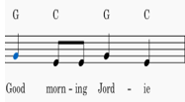  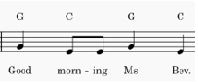  -When S. can aurally identify initial sounds in words (S. names), they can them begin manipulating sounds using letter tiles and recording words on mini whiteboards, moving from PA to phonics.  -Some S. will require lots or aural practice prior to being able to identify/ manipulate sounds in words.  Change beginning phoneme e.g.,  s/i/t  p/i/t  l/i/t  Change final phoneme e.g.,  s/i/p  s/i/m  s/i/ck  Change medial phoneme e.g.,  s/i/p  s/a/p  s/u/p
Lesson 2 | AC9AMUFD01 Play games to develop subject specific practices such as pitch, beat and rhythm recognition.  MUES1.1  AC9EFLA07 Explore the contribution of images and words to meaning in stories and informative texts. ENE-UARL-01  AC9EFLE01 Share ideas about, poems and images in literature.  - Identify features of culture related to characters and events.  ENE-UARL-01  AC9EFLA07 Explore the contribution of images and words to meaning in stories and informative texts. ENE-UARL-01  AC9EFLA05 Recognise sentences are key units for expressing ideas. ENE-CWT-01  VAES1.1 | LI Orientation to text  -Introduce song/ text with a toy from the ocean to engage S. and set the scene for game and text e.g., sea creatures set.  -Teach the words of “Charlie over the ocean”, line by line (appendix 3), as an echo song. Play the circle game with S.  LI: Learning about the text through the illustrations.  -Discuss the front and back cover. Unpack the orthography of title. What do you think this text is about? Why? What is happening on the cover? What are the children doing? What does “seasons” mean?  -Talk about what’s happening on each page, using scanned version of text as a basis for discussion.  -KQ:  -Discuss S. favourite illustrations in text and why.  -Choose an illustration that tells an interesting story. -T. models a sentence about a particular illustration, using vocabulary from text.  -T. guides S. in writing a sentence about illustration.  -S. draw/ write independently about their favourite illustration from text.  -Gallery walk to share pictures and stories with each other.  -T. and or S. caption artworks.  -Display artworks in classroom. | 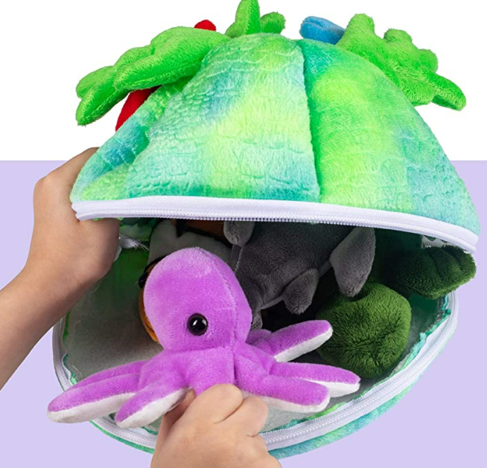  Source: Amazon. Plush Sea Creatures set.  Write title on IWB.  Orthography: Identify beginning sounds “Sing me the Summer”. Chunk words into individual phonemes.  S/i/ng  S/u/mm/er  s/ea/s/o/n/s  E.g., T. model writes:  The children play at the beach.  -T. will need to support reluctant writers in drawing/ annotating the favourite illustration/s in text.  Gallery walk  -S. spread their work on the floor and class walk around observing and discussing each other’s work.  Some S. may draw, some S. may write random letters as they transition to formal communication in their personal writing journey.  -Ensure there are models of language for S. to draw on in their writing, around the classroom.
Lesson 3 | AC9EFLA08 Recognise/ develop an awareness of vocabulary used in familiar contexts related to everyday experiences, personal interests and topics taught at school. ENE-VOCAB-01  -Identify learning area specific words when learning new topics.  -Expanding vocabulary through informal interactions and planned activities.ENE-VOCAB-01  AC9EFLE02 Respond to stories and share feelings and thoughts about their events and characters. ENE-UARL-01  AC9EFLA08 Recognise and develop awareness of vocabulary … ENE-VOCAB-01  AC9AMUFC01 Creating art works to communicate ideas. VAES1.1, 1.2 | LI Set the scene. Enjoy T. read-aloud  -T. tells a story about blue bottles to engage S./ set the scene.  -T. teach the words to the song, “Ickle, Ockle Blue Bottle” one phrase at a time.  -Teach the movement game/s “Ickle Ockle Blue Bottle” (Appendix 4).  -Identify the beat and rhythm of the song.  -Play the games together (2 versions), including body percussion.  -Talk about how the game/s made you feel, e.g., whether you liked/ disliked them. Point out the range of opinions in the class, beginning a focus on perspective that continues throughout the unit.  -T. reads text, “Sing Me the Summer” to the class with prosody.  -Talk about what happens in each season in the text.  -Discuss the seasons and how they impact our lives. Introduce the words for each of the seasons; Summer, spring, autumn, winter, and where they come from (etymology).  -T. makes a vocabulary chart of all the things we do and play in each season to display in classroom, as a scaffold for writing. S. provide vocabulary for seasons chart. S. illustrate chart.  -Talk about the colours of the seasons. KQ: Can we see which season it is in each illustration? How do we know? E.g., p1,2; p7,8; p17,18; p19-22 text.  -Discuss favourite seasons.  -S. make artworks using the colours of their favourite season, depicting their activities during that season.  -S. caption artwork using words from Seasons vocabulary chart.  -Share/ read their artworks with/ to the group. | Oral narrative about blue bottles in the sea  -T makes up an engaging brief story to set the scene.  -Identify rhyme orally e.g., “Ickle, ockle, blue bottle. KQ: Where is the rhyme in the words?  -Write words on IWB and circle rhyming phonemes in words as visual prompts.  Video- Four seasons  SEASONS SONG for kids | Pancake Manor - Bing video  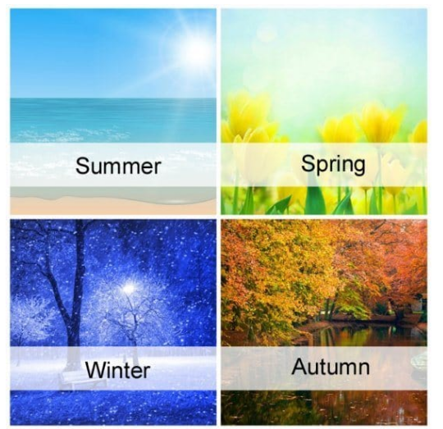  Source: seasons colours (prettyyourworld.com)  The etymology of the seasons:  Summer- Old English word meaning the hottest time of year  Autumn- A French word thought to mean “falling leaves”.  Winter- German word meaning a cold, wet time of the year  Spring- when new growth springs from the ground. Old English.  -S. choose which media they wish to use for their season’s artwork e.g., coloured paper, crayon, paint, textas etc.
Lesson 4 | AC9EFLY09 Recognise/ generate rhyming words, syllables, and sounds in spoken words.ENE-PHOAW-01  AC9EFLY13 Use knowledge of letters and sounds to spell words ENE-SPELL-01  AC9AMUFE01 Use play, imagination, knowledge to discover possibilities and develop ideas.  -Performing soundscapes using music and movement skills they have learnt and practised.  MUES1.1, 1.2, 1.3, 1.4  AC9EFLY09 -Recognise/ generate rhyming words, syllables, and sounds in spoken words.ENE-PHOAW-01  AC9AMUFD01 -Respond to the emotions you experience while listening to different pieces of music.  MUES1.4 | LI Learn about rhyming words, opposites and tricky words in text. -T. re-reads text to class, modelling fluent oral reading. -S. follow and join in reading text, building fluency. -T. stops at specific spots in text to draw S. attention to specific aspects of text. Introduce and explicitly teach rhyming words, compound words, silent letters, opposites in text. LI Identify high and low notes, move to the music, attentive listening. -Listen to classical music file, Trois Gymnopedies. Discuss the visual text that accompanies sound file. E.g.- the text is a series of old-fashioned paintings from Europe. The music was written a long time ago. KQ: How do we know this? What musical instruments can you hear in the music? (focus on timbre in music) -Talk about how the music goes up and down, (pitch) and is slow (tempo) and graceful.  -S. move to the music. Devise actions together to match the classical music. Use scarves and ribbons to identify pitch (high and low notes) and tempo (fast and slow). -Talk about how the music makes you feel. KQ: Does everyone agree? Why/ why not? How do you think the composer felt about the music? How do you know? -Formative assessment task: Orally assess S. P.A. in a game setting. E.g. T. asks S. around the circle: -What words rhyme with e.g., …song? -What words are opposite to e.g., …day? - What do these words say… e.g., knees? -T. uses a class list as checklist to record S. responses. | Rhyming words in text e.g., storm/warm; bright/night; breeze/knees; again/rain rows/grows; sway/away  Compound words: Bonfires, springtime, everything  Silent letter: knees  Opposites: day/ night; hot/ cold; warm/ cool…  Erik Satie - Gymnopédies - Bing video (composed 1888)  Scarves and ribbons are useful tools for S. to demonstrate pitch in music. S. wave scarves/ ribbons- high for high notes, and low for low notes in unison. Wave scarves quickly for fast tempo and slow for slow tempo in music.  Example Student performance Trois Gymnopedies  Extension: Use a slide whistle to assist S. to identify high and low notes. Have S. follow a squiggle as T. writes it on IWB. E.g., S. move their bodies low down on a low sound and move their bodies higher/ lower as pitch increases/ decreases.  Slide whistle sound effect - Bing video  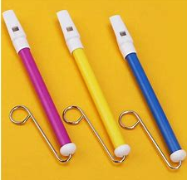  Source: slide whistle - Search Images (bing.com)
Lesson 5 | AC9AMUFE01 Use play, imagination, knowledge to discover possibilities and develop ideas.  -Play games to develop subject specific practices such as pitch, beat and/ or rhythm recognition.  MUES1.1  AC9EFLE01  Shares ideas about stories, poems and images in literature…  ENE-UARL-01  VAES1.4  AC9EFLY06  Create and participate in shared editing of short written texts to record and report ideas using some learnt vocabulary, basic sentence boundary punctuation and spelling some C-V-C words. ENE-CWT-01  AC9AMUFC01 Create works in a variety of forms to communicate ideas. MUES1.2 | LI Build new vocabulary  -T. discusses what creatures we would find in the sea. - Re-play “Charlie over the ocean”. S. choose sea life vocabulary to include in game (appendix 3). -Class watch virtual aquarium video. Discuss what was viewed in the video. KQ: What creatures did you see? How did watching the virtual aquarium make you feel? How did the music add to the text? What words describe how you were feeling, while you watched the video? -T. records feelings words on IWB. S. read words as they are recorded. Discuss initial, final and medial phonemes in feelings words. -T. model writes from sentence stem in text: Here is…… -T. “shares the pen”. Individual S. come to IWB to complete the sentence stem. Read new sentences together. -S. individually write on little whiteboards using sentence stem from text. Share writing. -T. re-reads text with prosody. Invite S. to join in to build fluency. Stop intermittently in story to discuss the feelings of characters in illustrations. | (212) Aquarium 4K VIDEO (ULTRA HD) 🐠 Sea Animals With Relaxing Music - Rare & Colorful Sea Life Video - YouTube  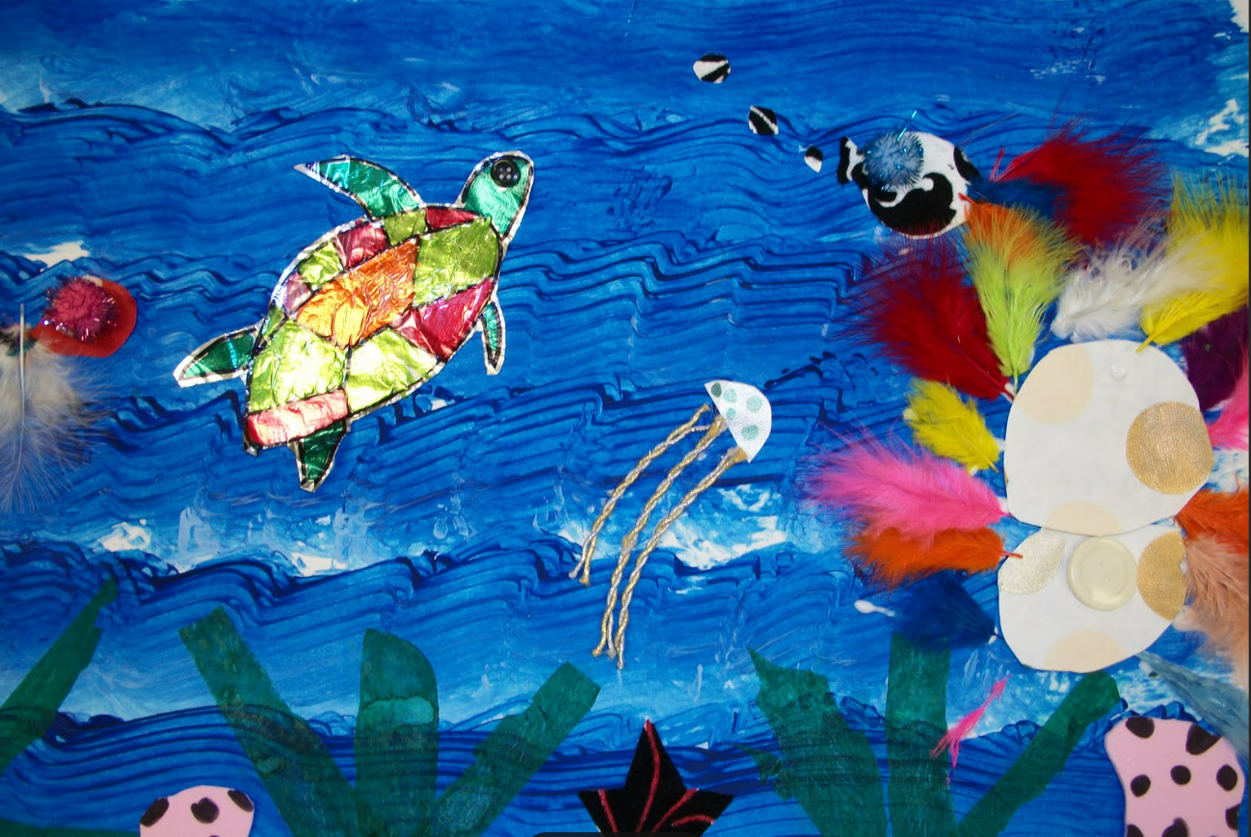  Source sea collage - Search Images (bing.com)  Example word bank: Feelings words sad, happy, excited, wonderous… elicited through discussion about virtual aquarium, and illustrations in text.  “Share the pen”- a guided writing strategy where S. write on IWB with guidance from T. Class read what S. has written.  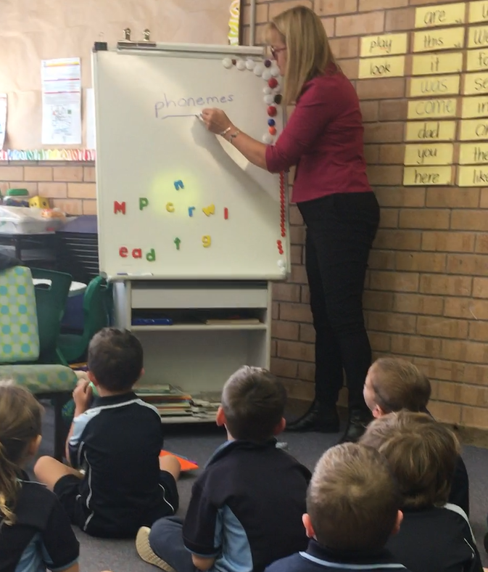 Source: author’s own photograph. Phonics drill.
Lesson 6 | AC9EFLA02 Recognise how feelings and preferences may be communicated in speech and gestures.  MUES1.4  AC9EFLY14 Read and write some high frequency words and other family words ENE-CWT-01  AC9EFLY13 Use knowledge of letters and sounds to spell words.ENE-SPELL-01 | -LI Revise, practice reading and writing h-f words.  -Teach S. “How do you feel today?” song (appendix 7). Sing the song in a sharing circle. -Drill known h-f words on display in classroom. -T. re-reads text. S. encouraged to join in to build reading fluency. -When class read a h-f word they know in the text, they put their hands on their head. The first child who raises their hand, reads the h-f word. -Play h-f word hunt in pairs. Each child is given a photocopied double page spread. -S. highlight the h-f words they know on their photocopied pages. S. count the number of h-f words they find. -S. write all the h-f words they find on little whiteboards. -S. share their words and reflect on what they learned from playing h-f word hunt. Discuss. | Enrichment activities: -Additional texts to talk about feelings e.g.  Provide a range of age-appropriate “feelings books” from school library for perusing, independent reading, sharing.  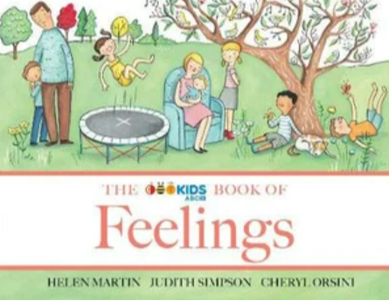  e.g., ABC Book of Feelings (2019)  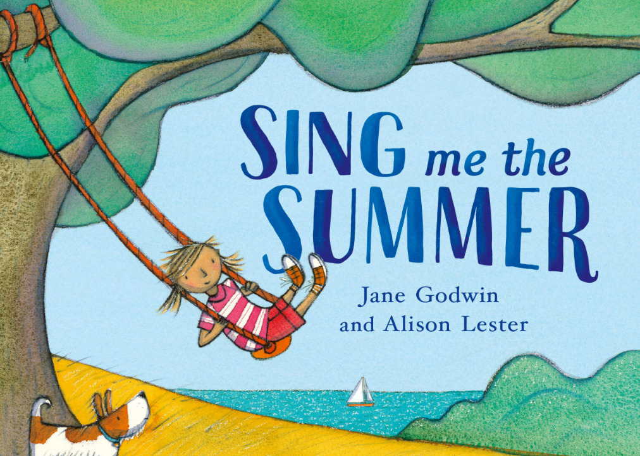  -photocopied double page sheets from text (one per pair). Avoid copying pages with few words e.g., p5-6; p29-30.
Lesson 7 | AC9AMUFP01 Performing song using music skills they have learnt and practiced e.g., listening to and staying in time with the group.  MUES1.1  AC9EFLE01 Share ideas about stories, with texts by First Nations Australian, and wide-ranging Australian and world authors and illustrators  ENE-UARL-01  AC9EFLE03 Recognise different types of literary texts and identify features including events, characters, and beginnings and endings.  ENE-UARL-01  AC9AMUFP01 Talking about ideas in artworks including processes used to make the work, including patterns, pathways, or lines. Talking about important features of works. VAES1.4  AC9AMUFE01 Listen to First Nations Australians talk about the importance of the arts for connecting to people, place, and culture.  AC9EFLY13 Use knowledge of letters and sounds to spell words.  ENE-SPELL-01  AC9EFLE01  Shares ideas about stories, poems and images in literature…  ENE-UARL-01 | LI Use music to help build prosodic oral reading  -Learn to sing the song, “Sing me the Summer”. -T. teaches melody of song, one musical phrase at a time. -S. move to the music using a waltz step. -Add gentle untuned percussion (soft dynamics) on 1st beat of the bar. -Perform song for an audience. LI Identify and discuss childrens’ play activities in an Aboriginal (true) story  T. introduces text Ngaginybe Jarragbe (2020). Shirley Purdie. Magabala. -T. tells S. how “Just as children play in Sing me the summer, to have fun and learn; in this text children learn from their relatives the things they will need to do when they are grown. Shirley talks about when she was a child, so things are a little different to today. Keep this in mind while listening to the story. The book, although a childrens’ book (audience) its purpose is to tell readers about her early life and it is a true story. Next to her story, are Shirley Purdie’s stunning artworks”. Peruse photo of well-known author/ illustrator and her artworks.  -T. share that Shirley Purdie is from the Kimberley region in WA (context). Locate region on a map of Australia. Listen to Shirley’s speech (Interview with Shirley Purdie video). Talk about how Shirley speaks an Aboriginal dialect of Australian English. Show S. a map of Aboriginal languages across Australia and discuss how there are many Aboriginal languages.  -Discuss the title and identify which phonemes rhyme. T. decode words on IWB.  -Look at back cover. Identify the Aboriginal language in text.  -Notice the colours of the illustrations. Talk about colours of the bush, ochre/ how it is made. Watch video “How Ochre is made”. Discuss. -Using scanned version of text on IWB, discuss paintings, one page at a time. KQ: What do you think is happening in this picture? -Choose one artwork. T. models a sentence on IWB about a painting from text. E.g., (p16) The girls find a bird’s nest. -T. guides S. in drawing/ writing a sentence about an illustration in text. Share drawings/ writing. | Sing Me the Summer song (appendix 8)  -S. struggling to retain phonemes, words, text may benefit from putting content in a musical context. It helps them to remember (Curtis, 2007).  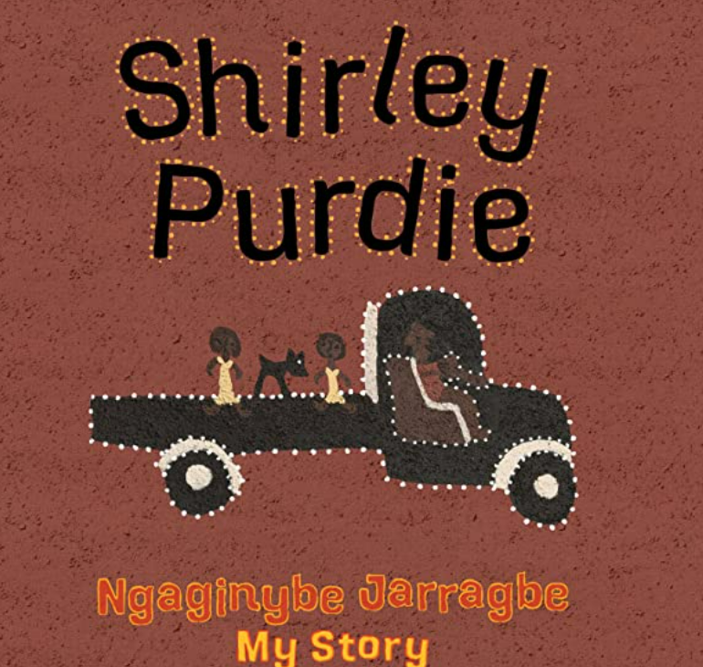  Source: text cover  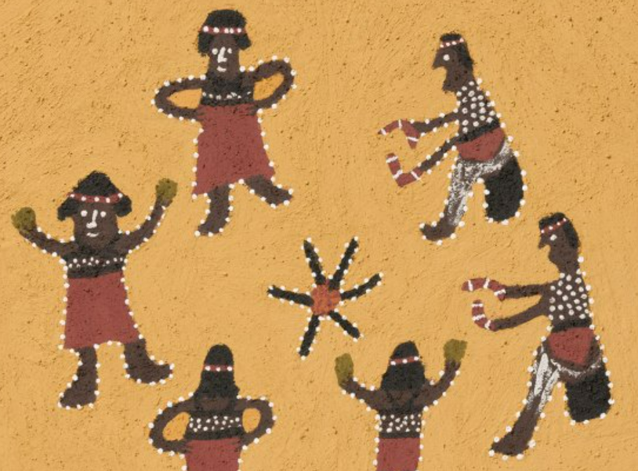  Source: text p1 Women’s Dance  Shirley Purdie  Rhyming phonemes (medial)  Ir, ur  Other words containing ir:  b/ir/d, c/ir/cle, d/ir/t  Other words containing ur:  b/ur/n, h/ur/t, c/ur/l  Shirley Purdie interview Interview with Aboriginal Artist Shirley Purdie - Bing video  Aboriginal languages map IATSIS-Map-of-Ind-of-Australia_1996_David_R_-Horton-1.jpg (3969×2891) (noongarboodjar.com.au)  Shirley Purdie  Rhyming phonemes (end)  Ey, ie both say the short i sound  Other words ending in ey:  Abb/ey, Bail/ey, Jo/ey  Other words ending in ie:  Am/ie, gen/ie, yow/ie  Video to show how ochre is made  Ochre and the Indigenous Culture - Bing video  Optional activity  Talk to the local Aboriginal Lands Council and see if there is a local person who can show S. how to make ochre from local clay. Have students grind some clay, add rainwater to make paint and use it to create an artwork, like in text.  -S. writing journeys are unique to them as they transition from drawing or sign creation, to sign use or written communication while learning to write (Mackenzie & Scull, 2018).  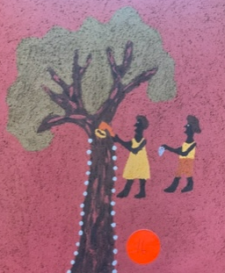  Source: Shirley Purdie (2020) p16.
Lesson 8  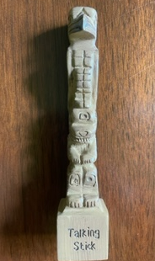 | AC9EFLY03 Identify some differences between imaginative and informative texts. ENE-UARL-01  AC9EFLE04  Explore and replicate the rhythms and sound patterns of literary texts such as poems, rhymes, and songs.  AC9EFLA02 Explore different ways of using language to express preferences, likes and dislikes. ENE-UARL-01  AC9EFLE01 engaging with texts by First Nations Australians, reflecting on experiences different / like their own. ENE-UARL-01 | LI Listen, enjoy read-aloud. Focus on meaning and cultural knowledge.  -T. reads text, “Shirley Purdie” to the class with prosody.  -Talk about what is happening on each page of the text. Stop reading to focus on meaning and respond to S. questions.  KQ: How is the children’s play helping them to learn?  -Talk about local Aboriginal language and what they know/ have learned. Revise any words, rhymes or songs S. have learned from the local language group.  -Incorporate local Aboriginal language in the classroom where appropriate. E.g.,  Nunda Kumba Kumba (Awabakal language for thank you).  -Learn rhythm patterns to garner attention in class, at the same time teaching local Aboriginal language (E.g., appendix 10)  -Visit a yarning circle. Reflect on and think critically about the text, Shirley Purdie together, a true story about her life. Pass around a talking stick, inviting each S. responds. K.Q. What did you think of the book? Why did you think that? How does your opinion differ from others in the class? How are children having fun and learning through play in the book, Shirley Purdie? | -It is useful to read text to S. on IWB so T. & S. can interact with text as you are reading, pointing out key features of text e.g. layout, punctuation, interesting vocabulary.  -It is beneficial to have an Aboriginal teacher/ /advisor in the classroom during T. read-aloud to explain terminology, cultural knowledge, and language in text, during read-aloud (if available). The LALC may be able to suggest a local person who the T. teacher can invite to visit and teach S. local Aboriginal language if no Aboriginal teacher exists in the school.  -Appendix 10 rhythm pattern e.g., in Broader Bundjalung, Minyabul, mid-north coast, NSW.  T. says Yabba bulla, Yabba bulla, look at me  S. responds Yabba bulla, yabba bulla, Look at you
 | Lesson 9  AC9AMUFE01 Enjoying songs used for celebrations.  MUES1.3, 1.4  AC9AMUFD01 Play games to develop subject specific practices such as pitch, beat and/ or rhythm recognition.  MUES1.1  AC9EFLE01 Engage with texts that portray Australian family life in different settings across Australia.  ENE-UARL-01  AC9EFLY06 Create and participate in shared editing of short written texts to record and report ideas. ENE-CWT-01  AC9EFLE02 Respond to stories and share feelings and thoughts about their events and characters. ENE-UARL-01  VAES1.4  MUES1.4 | Learn and perform the action song, “Sea-shells, Cockle Shells” (appendix 6) -Teach S. the words of the action song, one phrase at a time. -Clap the beat, learn the rhythm. Revise solfège signs. -Make/ write rhythm cards for S. to follow. -Learn the actions and teach S. how to go through a window in pairs (appendix 6) -S. sing song and perform actions. -Through class discussion, S. reflect on what they learned from singing the song and playing the game, “Sea shells, cockle shells”.  LI Read, enjoy and understand text - T. orientates S. to text, “When I grow up”. Ask who has seen Matilda performed. “This book/ song is from the screenplay, Matilda, a funny book written by a famous author named Roald Dahl. While I read, I want you to notice all the things the children are doing in the story”. -T. reads text with prosody. -2nd read, point out imagery, symbol and connotation in text. -3rd read, identify/ record all verb groups in text from illustrations. KQ: What are the children doing? How are they feeling? -T. creates a word bank on IWB to assist S. with their writing task/ provide an authoritative source. -T. chooses their favourite page in text and explains why they chose that page. -T. model writes a sentence about that page and illustrates it on IWB. -T. guides S. in choosing their favourite page to draw/ write about. -Independent drawing/ writing/ reading based on an illustration from text. -Share video of Tim Minchin singing/ performing the text. -S. follow on in book, building reading prosody. -Talk about how the song made you feel, drawing on feelings words on chart in classroom.  -Reflective, summative KQ: Do grown ups really do all these things? | Example rhythm cards:  Sea-shells cock-le shells  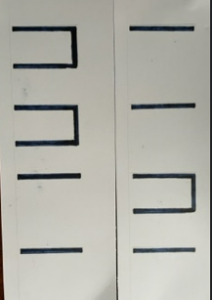  Ee-vie I-vie ov-er.  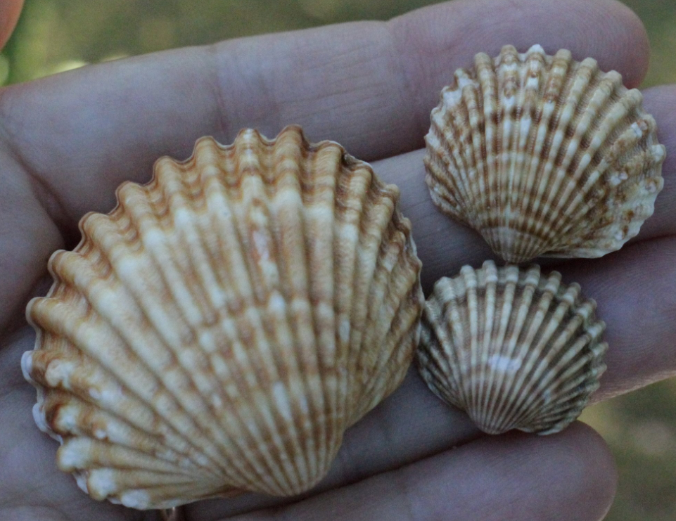  Encourage S. to bring in their favourite shells to share, focusing on varying opinions and views as to why some S. like particular shells, and why other S. do not.  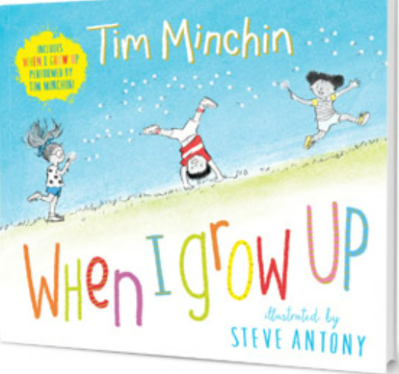  Tim Minchin performing the song to accompany the text:  Tim Minchin Sings "When I Grow Up" - Bing video (song begins 1.16 mins)  Symbol, imagery, connotation in text:  -Story paths in text. Words move around the page, suggesting movement, adding to meaning. We follow the path as we read.  -Font changes size, the words get bigger or smaller to add to meaning.  -Some words are bolded for emphasis.  -Word play and repetition for emphasis.  -The illustrations tell a story.  Word Bank  (verb groups from text)  -Climbing trees,  -reading books,  -riding bikes,  -eating sweets,  -having pillow fights,  -watching cartoons,  -being brave,  -have treats every day  -play things that mums pretend that mums don’t think are fun,  -wake up when the sun comes up,  -lie in the sun.
Post-test  5-10 minutes per child  vocab, oral reading sample from text.  Writing is assessed throughout unit. | AC9EFLA08  ENE-VOCAB-01  AC9EFLA06  ENE-CWT-01 | -Post-test vocabulary, h-f words, oral reading from text.  -Post-test writing task. S. draw/ write/ share their opinion about a text addressed throughout the unit.  -Map S. creating texts NLLPV3 , CrT p41.  -Map S. oral reading NLLPV3 PKWp25, FlY p25.  -T. completes appendix 11, T. reflection and evaluation. | T. assesses S. 1-1. Choose a time S. are engaged in independent group activities.  -Appendix 1.  -Post-test vocabulary, h-f words, oral reading from main text.  -T. map S. growth on NLLP PKW, FIY throughout unit.  -Appendix 11: T. reflection and evaluation.

References:
Curtis, L.J. The Role of Music in Early Literacy Learning: a kindergarten case study [Unpublished PhD thesis]. Kansas State University.
Mackenzie, N. & Scull, J. (2018). Understanding and supporting young writers from birth to 8. Routledge.
Sandberg, A. & Heden, R. (2013). Play’s importance in school. Education 3-13. 39(3), p317-329.

