Name of unit: True or false
Introduction to unit
This integrated English and music unit targets Foundation students early in their first formal year of education, whilst they are learning and consolidating their alphabetic knowledge. It is anticipated the unit will be taught alongside the school synthetics phonics program, each mutually reinforcing the other. As students learn the alphabetic code, at the same time they are learning about key English and music concepts through quality literature and music.
Deep knowledge and understanding NSW outcomes in blue
Key concept | Focus question(s) | Curriculum content
Context  Imagery, symbol, and connotation  Elements of music  using a range of listening, singing, moving and instrumental activities | Is the story true or not (false)?  How do you know?  How is this story like your life?  Who do you think this book is for?  What do these symbols tell us in the text?  What do the illustrations tell us about the story?  How can we change the words to make a new story?  How can we change the rhyme, chant or song using different words?  Can we copy a simple musical pattern (like the interval of a falling minor third e.g. miaow, cuckoo, coo-ee)? | AC9EFLY03  Talking about what is real and what is imagined in texts  Identifying and selecting texts for information purposes  Comparing images in imaginative texts with images in information texts ENE-UARL-01  AC9EFLY04  Attempting to work out unknown words by using phonic decoding and knowledge of hf words ENE-PHOKW-01  AC9EFLY10  Making new words when beginning-medial-end phonemes are replaced with a different phoneme ENE-PHOKW-01  AC9EFLY11  Recognise and name upper and lower-case letters (graphs) and know the most common sound that each letter represents ENE-HANDW-01, ENE-PHOKW-01  AC9AMUFD01-improvise rhythmic patterns, explore singing/ speaking voices, responding to emotions whilst listening to stories, song; and extending and varying known songs, chants, and rhymes by adding words and movements.  AC9AMUFD01-play games to develop subject specific practices such as pitch, beat and or rhythm activities  AC9AMUFC01-extending and varying known songs, chants, or rhymes  AC9AMUFP01-performing songs, chants/ raps. Sharing their work with peers.  MUES1.1, 1.2, 1.4; MUS1.3

Other significant learning
Other knowledge, understanding and skills, attitudes, and values | Curriculum content
Phonemic awareness (PA)  Character  Narrative  Use play, imagination, music knowledge, processes, and skills to discover possibilities and develop ideas. | Orally identify and produce rhyming words, alliteration, syllables in words. Provide other words that start with same sounds. Orally participate in PA word building (decoding and encoding) games. ENE-PHOAW-01  -Identify main characters in text. Describe them.  -Talk about the evidence/language used in text (based on what characters say, think and do in the story) ENE-UARL-01  Is the story real (true) or imagined (false)? How do you know? Why are imaginative texts so delicious? Identify beginning, middle, end of story. Discuss complication and how it is resolved in main text. ENE-UARL-01  Identifying high/ low; fast/slow sounds.  Participating in activities to identify pitch through improvising sounds going up/ down gradually.  Imitating high/ head voices. MUES1.4  Learn rhythmic patterns of words  Learning to sing in tune through playing copycat games. MUES1.1  Use hand movements/ instruments to reproduce rhythm patterns of rhymes/ songs. MUES1.1

Assessment
-Provide an oral narrative about an illustration from main text.
-Tell a story that is true. Tell a story that is false (yarning circle).
-Create a fictional character. Draw it and provide a caption that is false.
-Draw an illustration of something that is true and tell the class about it.
-Play true or false circle game (orally providing a story and class determine true or false).
-Orally encode and decode CVC words using known phonemes/ graphemes.
-Echo songs to match pitch.
-Clapping/ playing instruments to show syllabification in words.

Assessment task that addresses the key concept
Curriculum content | Outline of task | Criteria for assessment
Context  Imagery, symbol, connotation  Elements of music:  -singing in tune  -identifying pitch (high/ low sounds)  -identifying dynamics (loud/soft)  -identifying, following, and creating rhythmic patterns | -From a range of texts, S. successfully identify books that are informative (true), and books that are imaginative (false). Discuss the main features of factual and literary texts.  -Identify the meaning and purpose of a range of symbols in main text e.g. punctuation including commas, full stops, exclamation marks, vectors, capital letters, speech marks, different fonts for emphasis.  -Discuss word play, alliteration, rhyme, humour in text and illustrations.  -Retell the story using the illustrations from text.  -T. and S. repeat, sing and perform echo songs and chants to match pitch.  -Play musical games identifying pitch, dynamics, and rhythmic patterns. | Can identify which are imaginative and which are information texts.  Can talk about the main features of factual and literary texts.  ENE-UARL-01  Orally identifies symbols in text.  S. identify the main events of story using the illustrations.  ENE-UARL-01  -S. sing echo songs in tune. E.g., My Highland Goat ;  Going on a Bear Hunt.  Identify high/ low notes; loud/ soft sounds using appropriate body language and actions.  Identifying, singing, and creating simple rhythmic patterns.  AC9AMUFC01  MUES1.1, MUES1.4

Resources
-Bland, N. (2008).The Very Cranky Bear. Scholastic.
-BBC Earth. (2012). Why do bears hibernate. Youtube. Why Do Bears Hibernate? | Big Sky Bears | BBC Earth - Bing video
-Collection of high-interest literary/imaginative and informative/ factual texts from school library (at least 10).
-Bell, D. & Colpoys, A. (2021). Tomorrow is a Brand-New Day. Scribble.
-Bland, N. Bear books from school library e.g. Nick bland & Bear books - Bing images

Unit overview
True or false is an integrated English unit that authentically links with the Australian curriculum V9 The Arts-Music. Throughout the unit, S. will learn to distinguish between literary and factual texts of a range of genres. They will also interact with the elements of music including singing in tune, identifying pitch, dynamics, and rhythm.
In English the key concepts include context and imagery, symbol, and connotation; and how these concepts work together to contribute to meaning in texts. The elements of music in the unit include rhythm, duration, pitch, dynamics, and expression, taught through games and songs that engage, build a love of music and at the same time, assist students in their language and literacy learning, particularly reading fluency, vocabulary and meaning- making (comprehension).
Abbreviations in unit: T.=teacher, S.= students, IWB= interactive whiteboard, LI=learning intention, KQ= key class discussion questions.

Unit title
True or False

Body of unit

Period of time | Curriculum content | Teaching, learning and assessment | Adjustments and extensions
Pre-test  5-10 minutes per child. | AC9EFLA08  -Recognise/ develop awareness of vocabulary.  ENE-VOCAB-01  AC9EFLA06  -Reading simple sentence.  ENE-REFLU-01 | -Pre-test vocabulary, high-frequency words from text.  -Pre-test oral reading passage from text (appendix 1)  -Map S. oral reading NLLPV3 PKWp25, FlY p28. | T. assesses S. 1-1. Choose a time S. are engaged in independent group activities.  Individual assessment tasks.
Lesson 1 | AC9AMUFD01  -Play games to develop subject specific practices such as pitch, beat, rhythm recognition.  AC9AMU2P01  -Singing songs, performing chants/ raps.  MUES1.1  AC9EFLY04  -Orientation to text.  ENE-UARL-01  AC9EFLY04  -Attempting to work out unknown words by using phonic decoding and knowledge of h-f words.  ENE-PHOKW-01  AC9AMUFP01 -Discuss characters and situations associated with the story.  ENE-UARL-01  MUES1.4  AC9FLY09  -Recognise and generate rhyming words, alliteration patterns, syllables and sounds. ENE-PHOAW-01  AC9AMUFC01 -Creating art works in a range of forms to communicate ideas. | -Introduce song with a koala puppet to engage S. Play Koala Brown clapping game (appendix 2).  LI Predict what might happen in text based on title and cover  -Talk about the cover together  KQ: What do you think the story is about? Tell us about the animal on the cover. How do you think he feels? Why do you say that? Can you make a face like that?  -Discuss our feelings and what makes us feel that way.  -Phonemic awareness activities. Orally identify the beginning sound in words. E.g. koala, brown, bear, cranky. Identify these letters on alphabet chart. Practise writing them in the air, following along with the teacher.  -Talk about the title on cover. What sort of letters are they? Why do you think they’re written like this? Have you seen any of these words before?  -Read the back cover to class.  KQ: What do you notice about jingle, jangle, and jungle?” “What do you notice about wet and windy day?” “What else do you see on the back cover?”  -S. draw a picture about what might happen in the text. Caption picture. Share.  -Sing If you’re happy and you know it (angry, sad). Students provide actions for each verse. Match facial expressions to feeling in each verse. | Teach children the words/ clapping pattern prior to teaching the game, Koala Brown.  (appendix 2).  -Some S. may not be able to aurally identify initial sounds in words in title of text. They will benefit from lots of oral repetition of the words till they hear the initial sounds.  -S. making the letters with playdough / writing letters on mini whiteboards for consolidation.  -S. may need to repeat words multiple times to identify initial phonemes.  -Point out to students they all start with the same sound. Identify sound on alphabet chart.  -If you’re happy and you know it song to reinforce focus on feelings in text.  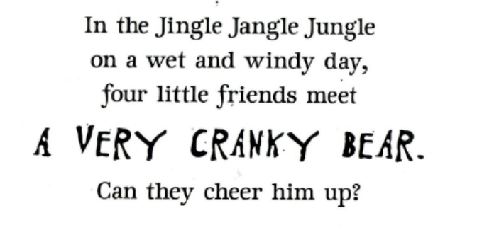  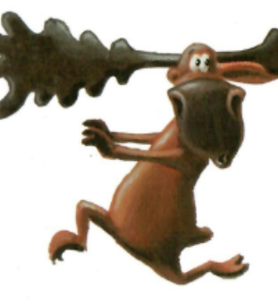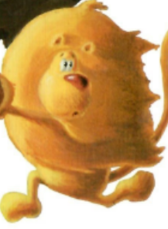  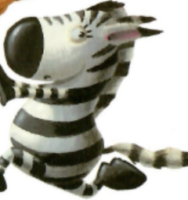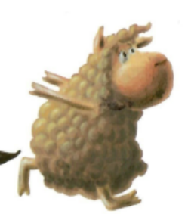  Source: back cover, text.
Lesson 2  Lesson 3 | AC9EFLY11  -Recognise and name upper- and lower-case letters.  ENE-PHOKW-01, ENE-HANDW-01  AC9AMUFC01  -Add movements / actions and improvise movement patterns.  MUES1.2  AC9AMUFD01 -Playing games to develop subject specific practices.  MUES1.1  AC9EFLY08  -Form most lower-case and upper-case letters using learnt letter formations.  ENE-HANDW-01  AC9 EFLE04  -Using music and actions to enhance appreciation of rhymes, poems, chants,  and songs.  MUES1.1  AC9EFLE05 -Sequencing pictures to retell a story.  ENE-UARL-01  AC9EFLE02  -Respond to stories and share feelings and thoughts about their events and characters.  ENE-UARL-01  AC9EFLE02  -Use drawing and beginning forms of writing to express personal responses to stories.  ENE-CWT-01 | -Revise initial sounds from previous lesson e.g., k, b, c  Teach Ants in Apple for target sounds (appendix 3).  -S. make up actions for target sounds in song. T. takes care when introducing k, c. Both make a similar sound e.g. koala, cranky.  -T. explicitly models how to make each letter (revision).  S. follow using air writing for each letter.  -Show alphabet cards for each letter sound.  -Teach children the letter drill/ song Hey Ho (appendix 4)  -Play Hey Ho game. T. flashes a letter sound card and students sing the associated words in song to match letter sound on card.  -S. practise writing letters on little whiteboards. Hold under chins and share letter writing.  LI Retell events through illustrations in text.  -T. shows each page illustration on IWB. Class talk about what’s happening on each page, in order.  KQ:  -Why is the book called, “The Very Cranky Bear?”  -Who are the main characters in this book? Are they real/ true? Why do you say this?  -What’s happening here? How do you know?  -What do you think they’re saying?  -What are they doing now? Why?  -What happens next?  -S. draw their favourite picture from text. S. tell the class where it fits in the story (beginning, middle or end).  -T. organises a “gallery walk”. Display all pictures on floor and class tell each other about their pictures, as S. walk around looking at them.  -S. ask each other questions about their pictures. | Drill letter names to “Ants in the Apple” tune e.g.:  -Koalas kicking  -Bears are babbling  -Caterpillars crawling  (appendix 3)  -Reinforce letter sound knowledge using Hey Ho letter drill song (appendix 4).  -Drill letter sound associations using letter cards for additional practice with S. who require consolidation.  -Extension/ consolidation activity: Luke Yeoman writing letters for early learners (704) Letter Formation - YouTube to help S. form correct letter formations. -Scanned version of text required to share /discuss illustrations on each page.  -Numbering pages may be useful when referring to illustrations in text during class discussions.  -T. scaffolds S. talk about illustrations in text using KQs.  -Pictures using thick crayons and A3 paper to facilitate developing fine motor skills.  -Consolidating comprehension of text through drawing.  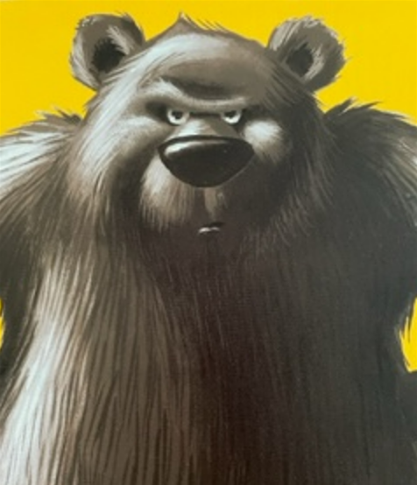  Source: text cover The Very Cranky Bear: 10th Anniversary Edition by Nick Bland - Book - Kmart
Lesson 4 | AC9AMUFE01  -Singing songs that help teach content.  MUES1.1  AC9EFLE02  -Discuss events and characters in texts and connecting them to their own experiences.  ENE-UARL-01  AC9EFLY03  -Talking about what is real and what is imagined in texts.  Comparing images in imaginative texts with images in information texts.  ENE-UARL-01  AC9AMUFE01  -Exploring how illustrations/ images in a text help to communicate narrative or information.  ENE-UARL-01 | LI: Listen to, follow on IWB and enjoy T. read-aloud, “The Very Cranky Bear”.  -T. reads text to group with prosody, modelling fluent oral reading.  -Discuss what the story is about together. Introduce new vocabulary, “hibernation”, describing how bears go to sleep for the winter.  KQ: Is the story true or false? Why do you say that?  -Watch the video, “Why do bears hibernate?”. Talk about whether this visual text is true or false. How do you know?  KQ:  What did you learn about bears?  What is hibernation?  Why do bears hibernate?  -Modelled, guided and independent writing:  -T. models a fact about bear hibernation on IWB.  -T. guides S. in writing/ drawing a fact they learned from video.  -S. independently draw/ caption/ write a fact about bears and hibernation. | Introduce term, “imaginative” text, meaning the composer, Nick Bland made it up using his imagination. He created the story in his mind.  -Why do bears hibernate  Introduce the term, “informative” text meaning we learn true information from the text. We can believe it.  -Peruse library books / informative texts containing information about hibernation e.g.,  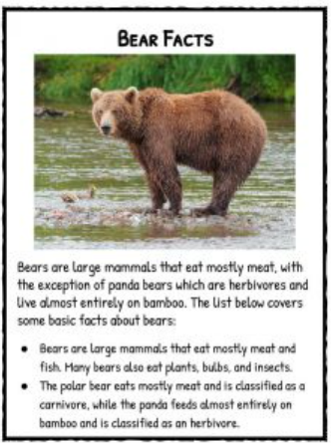  Source: Bears Facts & Worksheets | Origin, Anatomy, Kinds (kidskonnect.com)
Lesson 5  Lesson 6 | AC9AMUFD01  -Identifying high/ low; fast/slow sounds.  MUES1.1  -Participating in activities to identify pitch through improvising sounds going up/ down.  MUES1.1  AC9AMUFC01  -Creating works in response to inspiration from sources such as play, imagination.  MUES1.2  AC9MUFP01  -Performing movement/ dance sequences.  MUES1.4  AC9AMUFD01  -Imagining how characters in a story might dress, move and making images to about characters.  Playing games to develop subject-specific practices such as pitch, beat…  -Exploring their speaking and singing voices and using their voice to communicate ideas and actions.  ENE-UARL-01 | LI: Revise fast and slow (tempo); loud and soft (dynamics) in music.  -T. re-reads text to class with prosody. -S. follow on with text on IWB as T. reads.  -S. invited to join in if they wish to.  -Teach S. the words of the song from text.  -S. listen to the MP3 of “The Very Cranky Bear”. Identify the beat of song.  -S. walk to the beat in a circle, as they listen and sing along (slow version MP3 appendix 6).  -S. move to the fast version of the song (fast version MP3 appendix 6).  -T. plays the song again a. loudly, b. softly.  -S. perform an action to show when the song is loud, and an alternate action when the song is soft.  -T. varies the volume of song, and S. change their action to model the dynamics of song as it changes from loud to soft.  - LI Learn about characters in the text from what they say, how they act and what they do in the story.  -Class discuss what we learned/ know about the characters from text.  KQ: “What did each character do? Why did they do that? What words tell us about each character? What character’s actions make us think this?”  -T. records the words provided by S. Print words in a large font inside animal shapes, and display in classroom.  -S. make paper plate character masks with assistance.  -S. reflect on text. S. share their feelings about the characters and the book with the class. KQ: “What do you think about each character? What do you think about the bear (moose, lion, zebra, and sheep)? Why? Why do you say that? What do you think about the story?”  -S. show their completed animal masks to class, describe which character they chose and why. N.B. Do not send masks home as we will use them for dramatization throughout unit. | MP3 recordings “The Very Cranky Bear” (appendix 6)  -Some S. may not be able to initially hear the beat in the music. They will need lots of repeated practice until they can independently identify beat in song.  -A slide whistle is a useful and fun tool to practise identifying high and low sounds through listening and movement; and gradually moving between the two. Great lesson break activity. -S. move their bodies high for high sounds, and gradually move down low for low sounds.  -Character maps:  - Bear  - Moose  - Lion  - Zebra  - Sheep  Write descriptive words inside animal shapes on IWB/ large card to display in the classroom.  - Animal Paper Plate Masks - diy paper plate masks (onecrazymom.com)  -S. choose a character from text and construct an animal mask, with assistance. 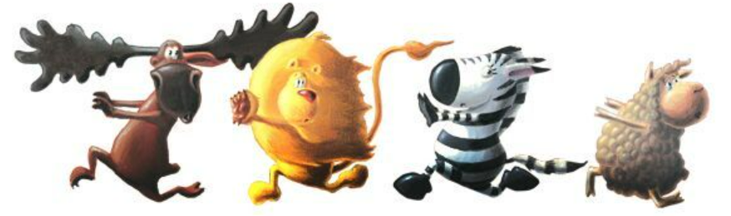  Source: very cranky bear characters - Bing images  -T. choose a time when there is assistance in-class to construct animal masks along with students.  e.g.,  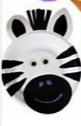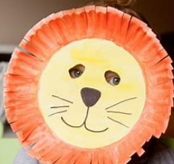  Source: Paper Plate Animal Masks - Bing images
Lesson 7 | AC9EFLY03  -Talking about what is real and what is imagined in texts.  ENE-UARL-01  AC9AMUFC01  -Extending and varying known songs chants or rhymes  MUES1.2  AC9AMUFE01 -Using facial expressions and gestures to communicate ideas.  MUES1.1  AC9EFLE01 -Respond to stories and share feelings and thoughts about their events and characters.  ENE-UARL-01 | LI Discern between tall (false/ made up) and true stories.  Circle games:  -Copycat game to develop aural/ musical memory: Sing a child’s name, add an action, and class copies. Next child does same. Continue around the circle, each child singing their name with an accompanying action. Class repeats rhythm and action for each child around the circle.  -True or False trickster game: Using talking stick, T. begins the game by inventing/ relating a brief story (using lots of expression and prosody).  -S. vote on each story by placing a red counter in front of them if it is a tall tale (false), and a blue counter if the story is true. Discuss responses.  -Pass the talking stick to the next person who wishes to participate and repeat. | e.g., Lor-ri  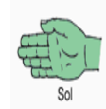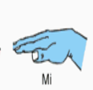  Examples of tall tale ideas for T. elaboration:  -A monster from outer space is in the playground…  -A dinosaur bone was found in the playground sand pit…  -School is cancelled today because a giant is in the Hall taking up all the assembly space…  -There is a planet visible in the night sky tonight which will look like a big read ball.  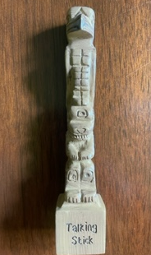
Lesson 8 | AC9EFLA09  -Identify punctuation as a feature of written text, different from letters…  ENE-CWT-01  AC9AMUFC01 -Manipulate objects… to create/ retell stories.  AC9AMUFP01  -Performing, listening respectfully, and engaging in post-performance discussions.  MUES1.1  ACE9EFLA02 -Recognise how feelings and preferences may be communicated in speech and gestures.  AC9EFLA05  -Recognise that sentences are key units for expressing ideas.  ENE-CWT-01  AC9EFLE02  -Respond to stories and share feelings about events and characters.  ENE-UARL-01  AC9EFLA09  -Identify punctuation as a feature of written text.  ENE-CWT-01 | LI Build reading fluency through drama  -Re-read text together on IWB, using musical score (appendix 6).  -T. points out punctuation in text on each page. E.g., capital letters, speech marks, commas, full stops.  -T. explains to S. that punctuation tells us “how” to read a text.  -S. “air draw” punctuation marks (learned from punctuation rap) when students notice punctuation symbols during class read-aloud of text. -Using S. made masks, S. read the voices for their particular character with prosody e.g. “ROAR” went the cranky bear, “ROAR, ROAR, ROAR”. -S. add actions as specified in text as they read e.g., He gnashed his teeth, and stomped his feet and chased them out the door (p6).  Modelled, guided and independent writing: -T. models writing a sentence about a character from the story on IWB, emphasising the use of punctuation in the sentence. -T. guides S. in writing a sentence about a character together. -S. write a sentence independently, drawing on knowledge of punctuation usage, modelled text and vocabulary displayed in classroom. | -The music score is loosely coupled to whole text (repeat MP3 file for each page as S. sing the words until the tune is familiar).  -It may be easier for S. if all characters sit together e.g. sheep, lions, zebras, moose, bears. Encourage the use of dramatic voices whist S. read the direct speech in text.  Extension / consolidation activity:  -Learn to dance the punctuation rap together.  Formative assessment:  - S. read text with prosody. (Y/N)  - S. use dramatic, prosodic voices whilst reading text. (Y/N)  - S. write a sentence with evidence of punctuation usage. (Y/N)  Example modelled writing on IWB:  The sheep was kind.  Building noun group  The woolly sheep was kind.  Building sentence complexity.  The woolly sheep was kind (why?) because he made a pillow for the bear to sleep on.  This can be done over several lessons. Re-reading writing from prior lesson to build fluency.
Lesson 9 | AC9AMUFD01  -Exploring singing voice and using voice to communicate ideas and feelings. MUES1.1  AC9EFLY04  -Attempting to work out unknown words by using phonic decoding and knowledge of h-f words.  ENE-PHOKW-01  AC9EFLY10  -Making new words when beginning-medial-end phonemes are replaced with a different phoneme.  ENE-PHOKW-01 | LI: Learn/ perform rhymes to develop pitch, beat and rhythm.  -T. teaches the rhyme “Engine, Engine Number 9” Use body percussion to identify/ learn to read the rhythm (appendix 7).  LI: Identify rhyming words in text  -Re-read text together. At end of each page, stop and identify rhyming words.  -Write rhyming words on IWB. Decode them into individual phonemes e.g., d/ay, p/ay, s/ay. Form new words by changing initial sounds.  -S. practise rhyming words from text writing words on mini whiteboards and forming new words by changing beginning and end phonemes.  -Encourage S. to share the pen and record new words they have made on IWB for the class. | -T. chunks the rhyme (appendix 7), teaching one line at a time.  -Model, guide and provide time for S. to independently practise rhyme, “Engine, Engine Number 9”.  -Rhyming words: e.g., p1 text  day play  mane plain  Forming new words that rhyme e.g.,  chin, in, f/in, b/in,  bi/t, si/t, l/it, m/it.  -Encourage S. to practise writing letter formations/ rhyming words on little whiteboards.  -Decoding and encoding drill and practice e.g.,  sh/ee/p, p/ee/p, d/ee/p  t/ee/th  -Magnetic letters are also useful for decoding and encoding activities.  -“Share the pen” is a strategy where S. write on IWB, as part of a collaborative joint construction (Mackenzie & Scull, 2018).  -Extension/ consolidation song, “Rhyme Song” (appendix 9).
Lesson 10 | AC9AMUFD01  -Improvise rhythmic patterns, explore singing/ speaking voices…adding movements. MUES1.4  ACAMUFC01 -Adding movement actions to songs as accompaniment.  AC9EFLY02  -Listening to and following instructions.  ENE-OLC-01  AC9AMUFE01  -Singing songs that help teach content or concepts from other learning areas.  MUES1.1  AC9EFLY11  Recognise and name vowel sounds in words in text  ENE-PHOKW-01 | LI: Learn a call and response action song.  T. teaches S. the song, Come back home my little chicks (appendix 8), including solfa signs, and French time names.  -T. models how to play the game.  LI Know and use vowels in reading and writing  -Talk about letters of the alphabet and how some letters have special jobs.  -T. introduces/ revises the terms vowels, and consonants, and explains the difference between the two.  -Teach the vowel song (appendix 9). Talk about short and long vowel sounds. Have S. provide examples of words containing short and long vowel sounds.  -Identify short and long vowel sounds in words from The Very Hungry Bear on IWB.  -In pairs, S. go on a vowel hunt in text. Highlight vowels in text.  -S. orally identify whether vowels make a short or long sound in words. | -Appendix 8  Circle game.  Song contains the following Solfege signs:  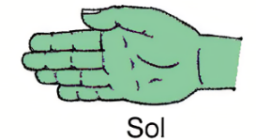  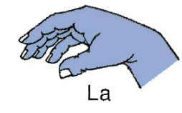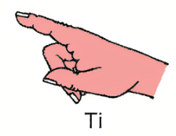  Appendix 9  Vowel song.  For the T.:  Vowels comprise those letters of the alphabet which are not consonants. Vowels are important because all words and syllables contain them. They can have short and long sounds.  -Pages of text blown up A3 (one per pair), and highlighters required for this activity.  The Very Hungry Bear:  strip stripe  man mane  cut cute  bit bite  min mine
Lesson 11 | AC9AMUFD01  Improvise rhythmic patterns, explore singing/ speaking voices  AC9AMUFP01  -Performing songs, chants/ raps using music skills they have learnt and practiced.  AC9AMUFD01  -Playing games to develop subject specific practices.  -Improvising rhythm patterns for clapping or stamping. MUES1.1, 1.2, 1.3  ACEFLY05  -Use comprehension strategies such as questioning to understand and discuss texts.  ENE-RECOM-01  AC9EFLA07 Recognising texts can be interpreted differently when only the words or images are read or viewed.  ENE-UARL-01  AC9AMUFE01 Identifying art works and experiences in their lives. Sharing ideas, communicate emotions and feelings in art works.  VAES1.4 | LI: Demonstrate the difference between beat and rhythm  -T. teaches the lyrics and melody of song, Cobbler, Cobbler (appendix 10). Explain what a cobbler does and the tools that they use.  -Using plastic hammers, S. play the beat. Then, the rhythm (words).  -S. alternate between beat and rhythm at a sign by the T.  -Play Cobbler, Cobbler circle game (appendix 11).  LI T. orientates S. to text, Bell & Colpoys (2021), “Tomorrow is a brand-new day”.  -Discuss cover, back cover. Identify rhyming words on back cover. Talk about meaning. Unpack the figurative language in these words.  KQ: What do you think the words on the back cover mean? Do you think this book is about boats and seas? Why/ why not? Do you think there may be a secret message in these words? Is it a literary or information text? How do you know?  LI Retell events through illustrations in text.  -T. shows each page illustration on IWB. Class talk about what’s happening on each page, in order.  -S. paint a picture of what makes them happy.  -T. organises a “gallery walk”. Display all pictures on floor and class tell each other about their pictures, as S. walk around looking at them.  -S. ask each other questions about their pictures. | Appendix 10  Cobbler, Cobbler  Plastic hammers are useful tools to keep the beat, play the rhythm.  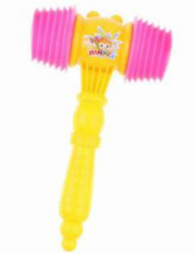  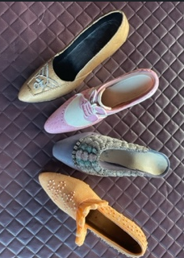  Miniature shoes for game “Cobbler, cobbler”.  “Good or bad, the things you do- are all part of being you- of learning how to take your boat on stormy seas and stay afloat.” Bell & Colpoys (2021). Back cover.  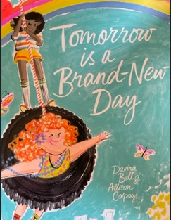  Source: text cover. Tomorrow is a brand-new day. Bell & Colpoys. (2021). Scribble.  -Scanned version of text, to display on IWB, may assist S. to notice minute detail in illustrations.  -S. paint a picture about happiness, a key theme in the text. S. share with class what makes them happy and why.  -Consolidating comprehension of text through visual arts (painting).
Lesson 12 | AC9EFLE02  -Discuss events and characters in texts and connecting them to their own experiences.  ENE-UARL-01  AC9EFLY03  Talking about what is real and what is imagined in texts.  ENE-UARL-01  AC9EFLA09 Identify punctuation as a feature of written text, different from letters.  ENE-CWT-01  AC9EFLE02  Respond to stories and share feelings and thoughts about events and characters.  ENE-UARL-01  AC9EFLA05 Recognise that sentences are key units for expressing ideas.  ENE-CWT-01  AC9EFLY10  Making new words when beginning-medial-end phonemes are replaced with a different phoneme.  ENE-PHOKW-01  AC9AMUFD01  Singing songs that help teach content or concepts.  AC9AMUFP01 -Perform movement sequences for a group.  -Talking about ideas in texts/ songs such as themes. | LI: Listen to, follow on IWB and enjoy T. read-aloud, “Tomorrow is a brand-new day”.  -T. reads text to group with prosody, modelling fluent oral reading.  -Discuss what the story is about together. Introduce new vocabulary, in-context, in-text: “unfortunate, on-purpose, disgrace, awry, jealous, disappointed, disgusted ” (feelings words).  -Identify symbols in text. -Revise known punctuation e.g., capital letters to begin sentences and for emphasis, full stops, and unfamiliar punctuation in text e.g., dash, apostrophe, brackets, exclamation mark.  KQ: Is the story true or false? Why do you say that? How do you know? What did the story make you feel?  Modelled, guided and independent writing:  -T. models a sentence about the story on IWB.  -T. guides S. in writing a sentence about the story together.  -“Share the pen” with S. to add to joint construction.  -S. independently draw/ caption/ write a sentence about the story. Share.  -Extension, consolidation activity: vocab building using little whiteboards/ magnetic letters.  -Teach Skinnamarink action song to class, to complete lesson and reinforce main ideas in text (appendix 12).  -Perform action song for assembly. | Teach new vocabulary:  un/fortun/ate  on-purpose  dis/grace  Morphology:  Prefixes un=not, dis=not, on  Suffix ate= full of, ed=already happened.  awry- not the normal way things happen.  Jealous- feeling insecurity and fear.  -S. will benefit from revising “punctuation rap” to revisit previously learned punctuation codes and conventions.  -S. practise writing punctuation learned on little whiteboards.  Extension reading activity:  S. independently read/ share/ dramatise/ discuss a range of Bland, N. Bear books.  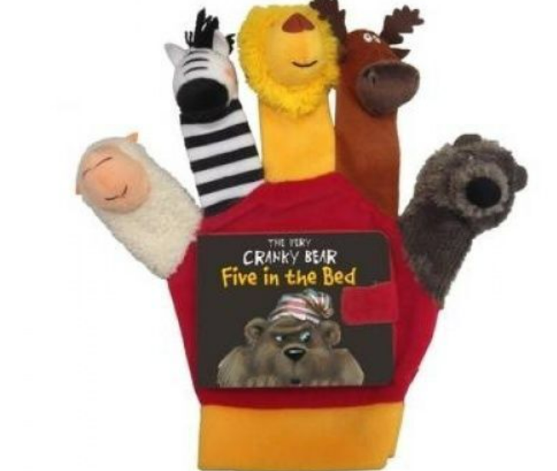  Source: Very Cranky Bear hand puppet. eBay Product ID (ePID) 106749992  -Consolidation/ extension activity:  Vocabulary building from text (using magnetic letters and little whiteboards) e.g.,  m/a/d- change initial sound  m/a/n- change end sound  m/e/n- change medial sound.  -S. record words they make on little whiteboards. Share.
Post-test  5-10 minutes per child  vocab, oral reading sample from text.  Writing is assessed throughout unit. | AC9EFLA08  ENE-VOCAB-01  VAES1.4  AC9EFLA06  ENE-REFLU-01 | -Post-test vocabulary, hfw, oral reading from text.  -Map S. oral reading NLLPV3 PKWp25, FlY p25.  -T. complete appendix 12, reflection and evaluation. | T. assesses S. 1-1. Choose a time S. are engaged in independent group activities.  -Appendix 1.  -Post-test vocabulary, hfw, oral reading from main text.  -T. map S. growth on NLLP PKW, FIY throughout unit.  -Appendix 12: T. reflection and evaluation.

